**VIDYALANKAR SCHOOL OF INFORMATION**

**TECHNOLOGY**

**Wadala (East), Mumbai – 400037**

**DATA ANALYSIS TOOLS**

AND

**DATA MINING**

**PRACTICAL**

**AFREEN SIRAJUDDIN SHAIKH**

**(Roll No: 183061031 )**

**ACADEMIC YEAR**

**2018-2019**

**PRACTICAL GUIDE**

**BEENA KAPADIA (DAT)**

AND

**PALLAVI TAWADE (DM)**

**SUBMITTED TO**

**UNIVERSITY OF MUMBAI**

**Submitted in partial fulfilment of the requirements**

**M.Sc.IT, Semester – I Examination**



**Vidyalankar School of Information Technology**

**Wadala (East), Mumbai – 400037**

**CERTIFICATE**

This is to certify that, **Ms./Mr_____________________________________**

Seat Number ______________studying in Master of Science in Information Technology Part-I (Semester-I) has satisfactorily completed the **Practical** in

the subject of “**DATA ANALYSIS TOOLS ”** as prescribed by University

of Mumbai, during the academic year 2018-2019.

**Subject Faculty Coordinator, M.Sc. (IT)**

**External Examiner**

**INDEX**

|  |  |  |  |  |
| --- | --- | --- | --- | --- |
| **Sr. No.** | **Title** | **Date** | **Page No.** | **Signature** |
|  | C programs |  |  |  |
|  | SQL Queries |  |  |  |
|  | Multiplication Table And Standard Deduction |  |  |  |
|  | Plotting A Graph |  |  |  |
|  | Implement The Statistical Distributions |  |  |  |
|  | Implement Regression And Goodness Of Fit |  |  |  |
|  | Generate Random Numbers Using Monte Carlo Method Using |  |  |  |
|  | Drawing An Inference |  |  |  |
|  | Implement Non-Parametric Testing |  |  |  |

**Installing all the Required Softwares for the Execution of the**

**Program.**

1. **Installing Sqlite**

1) Download the archive package of sqlite database named sqlite-autoconf-

3080600.tar.gz from the htpp:// www.sqlite.org.

2) After download of the sqlite-autoconf-3240000.tar.gz package ,copy the

package in the Home folder of Ubuntu 18.04 LTS

3) Open the Terminal. It will open in the Current Directory. We have to Extract

the package sqlite-autoconf-3240000.tar.gz

Then type the Command

beena@beena-VirtualBox:~$ tar xvfzsqlite-autoconf-3240000.tar.gz

4) After the Extraction of the package, the folder is created in the Current

Directory is known as sqlite-autoconf-3080600

5)Move to that new folder which has been created

beena@beena-VirtualBox:~$ cd sqlite-autoconf-3080600/

6) It is needed to configure all the files present in the sqlite-autoconf-3080600

folder

type the Command:

beena@beena-VirtualBox:~/sqlite-autoconf-3080600$ ./configure

7)After the configuration has been done,

Type the Command

beena@beena-VirtualBox:~/sqlite-autoconf-3080600$ sudo make

It will ask the password ,type the password and press the Enter Key

[sudo] password for tanvi:

make: Nothing to be done for `all'.

8) Now we need to install the “make” using the following command:

beena@beena-VirtualBox:~/sqlite-autoconf-3080600$ sudo make install

7)beena@beena-VirtualBox:~/sqlite-autoconf-3080600$ sudoldconfig

8)then we type this command to install sqlite

beena@beena-VirtualBox:~/sqlite-autoconf-3080600$ sudo apt-get installsqlite

9)After this operation, 495 kB of additional disk space will be used.

Do you want to continue [Y/n]? y

1. **How to install the gsl on ubuntu18.04**

1) Download the archive package of gsl named gsl-1.16.tar.gz from the

http:// www.gnu.org/s/gsl/‎

2) After download of the gsl-1.16.tar.gz package, copy the package in the

Home folder of Ubuntu 18.04

3) Open the Termina. It will open in the Current Directory. We have to Extract

the package gsl-1.16.tar.gz

Then type the Command

tarxvfz gsl-1.16.tar.gz

4) After the Extraction of the package, the folder is created in the Current

Directory is known as gsl-1.16

5) Move to that new folder which has been created

beena@beena-VirtualBox:~$ cd gsl-1.16

beena@beena-VirtualBox:~/gsl-1.16$

6) It is needed to configure all the files present in the gsl-1.16 folder

type the Command:

beena@beena-VirtualBox:~/gsl-1.16$ ./configure

7) After the configuration has been done,

Type the Command

beena@beena-VirtualBox:~/gsl-1.16$ sudo make

It will ask the password ,type the password and press the Enter Key

8) After the Make has been done it need to install the gsl

beena@beena-VirtualBox:~/gsl-1.16$ sudo make install

9) beena@beena-VirtualBox:~/gsl-1.16$ sudoldconfig

1. **How to install the apophenia on ubuntu18.04**

1) Download the archive package of apophenia named apophenia-1.0.tar.gz from the htpp:// apophenia.info/‎

‎

2) After download of the apophenia-1.0.tar.gz package, copy the package inthe Home folder of Ubuntu 18.04

3) Open the Terminal. It will open in the Current Directory. We have to extract

the package apophenia-1.0.tar.gz.

beena@beena-VirtualBox:~$ unzip apophenia-1.0.tar.gz

Archive: apophenia-1.0.tar.gz

4) After the Extraction of the package, the folder is created in the Current

Directory is known as apophenia-pkg

5) Move to that new folder which has been created

beena@beena-VirtualBox:~$ cd apophenia-pkg

6) It is needed to configure all the files present in the gsl-1.16 folder

type the Command:

beena@beena-VirtualBox:~/apophenia-pkg$ ./configure

7) After the configuration has been done,

Type the Command

beena@beena-VirtualBox:~/apophenia-pkg$ sudo make

It will ask the password ,type the password and press the Enter Key

[sudo] password for tanvi:

8) after the make has been done it needs to install apophenia as:-

beena@beena-VirtualBox:~/apophenia-pkg$ sudo make install

9)beena@beena-VirtualBox:~/apophenia-pkg$ sudoldconfig

**3.Installation of GNUPLOT On Ubuntu 18.04**

beena@beena-VirtualBox:~/Tanvi$ sudo apt-get install gnuplot-x11

**Practical No:1 – C Programs**

**1 a)Birthday paradox with structure and function.**

**Source code:**

#include<stdio.h>

#include<math.h>

typedefstruct

{

doubleone_match;

doublenone_match;

}bday_struct;

intupto=40;

voidcalculate_days(bday_struct days[]);

voidprint_days(bday_struct days[]);

void main()

{

bday_struct days[upto];

calculate_days(days);

print_days(days);

}

voidcalculate_days(bday_struct days[])

{

intct;

days[1].none_match=1;

for(ct=2;ct<=upto;ct++)

{

days[ct].one_match=1-pow(364/365.,ct-1);

days[ct].none_match=days[ct-1].none_match*(1-(ct-1)/365.);

}

}

voidprint_days(bday_struct days[])

{

intct;

printf("people\t matches me\t any match\n");

for(ct=2;ct<=upto;ct++)

{

printf("%i\t%.3f\t\t%.3f\n",ct,days[ct].one_match,1-days[ct].none_match);

}

}

**Output:**

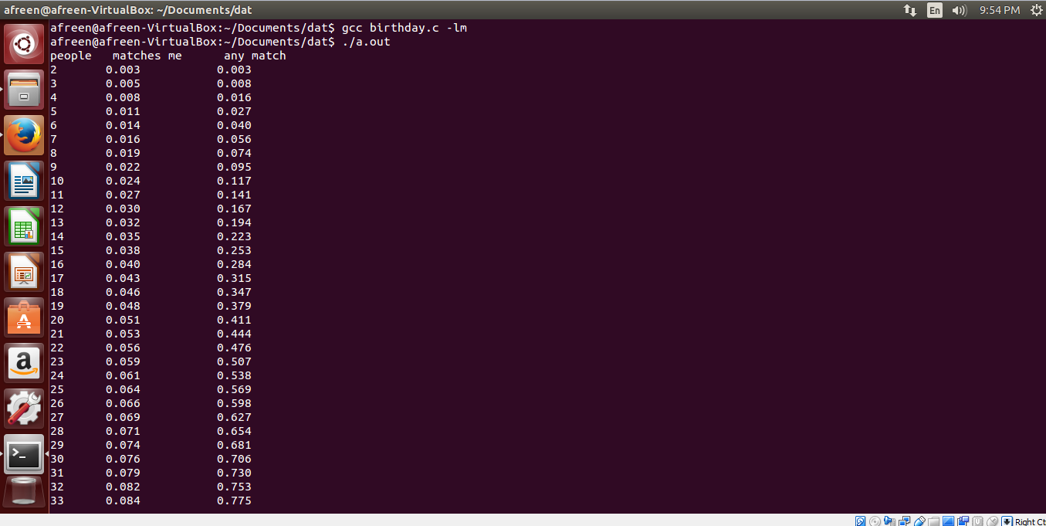

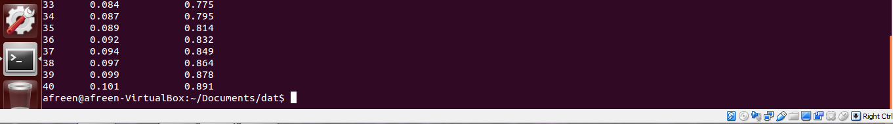

**1 b) Factorial of a number using function and pointer - a frame example**

**Factorial with function:**

**Source code:**

#include<stdio.h>

double fact=1;

double factorial(int n)

{

while(n)

{

fact*=n;

n--;

}

return fact;

}

void main()

{

int a;

printf("enter the value of a:");

scanf("%d",&a);

printf("%i factorial is %f.\n",a,factorial(a));

printf("a=%i\n",a);

printf("fact=%f\n",fact);

}

**Output:**

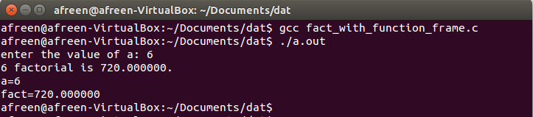

**Factorial with pointer:**

**Source code:**

#include<stdio.h>

double fact=1;

double factorial(int*n)

{

while(*n)

{

fact*=*n;

(*n)--;

}

return fact;

}

void main()

{

int a;

printf("enter the value of a\t");

scanf("%d",&a);

printf("a=%i\n",a);

printf("factorial=%10.0f\n",factorial(&a));

}

**Output:**

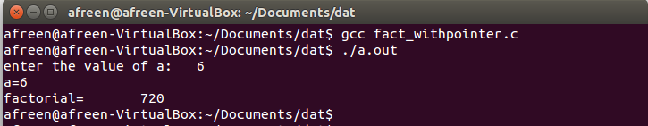

**1 c) Assertion in C**

**Source code:**

#include<assert.h>

#include<stdio.h>

floatfind_means(int in[5],int length)

{

inti;

assert(in!=NULL);

assert(length>0);

double mean=in[0];

for(i=1;i<length;i++)

mean+=in[i];

return(mean/length);

}

void main()

{

int a[5]={4,1,8,9,11};

floatmeanvalue=find_means(a,5);

printf("mean=%f\n",meanvalue);

}

**Output:**

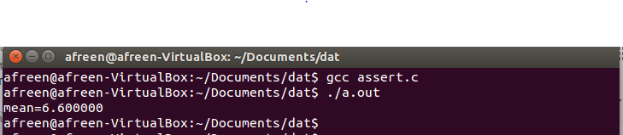

**1 d) String Functions**

**1] Source code:**

#include <stdio.h>

#include <string.h>

void main()

{

char str1[12]="abc";

char str2[12]="xyz";

char str3[12];

intlen;

strcpy(str3,str1);

printf("strcpy(str3,str1): %s\n",str1);

strcat(str1,str2);

printf("strcat(str1,str2): %s\n",str1);

len=strlen(str1);

printf("strlen(str1): %d\n",len);

strchr(str2,'o');

printf("strchr(str2,'o'): %s\n",str3);

strstr(str1,"llo");

printf("strstr(str1,\"llo\"): %s\n",str3);

}

**Output:**

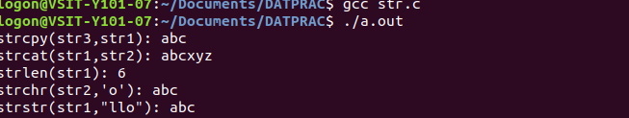

**2] Source code:**

#include<stdio.h>

#include<string.h>

void main()

{

char *s;

charbuf[]="Rahul Nishar";

s=strchr(buf,'a');

if(s!=NULL)

printf("found 'a' at %s\n",s);

}

**Output:**



**3] Source code:**

#include<stdio.h>

#include<string.h>

void main()

{

char *s;

charbuf[]="was a test";

s=strstr(buf,"is");

if(s!=NULL)

printf("found a string 'is' at %s\n",s);

}

**Output:**



**Practical No:2 – SQL Queries**

**Problem statement** :

To execute SQL queries in order to store and retrieve the data under study in a database. Sqlite is used for executing the queries.

i) Queries for performing DDL commands. DDL commands are used to create, modify and delete database objects. The data is stored in an RDBMS in the form of tables. Following are the queries to be performed for DDL commands in Sqlite

sqlite> CREATE TABLE COMPANY (ID INT PRIMARY KEY NOT NULL, NAME TEXT NOT NULL, AGE INT NOT NULL, ADDRESS CHAR(50), SALARY REAL );

sqlite> CREATE TABLE DEPARTMENT (ID INT PRIMARY KEY NOT NULL, DEPT CHAR(50) NOT NULL,

EMP_ID INT NOT NULL);

You can verify if your table has been created successfully using SQLIte command, .tables command

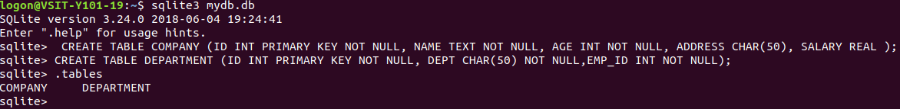

ii) Insertion value into the COMPANY and DEPARTMENT Table

sqlite> .tables

COMPANY customers emp orders

DEPARTMENT customers_temp employee randomcustomerdata

sqlite> INSERT INTO COMPANY (ID,NAME,AGE,ADDRESS,SALARY)

...> VALUES (1, 'Paul', 32, 'California', 20000.00 );

sqlite> INSERT INTO COMPANY (ID,NAME,AGE,ADDRESS,SALARY)

...> VALUES (2, 'Allen', 25, 'Texas', 15000.00 );

sqlite> INSERT INTO COMPANY (ID,NAME,AGE,ADDRESS,SALARY)

...> VALUES (3, 'Teddy', 23, 'Norway', 20000.00 );

sqlite> INSERT INTO COMPANY (ID,NAME,AGE,ADDRESS,SALARY)

...> VALUES (4, 'Mark', 25, 'Rich-Mond ', 65000.00 );

sqlite> INSERT INTO COMPANY (ID,NAME,AGE,ADDRESS,SALARY)

...> VALUES (5, 'David', 27, 'Texas', 85000.00 );

sqlite> INSERT INTO COMPANY (ID,NAME,AGE,ADDRESS,SALARY)

...> VALUES (6, 'Kim', 22, 'South-Hall', 45000.00 );

sqlite> INSERT INTO COMPANY VALUES (7, 'James', 24, 'Houston', 10000.00 );

sqlite> INSERT INTO DEPARTMENT (ID, DEPT, EMP_ID)

...> VALUES (1, 'IT Billing', 1 );

sqlite> INSERT INTO DEPARTMENT (ID, DEPT, EMP_ID)

...> VALUES (2, 'Engineering', 2 );

sqlite> INSERT INTO DEPARTMENT (ID, DEPT, EMP_ID)

...> VALUES (3, 'Finance', 7 );

iii) Select clause is a data manipulation command used for retrieving the data in the desired format from the database objects. The syntax of the various select clause and its purpose is given below:

sqlite> select * from COMPANY;

1|Paul|32|California|20000.0

2|Allen|25|Texas|15000.0

3|Teddy|23|Norway|20000.0

4|Mark|25|Rich-Mond |65000.0

5|David|27|Texas|85000.0

6|Kim|22|South-Hall|45000.0

7|James|24|Houston|10000.0

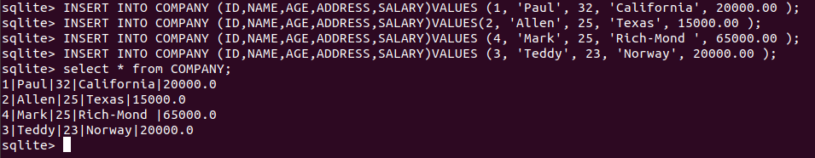

sqlite> select * from DEPARTMENT;

1|IT Billing|1

2|Engineering|2

3|Finance|7

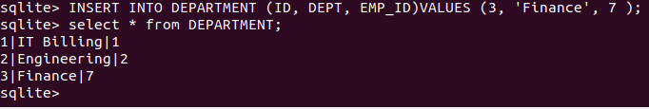

sqlite> .header on

sqlite> select * from DEPARTMENT;

ID|DEPT|EMP_ID

1|IT Billing|1

2|Engineering|2

3|Finance|7

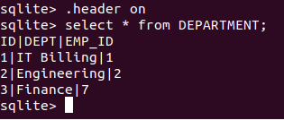

sqlite> .mode column

sqlite> select * from DEPARTMENT;

ID DEPT EMP_ID

---------- ---------- ----------

1 IT Billing 1

2 Engineerin 2

3 Finance 7

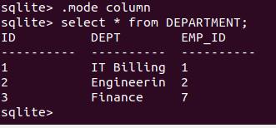

a) list down all the records where AGE is greater than or equal to 25 AND salary is greater than or equal to 65000.00:

sqlite> SELECT * FROM COMPANY WHERE AGE >= 25 AND SALARY >= 65000;

ID NAME AGE ADDRESS SALARY

---------- ---------- ---------- ---------- ----------

4 Mark 25 Rich-Mond 65000.0

5 David 27 Texas 85000.0

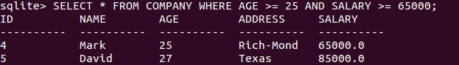

b) list down all the records where AGE is greater than or equal to 25 OR salary is greater than or equal to 65000.00:

sqlite> SELECT * FROM COMPANY WHERE AGE >= 25 OR SALARY >= 65000;

ID NAME AGE ADDRESS SALARY

---------- ---------- ---------- ---------- ----------

1 Paul 32 California 20000.0

2 Allen 25 Texas 15000.0

4 Mark 25 Rich-Mond 65000.0

5 David 27 Texas 85000.0

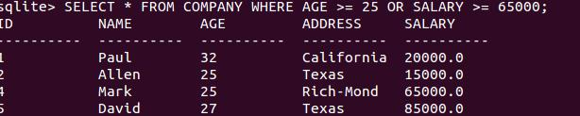

c) list down all the records where AGE is not NULL which means all the records because none of the record is having AGE equal to NULL:

sqlite> SELECT * FROM COMPANY WHERE AGE IS NOT NULL;

ID NAME AGE ADDRESS SALARY

---------- ---------- ---------- ---------- ----------

1 Paul 32 California 20000.0

2 Allen 25 Texas 15000.0

3 Teddy 23 Norway 20000.0

4 Mark 25 Rich-Mond 65000.0

5 David 27 Texas 85000.0

6 Kim 22 South-Hall 45000.0

7 James 24 Houston 10000.0

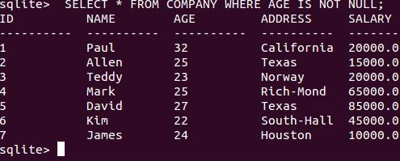

d) list down all the records where NAME starts with 'Ki', does not matter what comes after 'Ki'

sqlite> SELECT * FROM COMPANY WHERE NAME LIKE 'Ki%';

ID NAME AGE ADDRESS SALARY

---------- ---------- ---------- ---------- ----------

6 Kim 22 South-Hall 45000.0

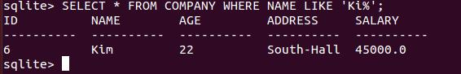

e) list down all the records where AGE value is either 25 or 27:

sqlite> SELECT * FROM COMPANY WHERE AGE IN ( 25, 27 );

ID NAME AGE ADDRESS SALARY

---------- ---------- ---------- ---------- ----------

2 Allen 25 Texas 15000.0

4 Mark 25 Rich-Mond 65000.0

5 David 27 Texas 85000.0

f) list down all the records where AGE value is neither 25 nor 27:

sqlite> SELECT * FROM COMPANY WHERE AGE NOT IN ( 25, 27 );

ID NAME AGE ADDRESS SALARY

---------- ---------- ---------- ---------- ----------

1 Paul 32 California 20000.0

3 Teddy 23 Norway 20000.0

6 Kim 22 South-Hall 45000.0

7 James 24 Houston 10000.0

g) list down all the records where AGE value is in BETWEEN 25 AND 27:

sqlite> SELECT * FROM COMPANY WHERE AGE BETWEEN 25 AND 27;

ID NAME AGE ADDRESS SALARY

---------- ---------- ---------- ---------- ----------

2 Allen 25 Texas 15000.0

4 Mark 25 Rich-Mond 65000.0

5 David 27 Texas 85000.0

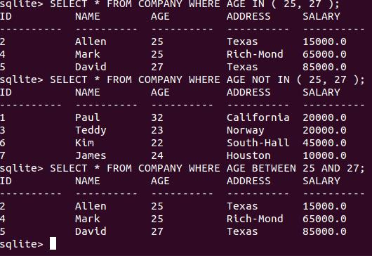

h) **finds all records with AGE field if SALARY > 65000**

sqlite> SELECT AGE FROM COMPANY

...> WHERE EXISTS (SELECT AGE FROM COMPANY WHERE SALARY > 65000);

AGE

----------

32

25

23

25

27

22

24

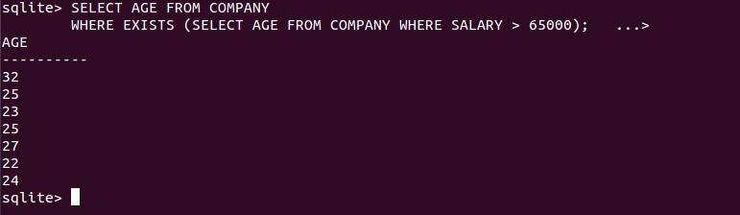

sqlite> select age from company where exists (select * from company where salary>110000);

sqlite> select age from company where exists (select * from company where salary < 65000);

AGE

----------

32

25

23

25

27

22

24

sqlite> select age from company where exists (select * from company where salary = 20000);

AGE

----------

32

25

23

25

27

22

24

sqlite> select age from company where exists (select * from company where salary = 60000);

sqlite> INSERT INTO COMPANY VALUES (8, 'Paul', 24, 'Houston', 20000.00 );

sqlite> INSERT INTO COMPANY VALUES (9, 'James', 44, 'Norway', 5000.00 );

sqlite> INSERT INTO COMPANY VALUES (10, 'James', 45, 'Texas', 5000.00 );

sqlite> select * from company;

ID NAME AGE ADDRESS SALARY

---------- ---------- ---------- ---------- ----------

1 Paul 32 California 20000.0

2 Allen 25 Texas 15000.0

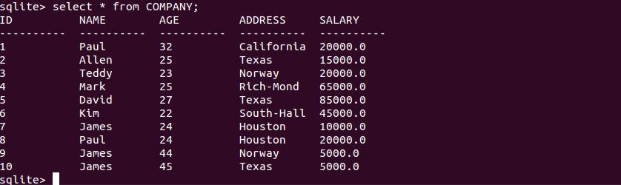3 Teddy 23 Norway 20000.0

4 Mark 25 Rich-Mond 65000.0

5 David 27 Texas 85000.0

6 Kim 22 South-Hall 45000.0

7 James 24 Houston 10000.0

8 Paul 24 Houston 20000.0

9 James 44 Norway 5000.0

10 James 45 Texas 5000.0



i) Find the total amount of salary on each customer

sqlite> SELECT NAME, SUM(SALARY) FROM COMPANY GROUP BY NAME;

NAME SUM(SALARY)

---------- -----------

Allen 15000.0

David 85000.0

James 20000.0

Kim 45000.0

Mark 65000.0

Paul 40000.0

Teddy 20000.0

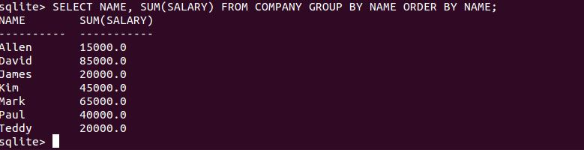

j) Order by Clause

sqlite> SELECT NAME, SUM(SALARY) FROM COMPANY GROUP BY NAME ORDER

...> BY NAME;

NAME SUM(SALARY)

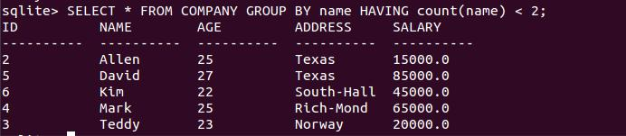---------- -----------

Allen 15000.0

David 85000.0

James 20000.0

Kim 45000.0

Mark 65000.0

Paul 40000.0

Teddy 20000.0



k) display record for which name count is less than 2:

sqlite> SELECT * FROM COMPANY GROUP BY name HAVING count(name) < 2;

ID NAME AGE ADDRESS SALARY

---------- ---------- ---------- ---------- ----------

2 Allen 25 Texas 15000.0

5 David 27 Texas 85000.0

6 Kim 22 South-Hall 45000.0

4 Mark 25 Rich-Mond 65000.0

3 Teddy 23 Norway 20000.0



sqlite> SELECT * FROM COMPANY GROUP BY name HAVING count(name) > 2;

ID NAME AGE ADDRESS SALARY

---------- ---------- ---------- ---------- ----------

10 James 45 Texas 5000.0

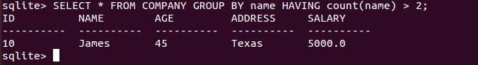

l) which would sort the result in Ascending order by SALARY:

sqlite> SELECT * FROM COMPANY ORDER BY SALARY ASC;

ID NAME AGE ADDRESS SALARY

---------- ---------- ---------- ---------- ----------

9 James 44 Norway 5000.0

10 James 45 Texas 5000.0

7 James 24 Houston 10000.0

2 Allen 25 Texas 15000.0

1 Paul 32 California 20000.0

3 Teddy 23 Norway 20000.0

8 Paul 24 Houston 20000.0

6 Kim 22 South-Hall 45000.0

4 Mark 25 Rich-Mond 65000.0

5 David 27 Texas 85000.0

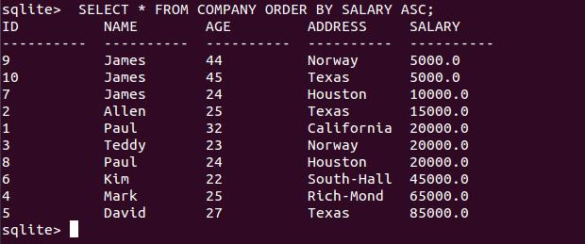

m) which would sort the result in descending order by NAME:

sqlite> SELECT * FROM COMPANY ORDER BY NAME DESC;

ID NAME AGE ADDRESS SALARY

---------- ---------- ---------- ---------- ----------

3 Teddy 23 Norway 20000.0

1 Paul 32 California 20000.0

8 Paul 24 Houston 20000.0

4 Mark 25 Rich-Mond 65000.0

6 Kim 22 South-Hall 45000.0

7 James 24 Houston 10000.0

9 James 44 Norway 5000.0

10 James 45 Texas 5000.0

5 David 27 Texas 85000.0

2 Allen 25 Texas 15000.0

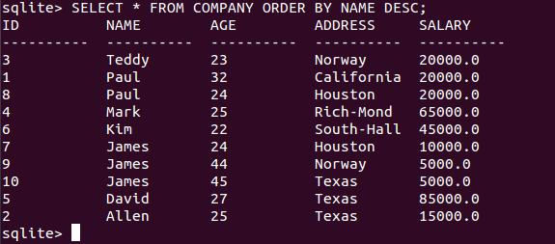

n) limit the row in the table according to the no of rows you want to fetch from table:

sqlite> SELECT * FROM COMPANY LIMIT 6;

ID NAME AGE ADDRESS SALARY

---------- ---------- ---------- ---------- ----------

1 Paul 32 California 20000.0

2 Allen 25 Texas 15000.0

3 Teddy 23 Norway 20000.0

4 Mark 25 Rich-Mond 65000.0

5 David 27 Texas 85000.0

6 Kim 22 South-Hall 45000.0

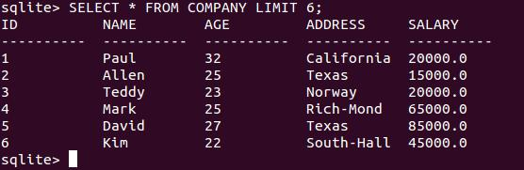

sqlite> SELECT * FROM COMPANY LIMIT 3 OFFSET 2;

ID NAME AGE ADDRESS SALARY

---------- ---------- ---------- ---------- ----------

3 Teddy 23 Norway 20000.0

4 Mark 25 Rich-Mond 65000.0

5 David 27 Texas 85000.0 South-Hall 45000.0

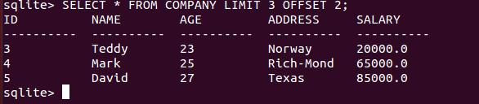

o) JOIN

sqlite> SELECT EMP_ID, NAME, DEPT FROM COMPANY CROSS JOIN

...> DEPARTMENT;

EMP_ID NAME DEPT

---------- ---------- ----------

1 Paul IT Billing

2 Paul Engineerin

7 Paul Finance

1 Allen IT Billing

2 Allen Engineerin

7 Allen Finance

1 Teddy IT Billing

2 Teddy Engineerin

7 Teddy Finance

1 Mark IT Billing

2 Mark Engineerin

7 Mark Finance

1 David IT Billing

2 David Engineerin

7 David Finance

1 Kim IT Billing

2 Kim Engineerin

7 Kim Finance

1 James IT Billing

2 James Engineerin

7 James Finance

1 Paul IT Billing

2 Paul Engineerin

7 Paul Finance

1 James IT Billing

2 James Engineerin

7 James Finance

1 James IT Billing

2 James Engineerin

7 James Finance

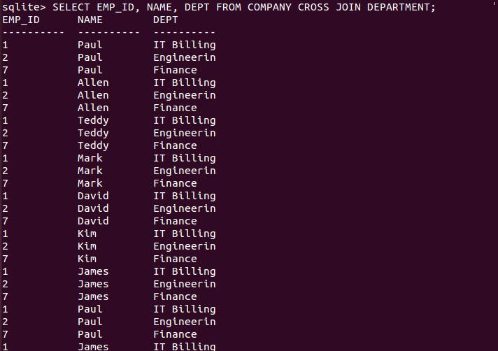

sqlite> SELECT EMP_ID, NAME, DEPT FROM COMPANY INNER JOIN

...> DEPARTMENT

...> ON COMPANY.ID = DEPARTMENT.EMP_ID;

EMP_ID NAME DEPT

---------- ---------- ----------

1 Paul IT Billing

2 Allen Engineerin

7 James Finance

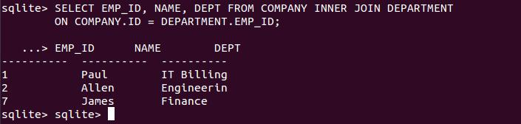

sqlite> SELECT EMP_ID, NAME, DEPT FROM COMPANY LEFT OUTER JOIN

...> DEPARTMENT

...> ON COMPANY.ID = DEPARTMENT.EMP_ID;

EMP_ID NAME DEPT

---------- ---------- ----------

1 Paul IT Billing

2 Allen Engineerin

Teddy

Mark

David

Kim

7 James Finance

Paul

James

James

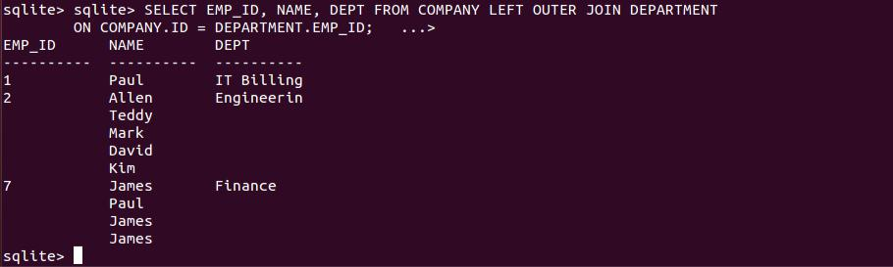

**Practical No:3 – Multiplication Table And Standard Deduction**

**3 a) Multiplication Table**

**Source code:**

#include<apop.h>

int main()

{

gsl_matrix *m=gsl_matrix_alloc(20,10);

gsl_matrix_set_all(m,1);

for(inti=0;i<m->size1;i++)

{

apop_matrix_row(m,i,one_row);

gsl_vector_scale(one_row,i+1);

}

for(inti=0;i<m->size2;i++)

{

apop_matrix_col(m,i,one_col);

gsl_vector_scale(one_col,i+1);

}

apop_matrix_show(m);

gsl_matrix_free(m);

}

**Output:**

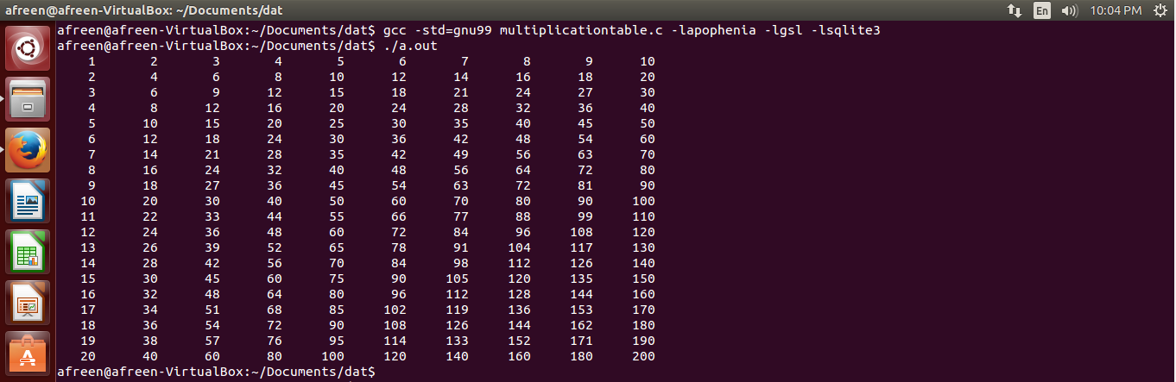

**3 b) Standard Deduction**

**Source code:**

#include<apop.h>

doublecalc_taxes(double income)

{

double cutoffs[] ={0,11200,42650,110100,178350,349700,INFINITY};

double rates[] ={0,0.10,.15,.25,.28,.33,.35};

double tax =0;

int bracket =1;

income -= 7850;

income -= 3400*3;

while(income > 0)

{

tax += rates[bracket] * GSL_MIN(income,cutoffs[bracket]-cutoffs[bracket-1]);

income -= cutoffs[bracket];

bracket ++;

}

return tax;

}

int main()

{

apop_db_open("mydata.db");

apop_opts.db_name_column="empname";

apop_data *d = apop_query_to_data("select empname,empincome as\ income from income order by empincomedesc");

Apop_col_tv(d,"income",income_vector);

d->vector = apop_vector_map(income_vector,calc_taxes);

apop_name_add(d->names,"taxowed",'v');

apop_data_show(d);

}

**Output:**

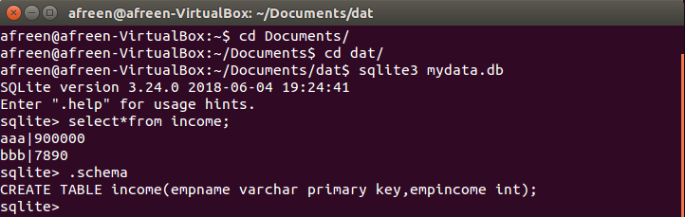

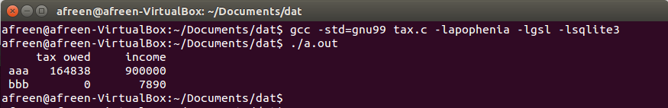

**Practical No:4 – Plotting A Graph**

**4 a)Plotting A Vector**

**Source code:**

#include<apop.h>

voidplot_matrix_now(gsl_matrix *data)

{

static FILE *gp=NULL;

if(!gp)

gp=popen("gnuplot -persist","w");

if(!gp)

{

printf("couldn't open Gnuplot.\n");

return;

}

fprintf(gp,"reset; plot '-' \n");

apop_matrix_print(data,.output_pipe=gp);

fflush(gp);

}

int main()

{

apop_db_open("data-climate.db");

apop_data *d=apop_query_to_data("select (year*12+month)/12., temp from temp");

plot_matrix_now(d->matrix);

}

**Output:**

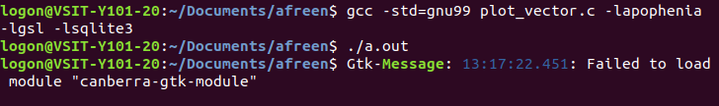

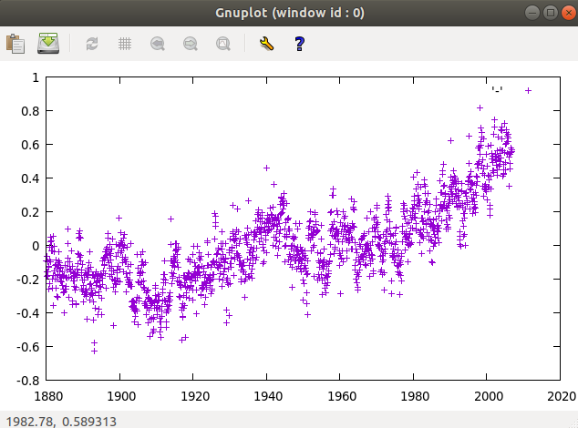

**4 b)Error Bar**

**Source code:**

#include<apop.h>

int main()

{

apop_db_open("data-climate.db");

apop_data *d=apop_query_to_data("select \

(yearmonth/100. - round(yearmonth/100.))*100 as month, \

avg(tmp), stddev(tmp) \

fromprecip group by month");

printf("set xrange[0:13]; plot '-' with errorbars\n");

apop_matrix_show(d->matrix);

}

**Output:**

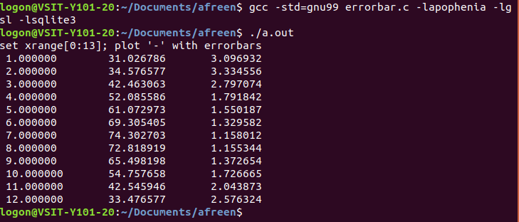

**Practical No:5 – Implement The Statistical Distribution**

**Discrete Distribution**

1. **Bernoulli Distribution**

**Source code:**

#include<stdio.h>

#include<gsl/gsl_randist.h>

int main()

{

inti;

double p=0.6;

float sum=0;

printf("random variable ||| probability ||| cumulative prob\n");

printf("---------------------------------------------------\n");

for(i=0;i<=1;i++)

{

float k=gsl_ran_bernoulli_pdf(i,p);

sum=sum + k;

printf("%d\t\t%f\t\t%f\n",i,k,sum);

}

printf("\n");

return 0;

}

**Output:**

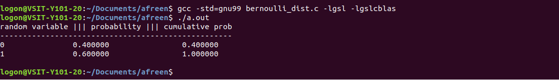

1. **Binomial Distribution**

**Source code:**

#include<stdio.h>

#include<gsl/gsl_randist.h>

int main()

{

inti,n=5;

double p=0.6;

float sum=0;

printf("random variable ||| probability ||| cumulative prob\n");

printf("---------------------------------------------------\n");

for(i=0;i<=n;i++)

{

float k=gsl_ran_binomial_pdf(i,p,n);

sum=sum + k;

printf("%d\t\t%f\t\t%f\n",i,k,sum);

}

printf("\n");

return 0;

}

**Output:**

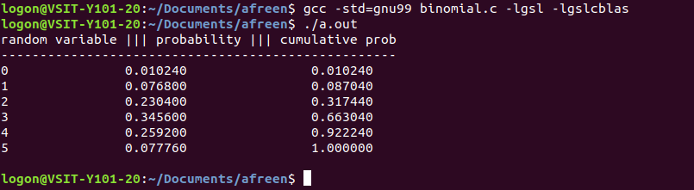

1. **Poisson Distribution**

**Source code:**

#include<stdio.h>

#include<gsl/gsl_randist.h>

int main()

{

inti,n=10;

double mu=3.0;

float sum=0;

printf("random variable ||| probability ||| cumulative prob\n");

printf("---------------------------------------------------\n");

for(i=0;i<=n;i++)

{

float k=gsl_ran_poisson_pdf(i,mu);

sum=sum + k;

printf("%d\t\t%f\t\t%f\n",i,k,sum);

}

printf("\n");

return 0;

}

**Output:**

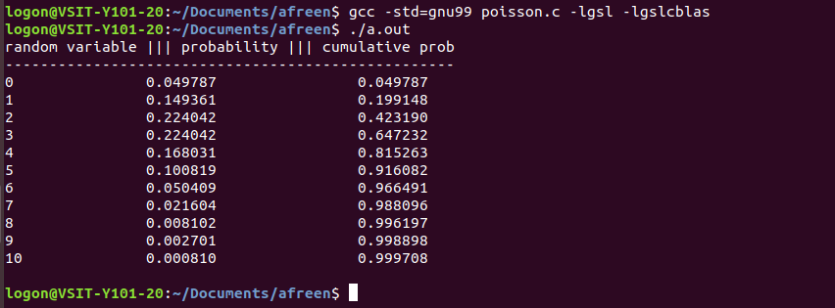

1. **Multinomial Distribution**

**Source code:**

#include<stdio.h>

#include<gsl/gsl_randist.h>

int main()

{

int k=3;

const double p[]={0.2,0.4,0.4};

const unsigned int n[]={2,3,4};

printf("random variable ||| probability \n");

printf("---------------------------------------------------\n");

doublepmf=gsl_ran_multinomial_pdf(k,p,n);

printf("%3.9f\n",pmf);

return 0;

}

**Output:**

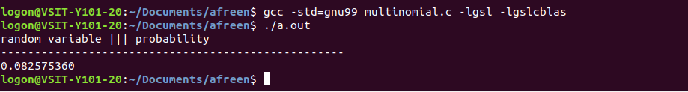

1. **Hypergeometric Distribution**

**Source code:**

#include<stdio.h>

#include<gsl/gsl_randist.h>

int main()

{

intx,f,s,n;

n=6;

x=2;

s=13;

f=39;

printf("random variable ||| probability \n");

printf("---------------------------------------------------\n");

doublepmf=gsl_ran_hypergeometric_pdf(x,s,f,n);

printf("%d %3.9lf\n",x,pmf);

return 0;

}

**Output:**

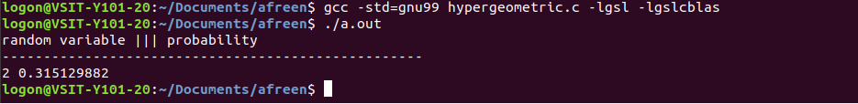

**Continous Distribution**

1. **Normal Distribution**

**Source code:**

#include<stdio.h>

#include<math.h>

#include<gsl/gsl_rng.h>

#include<gsl/gsl_randist.h>

#include<gsl/gsl_cdf.h>

void main()

{

doublep,q;

double x=10;

double sigma=5;

doublepdf;

printf("Normal distribution :x=%f sigma=%f\n",x,sigma);

pdf=gsl_ran_gaussian_pdf(x,sigma);

printf("prob(x=%f)=%f\n",x,pdf);

p=gsl_cdf_gaussian_P(x,sigma);

printf("prob(x<=%f)=%f\n",x,p);

q=gsl_cdf_gaussian_Q(x,sigma);

printf("prob(x>=%f)=%f\n",x,q);

x=gsl_cdf_gaussian_Pinv(p,sigma);

printf("pinv(%f)=%f\n",p,x);

x=gsl_cdf_gaussian_Qinv(q,sigma);

printf("qinv(%f)=%f\n",q,x);

}

**Output:**

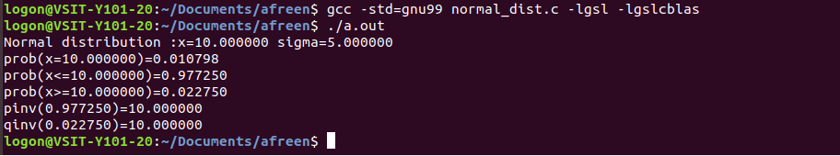

1. **Lognormal Distribution**

**Source code:**

#include<stdio.h>

#include<math.h>

#include<gsl/gsl_rng.h>

#include<gsl/gsl_randist.h>

#include<gsl/gsl_cdf.h>

void main()

{

doublep,q;

double x=4;

double zeta=2;

double sigma=1.5;

doublepdf;

printf("Lognormal distribution :x=%f zeta=%f sig

ma=%f\n",x,zeta,sigma);

pdf=gsl_ran_lognormal_pdf(x,zeta,sigma);

printf("prob(x=%f)=%f\n",x,pdf);

p=gsl_cdf_lognormal_P(x,zeta,sigma);

printf("prob(x<=%f)=%f\n",x,p);

q=gsl_cdf_lognormal_Q(x,zeta,sigma);

printf("prob(x>=%f)=%f\n",x,q);

x=gsl_cdf_lognormal_Pinv(p,zeta,sigma);

printf("pinv(%f)=%f\n",p,x);

x=gsl_cdf_lognormal_Qinv(q,zeta,sigma);

printf("qinv(%f)=%f\n",q,x);

}

**Output:**

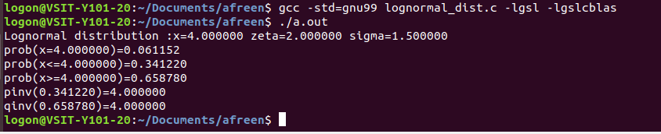

1. **Gamma Distribution**

**Source code:**

#include<stdio.h>

#include<math.h>

#include<gsl/gsl_rng.h>

#include<gsl/gsl_randist.h>

#include<gsl/gsl_cdf.h>

void main()

{

doublep,q;

double x=0.8;

double a=1;

double b=2;

doublepdf;

printf("Gamma distribution :x=%f a=%f b=%f\n",x,a,b);

pdf=gsl_ran_gamma_pdf(x,a,b);

printf("prob(x=%f)=%f\n",x,pdf);

p=gsl_cdf_gamma_P(x,a,b);

printf("prob(x<=%f)=%f\n",x,p);

q=gsl_cdf_gamma_Q(x,a,b);

printf("prob(x>=%f)=%f\n",x,q);

x=gsl_cdf_gamma_Pinv(p,a,b);

printf("pinv(%f)=%f\n",p,x);

x=gsl_cdf_gamma_Qinv(q,a,b);

printf("qinv(%f)=%f\n",q,x);

}

**Output:**

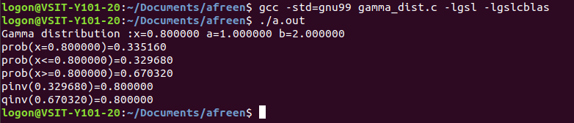

1. **Exponential Distribution**

**Source code:**

#include<stdio.h>

#include<math.h>

#include<gsl/gsl_rng.h>

#include<gsl/gsl_randist.h>

#include<gsl/gsl_cdf.h>

void main()

{

doublep,q;

double x=0.05;

double lambda=2;

doublepdf;

printf("Exponential distribution :x=%f lambda=%f\n",x,lambda);

pdf=gsl_ran_exponential_pdf(x,lambda);

printf("prob(x=%f)=%f\n",x,pdf);

p=gsl_cdf_exponential_P(x,lambda);

printf("prob(x<=%f)=%f\n",x,p);

q=gsl_cdf_exponential_Q(x,lambda);

printf("prob(x>=%f)=%f\n",x,q);

x=gsl_cdf_exponential_Pinv(p,lambda);

printf("pinv(%f)=%f\n",p,x);

x=gsl_cdf_exponential_Qinv(q,lambda);

printf("qinv(%f)=%f\n",q,x);

}

**Output:**

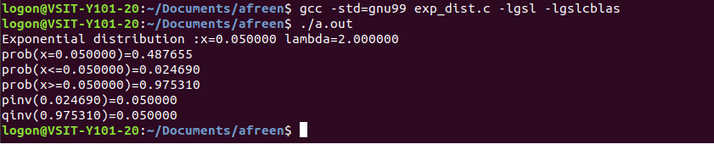

1. **Beta Distribution**

**Source code:**

#include<stdio.h>

#include<math.h>

#include<gsl/gsl_rng.h>

#include<gsl/gsl_randist.h>

#include<gsl/gsl_cdf.h>

void main()

{

doublep,q;

double x=0.8;

double a=0.5;

double b=0.5;

doublepdf;

printf("Beta distribution :x=%f a=%f b=%f\n",x,a,b);

pdf=gsl_ran_beta_pdf(x,a,b);

printf("prob(x=%f)=%f\n",x,pdf);

p=gsl_cdf_beta_P(x,a,b);

printf("prob(x<=%f)=%f\n",x,p);

q=gsl_cdf_beta_Q(x,a,b);

printf("prob(x>=%f)=%f\n",x,q);

x=gsl_cdf_beta_Pinv(p,a,b);

printf("pinv(%f)=%f\n",p,x);

x=gsl_cdf_beta_Qinv(q,a,b);

printf("qinv(%f)=%f\n",q,x);

}

**Output:**

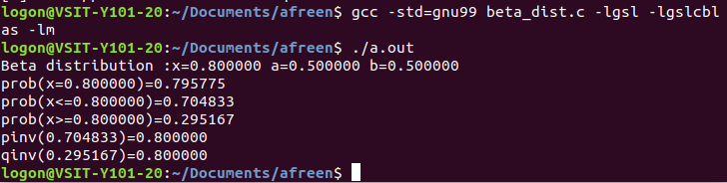

**Practical No:6 - Implement Regression**

**Implementing Regression**

**Source code:**

#include <stdio.h>

#include <gsl/gsl_fit.h>

int main(void)

{

inti, n = 4;

double x[4] = { 1970, 1980, 1990, 2000 };

double y[4] = { 12, 11, 14, 13 };

double w[4] = { 0.1, 0.2, 0.3, 0.4 };

double c0, c1, cov00, cov01, cov11, chisq;

gsl_fit_wlinear (x, 1, w, 1, y, 1, n,&c0, &c1, &cov00, &cov01, &cov11,&chisq);

printf ("# best fit: Y = %g + %g X\n", c0, c1);

printf ("# covariance matrix:\n");

printf ("# [ %g, %g\n# %g, %g]\n",cov00, cov01, cov01, cov11);

printf ("# chisq = %g\n", chisq);

for (i = 0; i< n; i++)

printf ("data: %g %g %g\n",x[i], y[i], 1/sqrt(w[i]));

printf ("\n");

for (i = -30; i< 130; i++)

{

doublexf = x[0] + (i/100.0) * (x[n-1] - x[0]);

doubleyf, yf_err;

gsl_fit_linear_est (xf,c0, c1,cov00, cov01, cov11,&yf, &yf_err);

printf ("fit: %g %g\n", xf, yf);

printf ("hi : %g %g\n", xf, yf + yf_err);

printf ("lo : %g %g\n", xf, yf - yf_err);

}

return 0;

}

**Output:-**

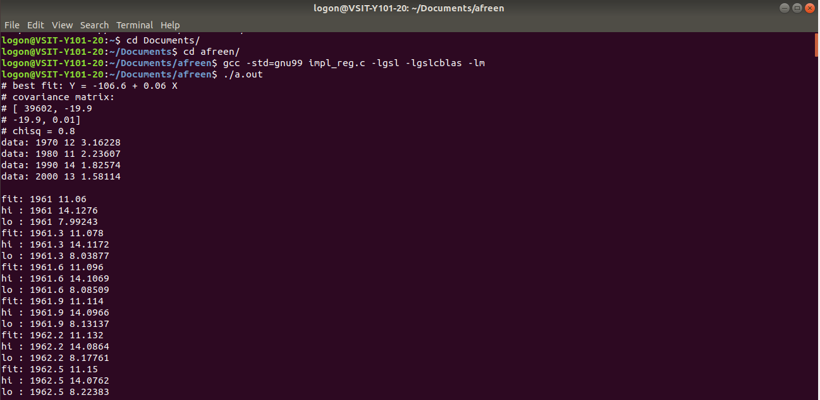

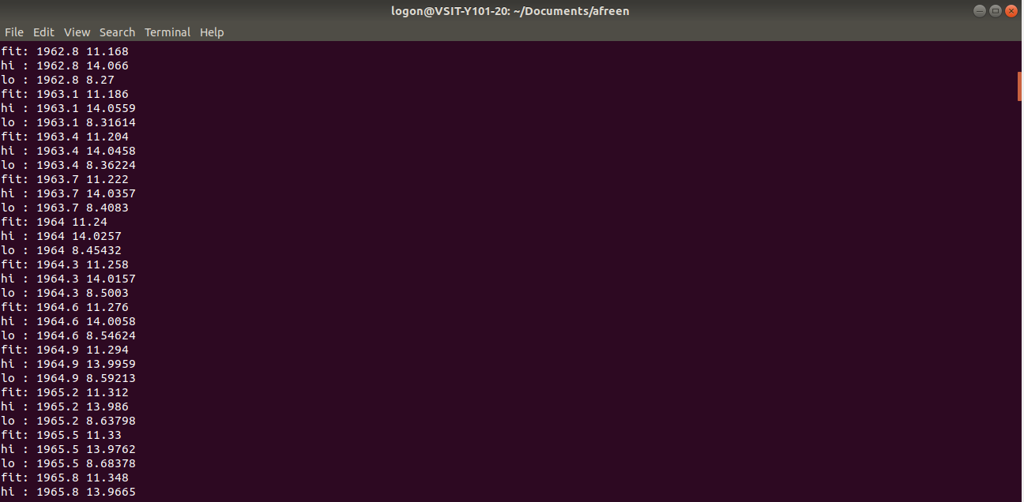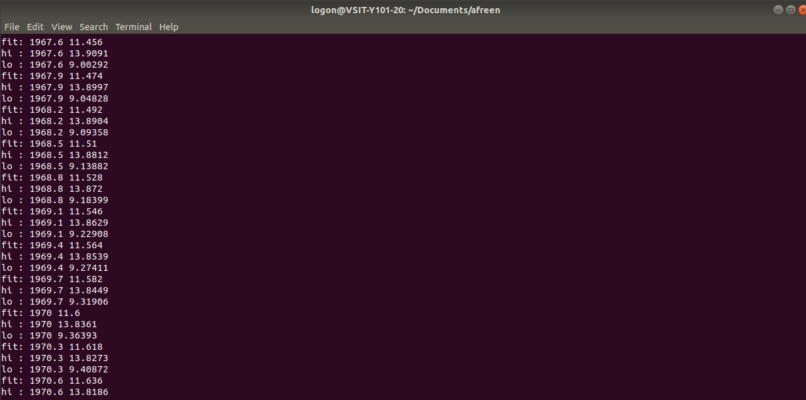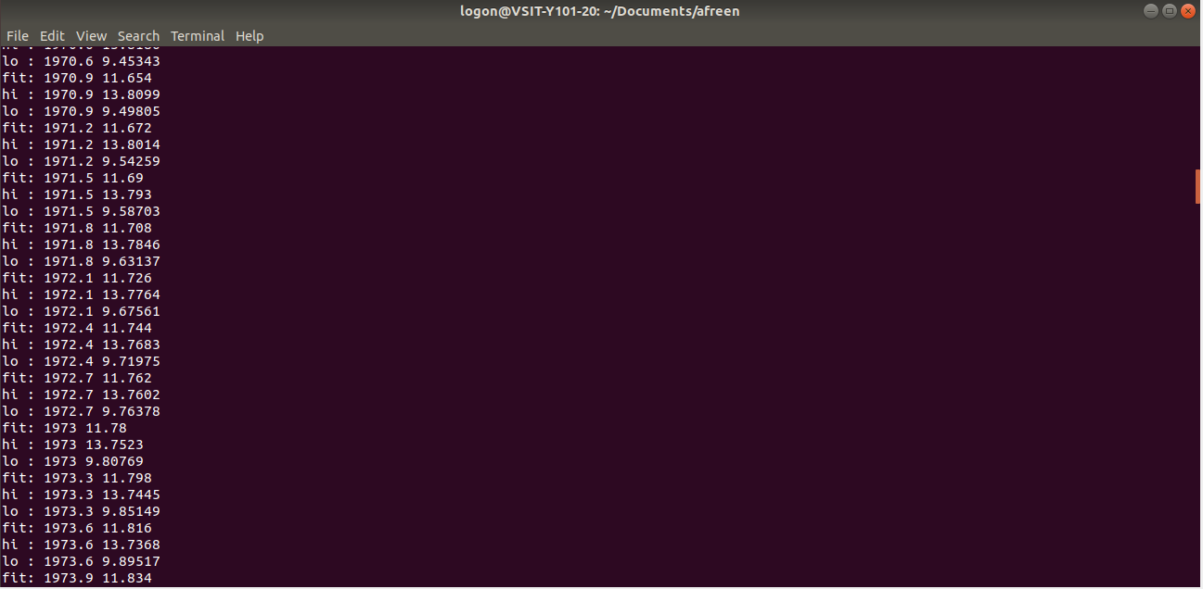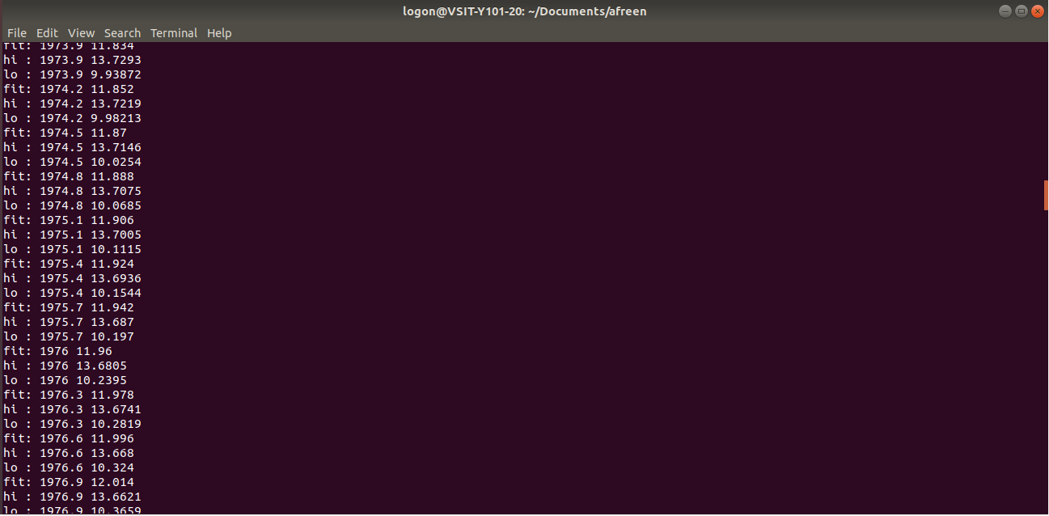

**Practical No:7 - Generate Random Numbers Using Monte Carlo Method Using**

1. **Exponential Distribution**
2. **Uniform Distribution**
3. **Binomial Distribution**

Some functions used for random number generation the functions used for random number generation are declared in the header file `gsl_rng.h'.

• constgsl_rng_type * T : holds static information about each type of

generator.

• gsl_rng_env_setup() : This function reads the environment variables GSL_RNG_TYPE and GSL_RNG_SEED and uses their values to set the corresponding library variables gsl_rng_default and gsl_rng_default_seed.

* **Program to Create a Global Generator using the Environment**

variables GSL_RNG_TYPE and GSL_RNG_SEED,

**Source code:**

#include<stdio.h>

#include<gsl/gsl_rng.h>

gsl_rng * r; /* global generator */

intmain(void)

{

constgsl_rng_type * T;

gsl_rng_env_setup();

T = gsl_rng_default;

r = gsl_rng_alloc (T);

printf ("generator type: %s\n", gsl_rng_name (r));

printf ("seed = %lu\n", gsl_rng_default_seed);

printf ("first value = %lu\n", gsl_rng_get (r));

gsl_rng_free (r);

return 0;

}

**Output:-**

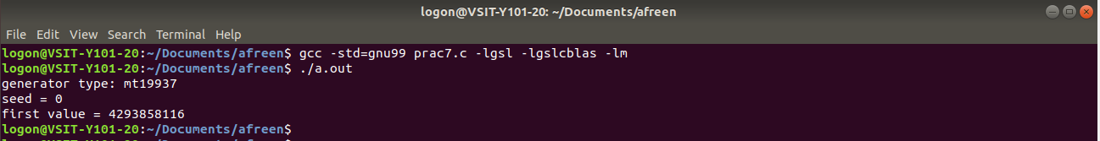

* **Using Exponential Distribution**

**Source code:**

#include<stdio.h>

#include<stdlib.h>

#include<math.h>

#include<gsl/gsl_rng.h>

#include<gsl/gsl_randist.h>

int main(intargc, char *argv[])

{

inti,n;

floatx,alpha;

gsl_rng *r=gsl_rng_alloc(gsl_rng_mt19937); /* initialises GSL RNG */

n=atoi(argv[1]);

alpha=atof(argv[2]);

x=0;

for (i=0;i<n;i++)

{

x=alpha*x + gsl_ran_exponential(r,1);

printf(" %2.4f \n",x);

}

return(0);

}

**Output:-**

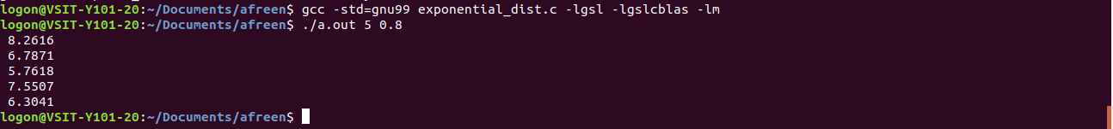

* **Generating Uniform Random Numbers in the Range [0.0, 1.0) Using Uniform**

**Distribution**

**Source code:**

#include<stdio.h>

#include<gsl/gsl_rng.h>

intmain(void)

{

constgsl_rng_type * T;

gsl_rng * r;

inti, n = 10;

gsl_rng_env_setup();

T = gsl_rng_default;

r = gsl_rng_alloc(T);

for(i = 0; i< n; i++)

{

double u = gsl_rng_uniform (r);

printf ("%.5f\n", u);

}

gsl_rng_free(r);

return 0;

}

**Output:-**

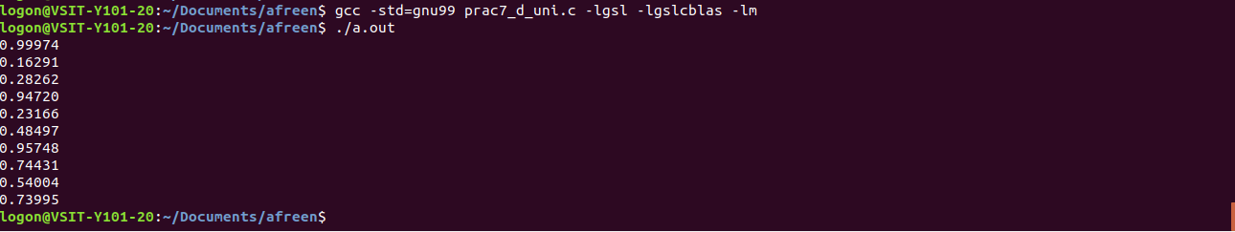

* **Using binomial distribution**

**Source code:**

#include <stdio.h>

#include <gsl/gsl_rng.h>

#include <gsl/gsl_randist.h>

intmain(void)

{

constgsl_rng_type * T;

gsl_rng * r;

inti, n = 10;

/* create a generator chosen by the environment variable GSL_RNG_TYPE */

gsl_rng_env_setup();

T = gsl_rng_default;

r = gsl_rng_alloc (T);

float p=0.3;

/* print n random variates chosen from the binomial distribution with mean parameter mu */

for (i = 0; i< n; i++)

{

unsignedint k = gsl_ran_binomial(r, p,n);

printf (" %u", k);

}

printf ("\n");

gsl_rng_free (r);

return 0;

}

**Output:-**



Following functions can be used to generate random numbers using different

distributions by knowing the parameters required.

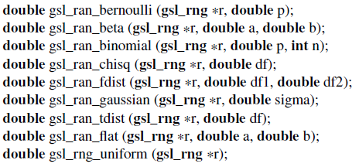

**Practical No:8 - Drawing an Inference**

* **Obtaining mean, standard error & p value for the given data.**

**Source code:**

#include <apop.h>

voidone_boot(gsl_vector *base_data, gsl_rng *r, gsl_vector *boot_sample);

voidone_boot(gsl_vector *base_data, gsl_rng *r, gsl_vector *boot_sample)

{

intbootsize=boot_sample->size;

intbasesize=base_data->size;

for(inti=0; i<bootsize; i++)

{

gsl_vector_set(boot_sample, i, gsl_vector_get(base_data, gsl_rng_uniform_int(r, basesize)));

}

}

int main()

{

intrep_ct = 10000;

gsl_rng *r = apop_rng_alloc(0);

apop_db_open("data-census.db");

gsl_vector *base_data = apop_query_to_vector("select in_per_capita from"" income where sumlevel+0.0 =40");

double RI= apop_query_to_float("select in_per_capita from income"" where sumlevel+0.0 =40 and geo_id2+0.0=44");

gsl_vector *boot_sample = gsl_vector_alloc(base_data->size);

gsl_vector *replications = gsl_vector_alloc(rep_ct);

for (inti=0; i<rep_ct; i++)

{

one_boot(base_data, r, boot_sample);

gsl_vector_set(replications, i, apop_mean(boot_sample));

}

doublestderror = sqrt(apop_var(replications));

double mean = apop_mean(replications);

printf("mean: %g; standard error: %g; (RI-mean)/stderr: %g; p value: %g\n", mean, stderror, (RI-mean)/stderror, 2*gsl_cdf_gaussian_Q(fabs(RI-mean),stderror));

}

**Output:-**



**Practical No:9 - Implement Non-parametric Testing**

* + 1. Anova

apop_data* apop_anova( char * table, char *data, char * grouping1, char *grouping2)

This function produces a traditional one- or two-way ANOVA table.

* 1. It works from data in an SQL table, using queries of the form select data from table group by grouping1, grouping2.
  2. Parameters:

|  |  |
| --- | --- |
| Table | The table to be queried. Anything that can go in an  SQL from clause is OK, so this can be a plain table name or a  temp table specification like (select ... ), with parens. |
| Data | The name of the column holding the count or other such  data |
| Grouping1 | The name of the first column by which to group data |
| Grouping2 | If this is NULL, then the function will return a one-way ANOVA. Otherwise, the name of the second column by which to group data in a two-way ANOVA. |

**Source code:**

#include <apop.h>

int main()

{

apop_db_open("data-metro.db");

charjoinedtab[] = "(select year, riders, line \

from riders, lines \

whereriders.station = lines.station)";

apop_data_show(apop_anova(joinedtab, "riders", "line", "year"));

}

**Output:-**

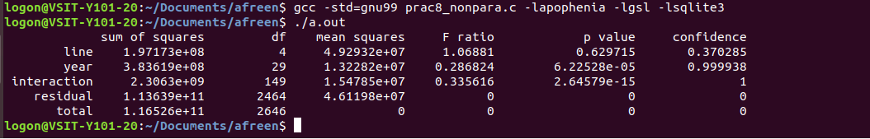

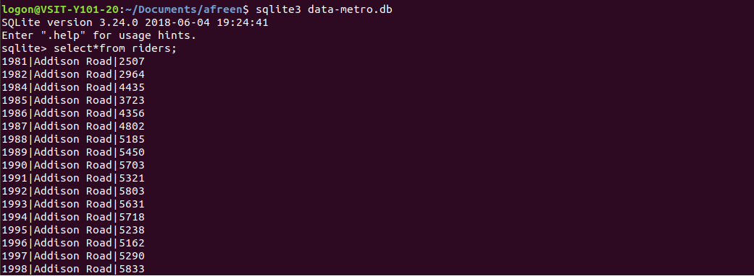

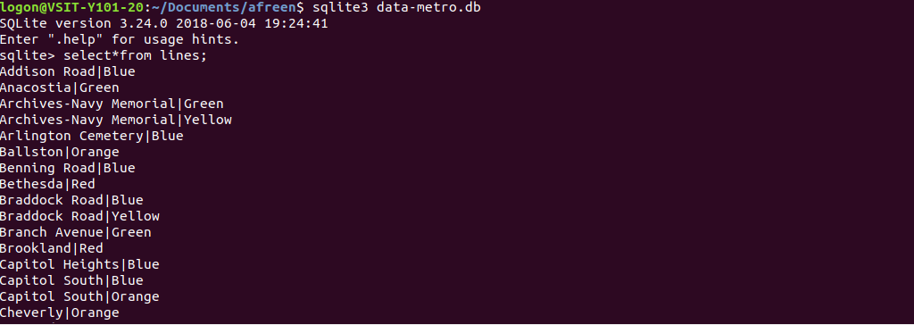





**Vidyalankar School of Information Technology**

**Wadala (East), Mumbai – 400037**

**CERTIFICATE**

This is to certify that, **Ms./Mr_____________________________________**

Seat Number ______________studying in Master of Science in Information Technology Part-I (Semester-I) has satisfactorily completed the **Practical** in

the subject of “**DATA MINING ”** as prescribed by University of Mumbai, during the academic year 2018-2019.

**Subject Faculty Coordinator, M.Sc. (IT)**

**External Examiner**

**INDEX**

|  |  |  |  |  |
| --- | --- | --- | --- | --- |
| **Sr. No.** | **Title** | **Date** | **Page No.** | **Signature** |
| **1.** | Decision Tree |  |  |  |
| **2.** | Naïve Bayesian Algorithm |  |  |  |
| 3. | Clustering Algorithm |  |  |  |
| 4. | Time Series Model |  |  |  |
| 5. | Association Algorithm |  |  |  |
| 6. | Text Mining Technique |  |  |  |
| 7. | Social Network Analysis |  |  |  |
| 8. | Apriori Algorithm |  |  |  |

**Practical No:1**

**Aim**:-**Prepare the analysis services for Adventure Work cycles or (any other database). Built the data mining model structure and built the decision tree with proper decision nodes and infer atleast five different types of reports.**

**Implementation:-**

**Creating an Analysis Services Project**

-Each Microsoft SQL Server Analysis Services project defines the schema for the objects in a single Analysis Services database.

**-To create an Analysis Services project**

1. Open SQL Server Data Tools (SSDT).

2. On the File menu, point to New, and then select Project.

3. Verify that Business Intelligence Projects is selected in the Project types pane.

4. In the Templates pane, select Analysis Services Multidimensional and DataMining Project.

5. In the Name box, name the new project DECISION TREE.

6.Click .

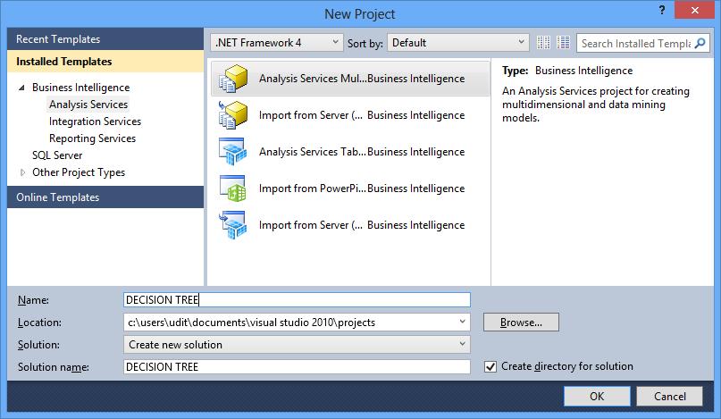

**Creating a Data Source**

-A data source is a data connection that is saved and managed in your project and deployed to your Microsoft SQL Server Analysis Services database.

**-To create a data source**

1. In Solution Explorer, right-click the Data Sources folder and select New DataSource.

2. On the Welcome to the Data Source Wizard page, click Next.

3. On the Select how to define the connection page, click New to add aconnection to thedatabase.

4. In the Provider list in Connection Manager, select Native OLE DB\SQL ServerNative Client 11.0.

5. In the Server name box, type or select the name of the server on which you installedFor example, type localhost if the database is hosted on the local server.

6. In the Log onto the server group, select Use Windows Authentication.

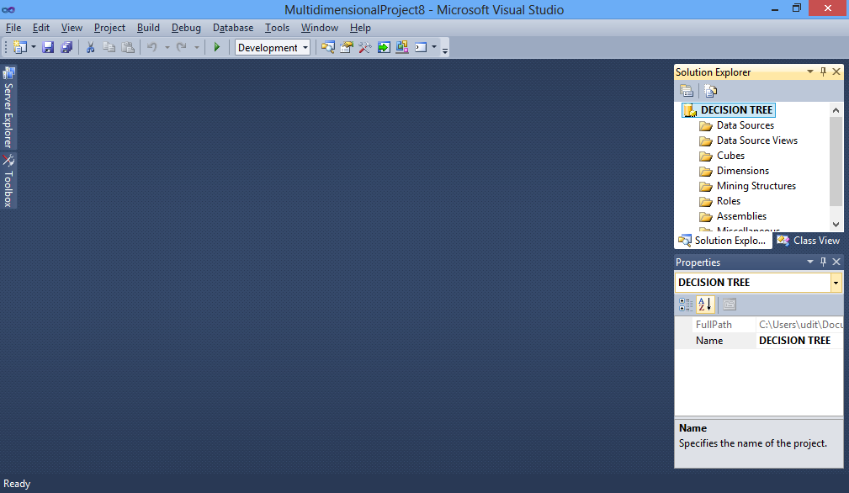

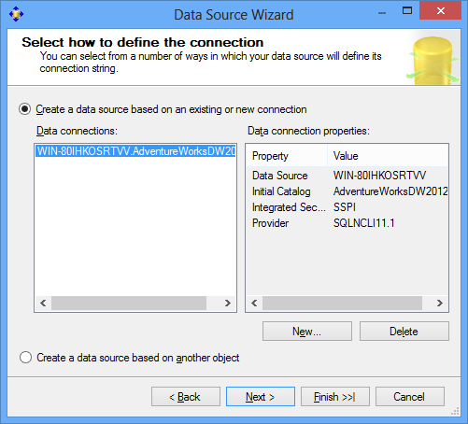

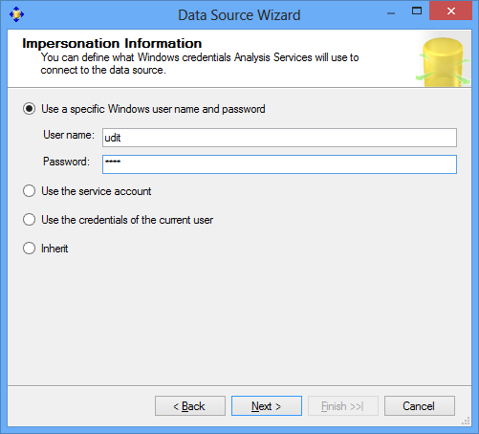

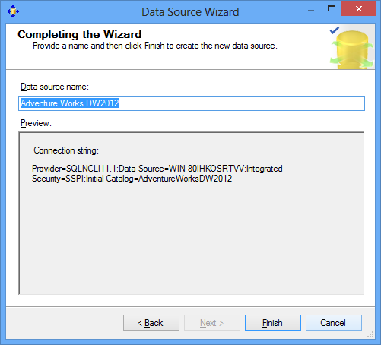

**Creating a Data Source View**

**-To create a data source view**

1. In Solution Explorer, right-click Data Source Views, and select New DataSource View.

2. On the Welcome to the Data Source View Wizard page, click Next.

3. On the Select a Data Source page, under Relational data sources, select theAdventure Works DW 2012 data source that you created in the last task. Click Next.

4. On the Select Tables and Views page, select the following objects, and thenclick the right arrow to include them in the new data source view:

• ProspectiveBuyer (dbo) - table of prospective bike buyers

• vTargetMail (dbo) - view of historical data about past bike buyers

5. Click Next.

6. On the Completing the Wizard page, by default the data source view is namedAdventure Works DW 2012. Change the name to Targeted Mailing, and then click Finish.

The new data source view opens in the Targeted Mailing.dsv [Design] tab.

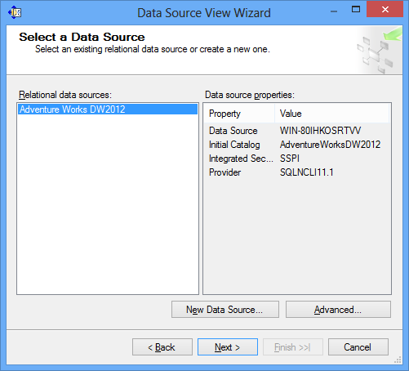

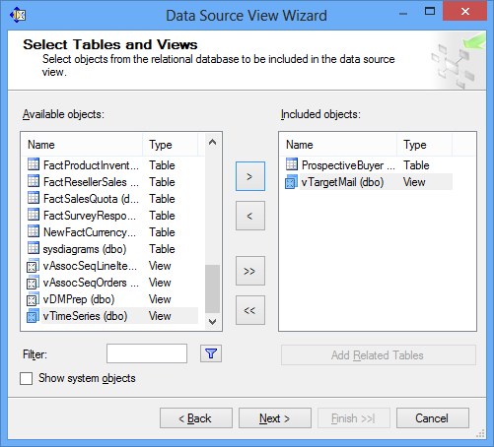

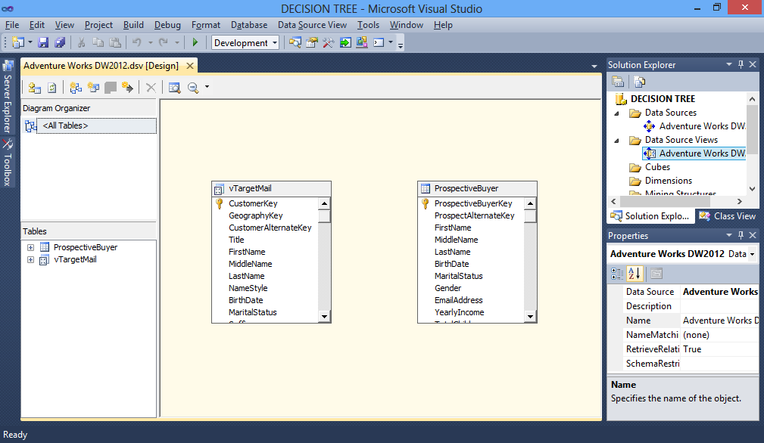

**Building a Targeted Mailing Structure**

**-To create a mining structure for the targeted mailing scenario**

1. In Solution Explorer, right-click Mining Structures and select New MiningStructure to start the Data Mining Wizard.

2. On the Welcome to the Data Mining Wizard page, click Next.

3. On the Select the Definition Method page, verify that From existing relational database or data warehouse is selected, and then click Next.

4. On the Create the Data Mining Structure page, under Which data mining technique do you want to use?, select Microsoft Decision Trees.

5. Click Next.

6. On the Select Data Source View page, in the Available data source views pane,select Targeted Mailing. You can click Browse to view the tables in the data source view and then click Close to return to the wizard.

7. Click Next.

8. On the Specify Table Types page, select the check box in the Case column for vTargetMail to use it as the case table, and then click Next. You will use the ProspectiveBuyer table later for testing; ignore it for now.

9. On the Specify the Training Data page, you will identify at least one predictable column, one key column, and one input column for your model. Select the check box in the Predictable column in the BikeBuyer row.

10. Verify that the check box in the Key column is selected in the CustomerKey row.

11. Select the check boxes in the Input column in the following rows. You can check multiple columns by highlighting a range of cells and pressing CTRL whileselecting a check box.

• Age

• CommuteDistance

• EnglishEducation

• EnglishOccupation

• Gender

• GeographyKey

• HouseOwnerFlag

• MaritalStatus

• NumberCarsOwned

• NumberChildrenAtHome

• Region

• TotalChildren

• YearlyIncome

12. On the far left column of the page, select the check boxes in the following rows.

• AddressLine1

• AddressLine2

• DateFirstPurchase

• EmailAddress

• FirstName

• LastName

Ensure that these rows have checks only in the left column.

13. Click Next.

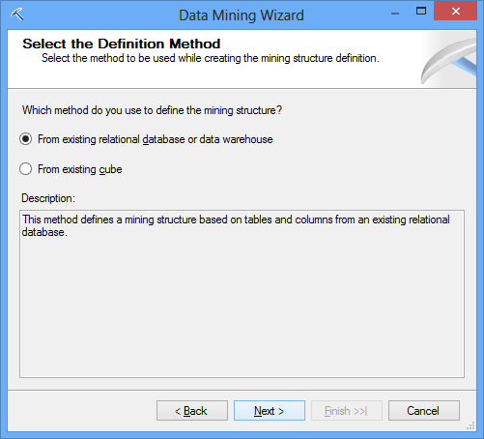

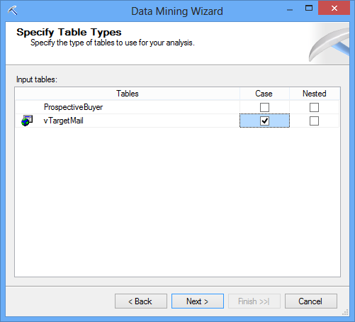

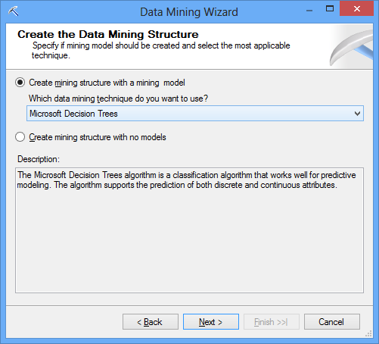

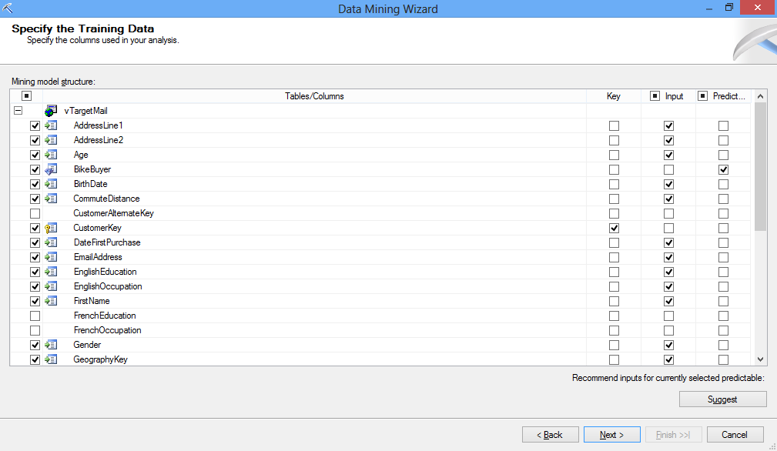

**Specifying the Data Type and Content Type**

1. On the Specify Columns' Content and Data Type page, click Detect to run an algorithm that determines the default data and content types for each column.

2. Review the entries in the Content Type and Data Type columns and change them if necessary

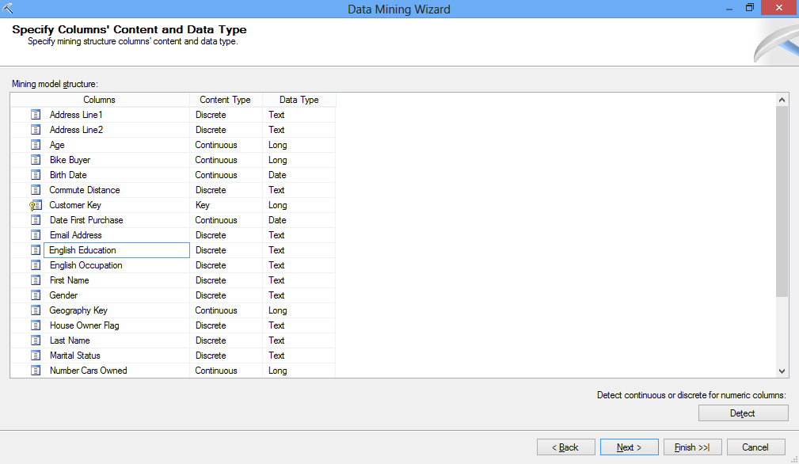

**Specifying a Testing Data Set for the Structure**

**-To specify the testing set**

1. On the Create Testing Set page, for Percentage of data for testing, leave the default value of 30.

2. For Maximum number of cases in testing data set, type 1000.

3. Click Next.

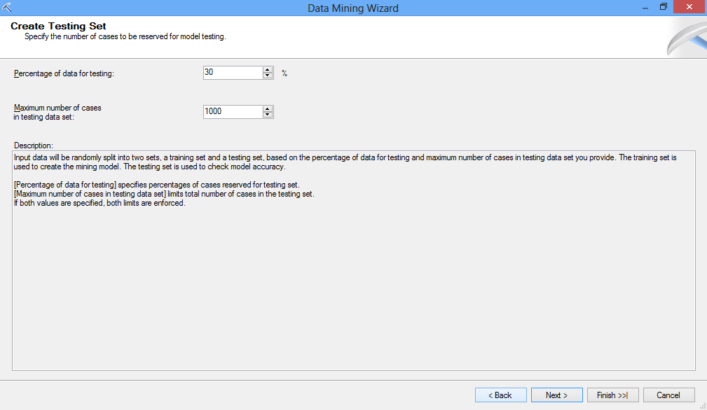

**-To name the model and structure and specify drillthrough**

1. On the Completing the Wizard page, in Mining structure name, type Targeted Mailing.

2. In Mining model name, type TM_Decision_Tree.

3. Select the Allow drill through check box.

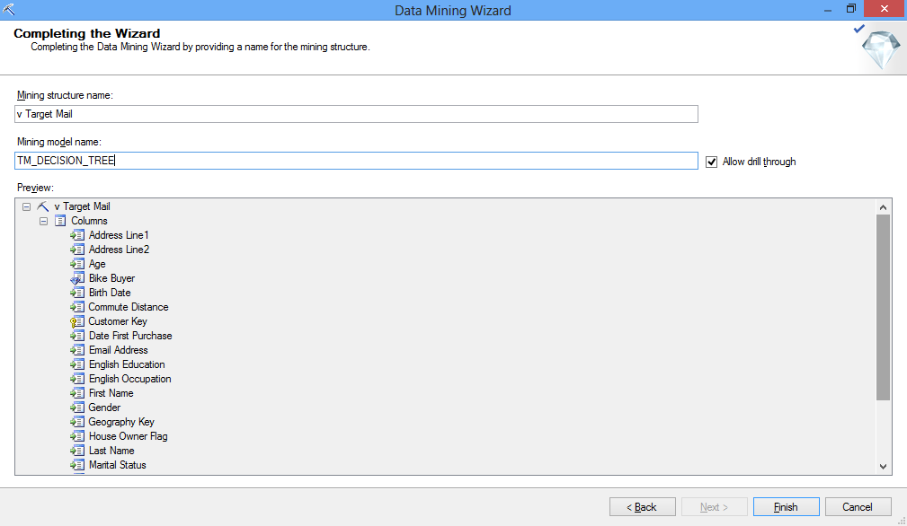

**Deploying and Processing the Models**

**-To deploy the project and process all the mining models**

1. In the Mining Model menu, select Process Mining Structure and All Models.

If you made changes to the structure, you will be prompted to build and deploy the project before processing the models. Click Yes.

2. Click Run in the Processing Mining Structure - Targeted Mailing dialog box. The Process Progress dialog box opens to display the details of model

processing. Model processing might take some time, depending on your computer.

3. Click Close in the Process Progress dialog box after the models have completed processing.

4. Click Close in the Processing Mining Structure - <structure> dialog box.

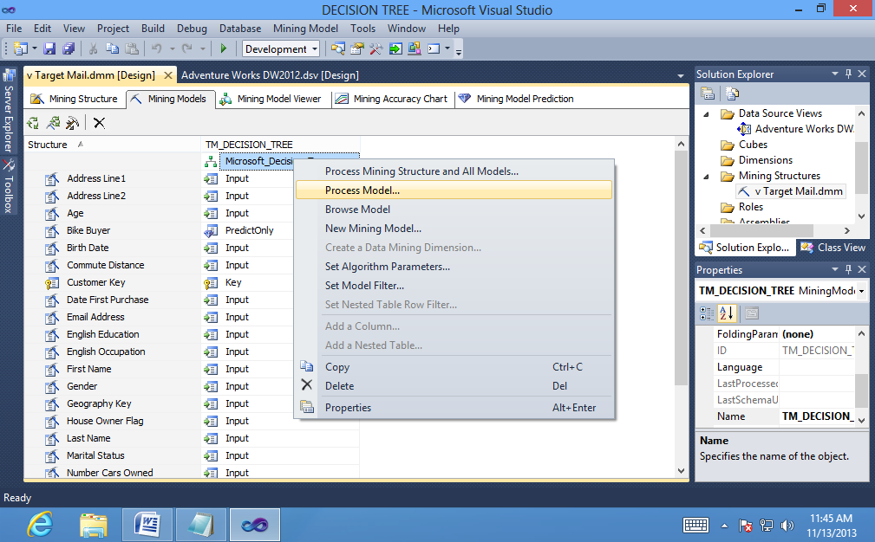

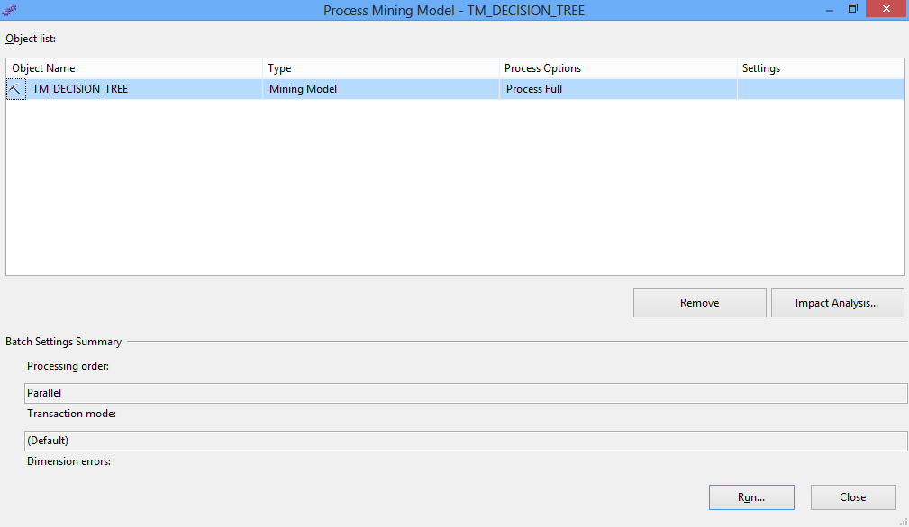

**Exploring the Decision Tree Model**

**-To explore the model in the Decision Tree tab**

1. Select the Mining Model Viewer tab in Data Mining Designer.

By default, the designer opens to the first model that was added to the structure

-- in this case, TM_Decision_Tree.

2. Use the magnifying glass buttons to adjust the size of the tree display. By default, the Microsoft Tree Viewer shows only the first three levels of the tree. If the tree contains fewer than three levels, the viewer shows only the existing levels. You can view more levels by using the Show Level slider or the Default Expansion list.

3. Slide Show Level to the fourth bar.

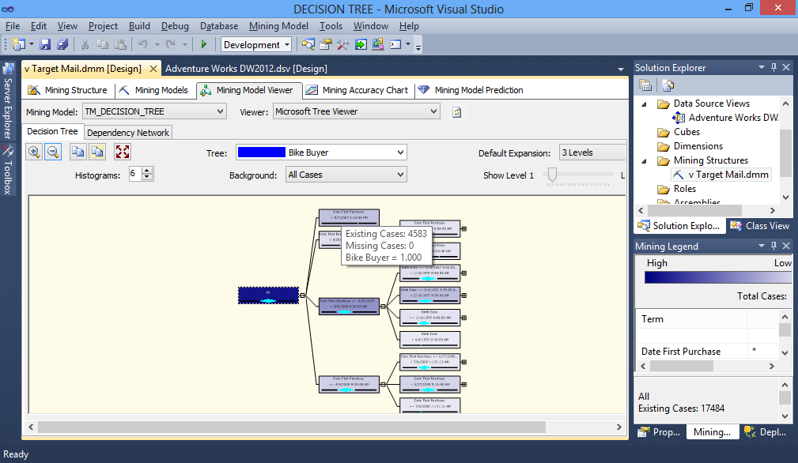

**-Dependency Network Tab**

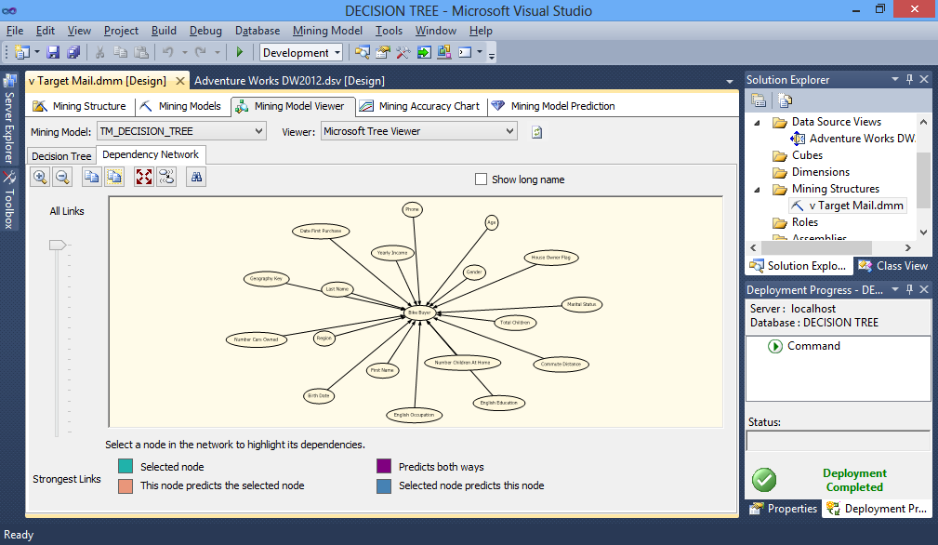

**-To drill through to case data**

1. Right-click a node, and select Drill Through then Model Columns Only. The details for each training case are displayed in spreadsheet format. These details come from the vTargetMail view that you selected as the case table when building the mining structure.

2. Right-click a node, and select Drill Through then Model and Structure Columns. The same spreadsheet displays with the structure columns appended to the end.

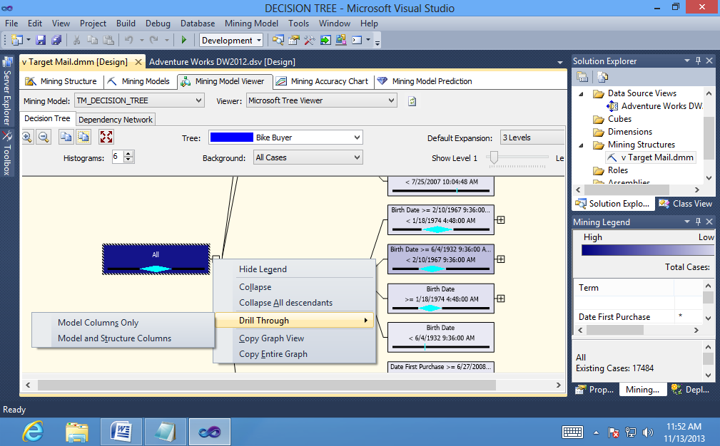

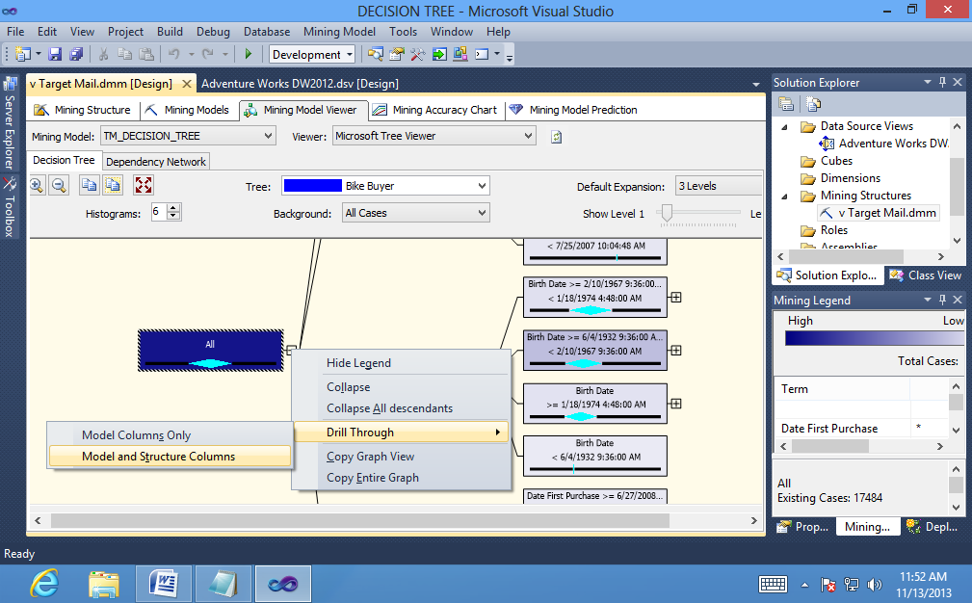

**Conclusion:** Using analysis services, we have thus implemented the decision tree algorithm successfully.

**Practical No: 2**

**Aim: Prepare the analysis services for the Adventure Works cycles or (any other database). Build the data mining model structure and implement the Naïve Bayesian algorithm.**

**Steps to create a Naive Bayes mining model:**

1. In the **Mining Models** tab of Data Mining Designer, right-click the **Structure**column, and select **New Mining Model**.

2. In the **New Mining Model** dialog box, under **Model name**, type

**TM_NaiveBayes**.

3. In **Algorithm name**, select **Microsoft Naive Bayes**, then click **OK**.

A message appears stating that the Microsoft Naive Bayes algorithm does notsupport the **Age** and **Yearly Income** columns, which are continuous.

4. Click **Yes** to acknowledge the message and continue.

A new model appears in the **Mining Models** tab of Data Mining Designer.

First , we need to select a data source ,thus right click on **Data Source** and select **New Data Source**

It will open a **Data Source Wizard** ,click on **Next**

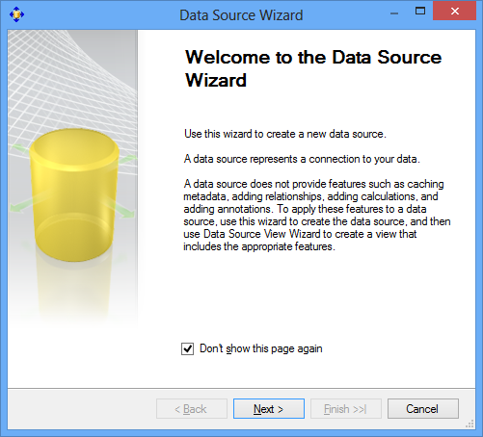

In the next window click on Next button and in the next window select first radio button and then type user name and password and click on **Next**



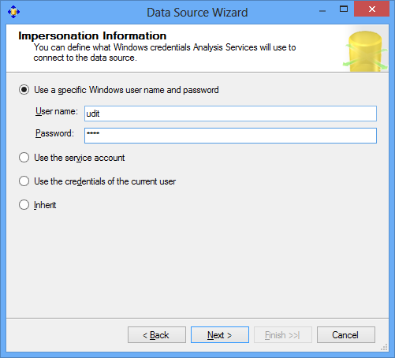

In the last window click on **Finish** button to end data source selection activity

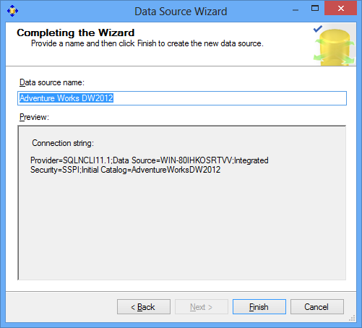

Now in solution explorer right click on the **Data Source Views**, select **New Data Source View**

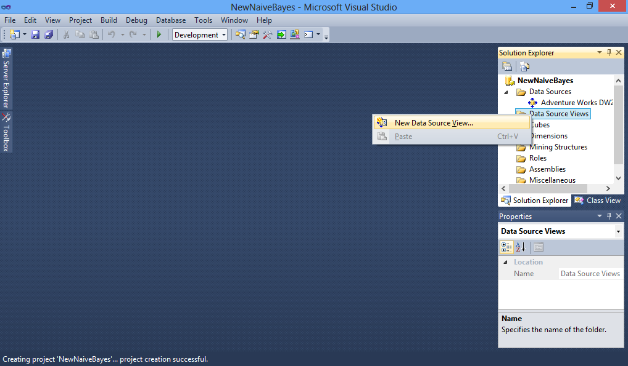

In the **Data Source View Wizard.**Verify that the proper relational data source is selected and proceed ahead by clicking on the **Next** button.

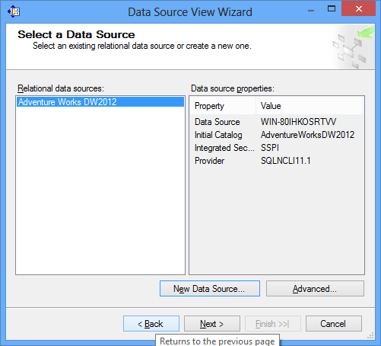

Select appropriate **Tables and Views** from the relational database that are to be included in the data source view. Click on **Next .**

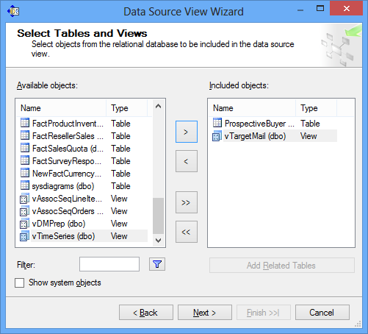

In the **Completing the Wizard window**, verify the data source name and click on **Finish**

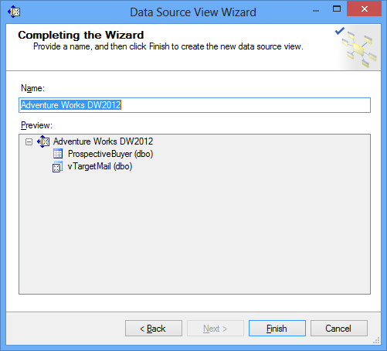

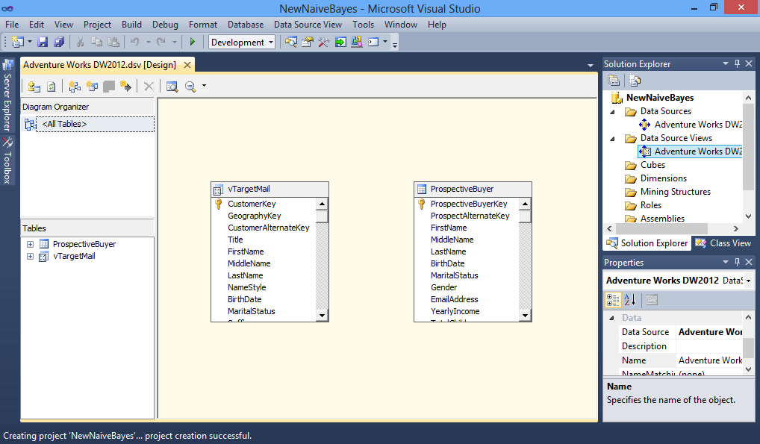

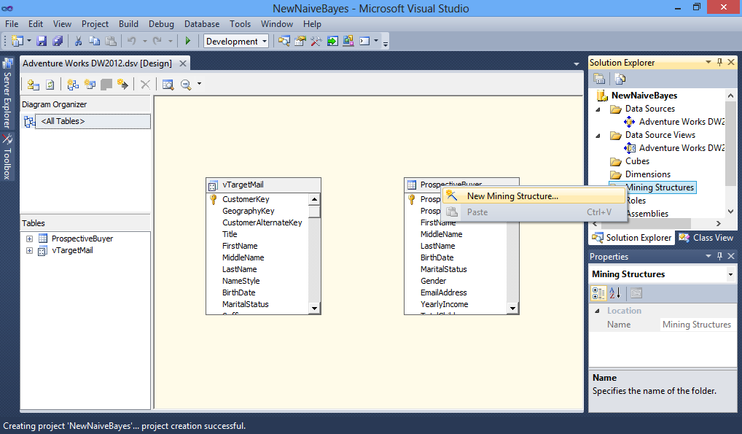

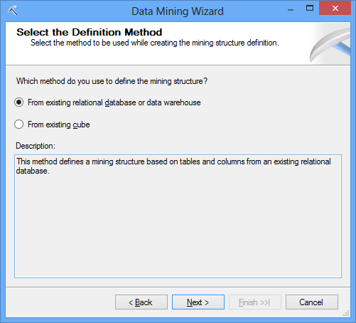

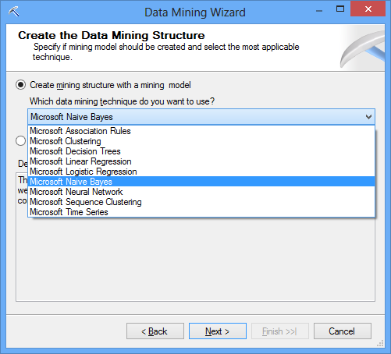



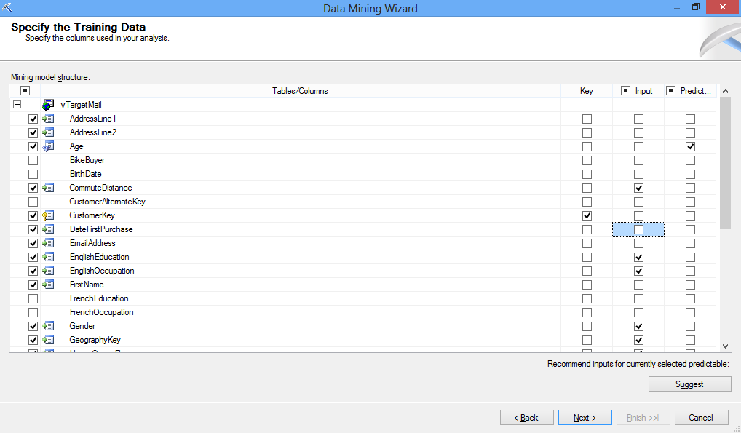

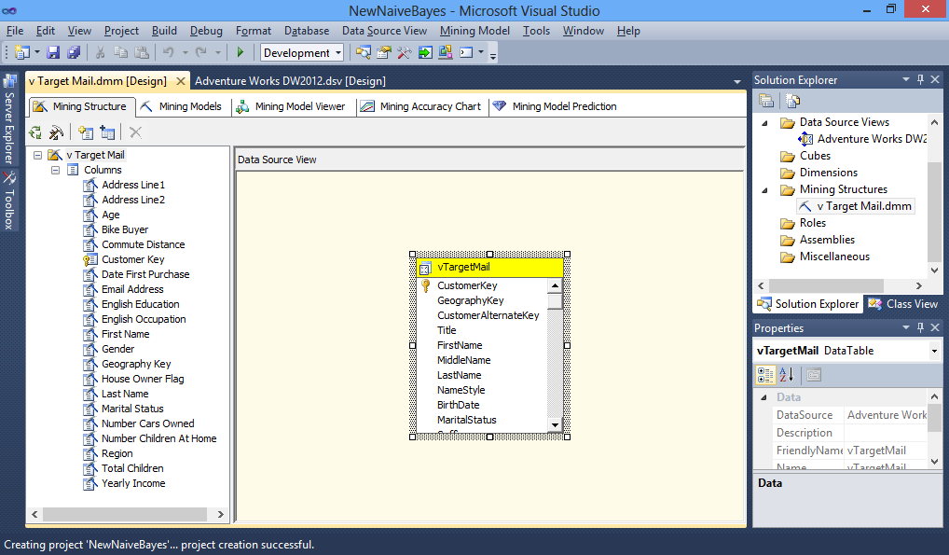

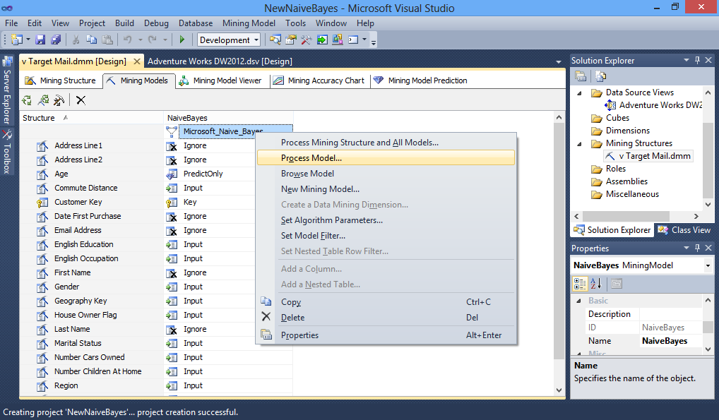

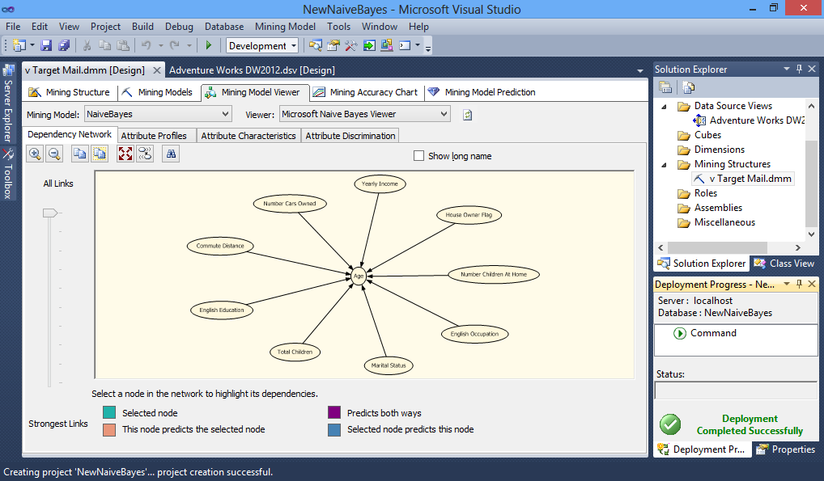

**Conclusion:** Using analysis services, we have thus implemented the naïve bayesian algorithm successfully.

**Practical No: 3**

**Aim: Prepare the analysis services for the Adventure Works cycles or (any other database). Build the data mining model structure and implement the clustering algorithm.**

* **To create a data source:**
* In **Solution Explorer**, right-click the **Data Sources** folder and select **New Data Source.**
* On the **Welcome to the Data Source Wizard page**, click **Next.**
* On the **Select how to define the connection page**, click **New** to add a

connection to the database.

* In the **Provider** list in **Connection Manager**, select **Native OLE DB\SQL Server Native Client 11.0.**
* In the **Server name** box, type or select the name of the server on which you

installed.

* In the **Log onto the server** group, select **Use Windows Authentication**.
* In the **Select or enter a database name list**, select and then click **OK**.
* Click **Next**.
* On the **Impersonation Information** page, click **Use the service account**, and then click **Next**.
* On the **Completing the Wizard** page, notice that, by default, the data source is named Adventure Works DW 2012.
* Click **Finish**.

The new data source, Adventure Works DW 2012, appears in the **Data Sources**

folder in Solution Explorer.

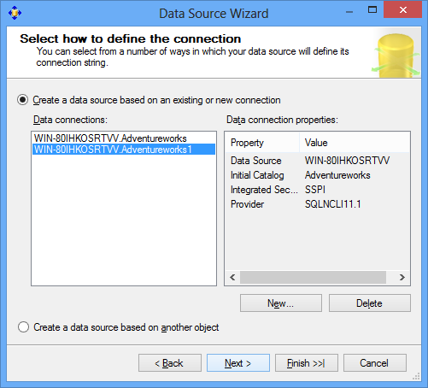

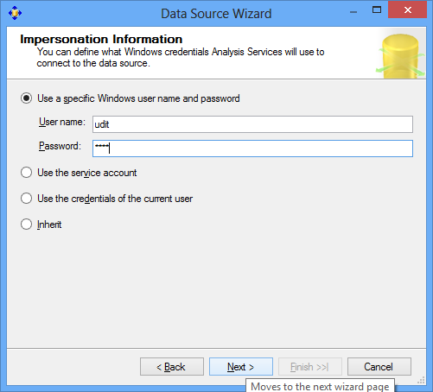

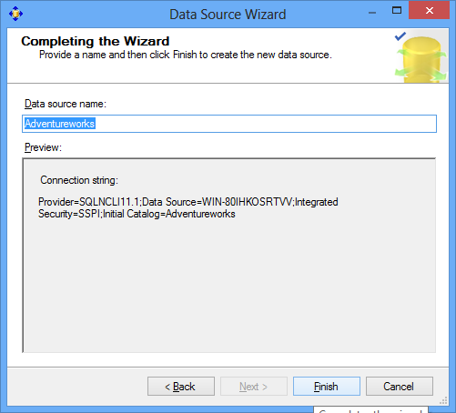

* **Creating a Data Source View**
* In **Solution Explorer**, right-click **Data Source Views**, and select **New Data**

**Source View.**

* On the **Welcome to the Data Source View Wizard** page, click **Next**.
* On the **Select a Data Source** page, under **Relational data sources**, select the Adventure Works DW 2012 data source that you created in the last task. Click**Next**.
* On the **Select Tables and Views** page, select the following objects, and then

Click the right arrow to include them in the new data source view:

• **ProspectiveBuyer (dbo)** - table of prospective bike buyers

• **vTargetMail (dbo)** - view of historical data about past bike buyers

* Click **Next**.
* On the **Completing the Wizard** page, by default the data source view is namedAdventure Works DW 2012. Change the name to **Targeted Mailing**, and then click **Finish**.

The new data source view opens in the **Targeted Mailing.dsv [Design]** tab.

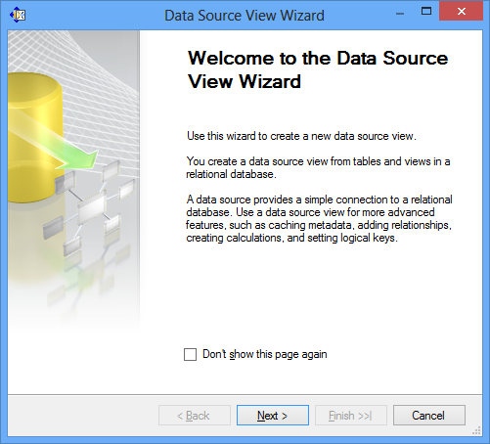

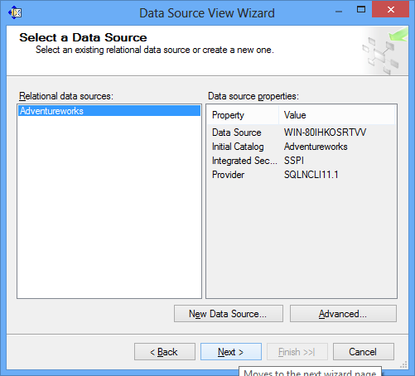

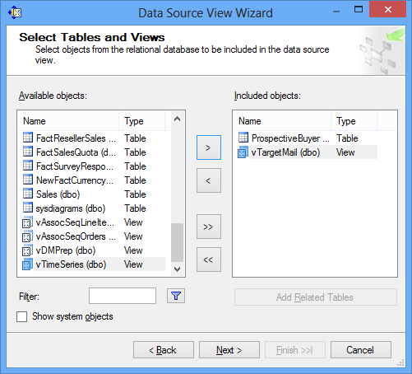

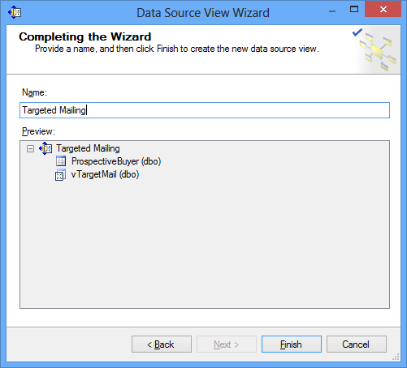

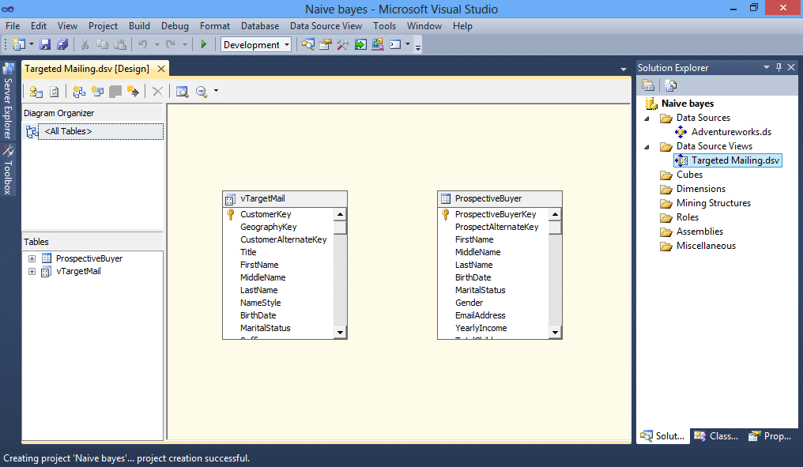

* **To create a clustering mining model:**
* Switch to the **Mining Models** tab in Data Mining Designer in SQL Server DataTools (SSDT).

Notice that the designer displays two columns, one for the mining structure andone for the **TM_Decision_Tree** mining model, which you created in the previouslesson.

* Right-click the **Structure** column and select **New Mining Model**.
* In the **New Mining Model** dialog box, in **Model name**, type **TM_Clustering**.
* In **Algorithm name**, select **Microsoft Clustering**.
* Click .

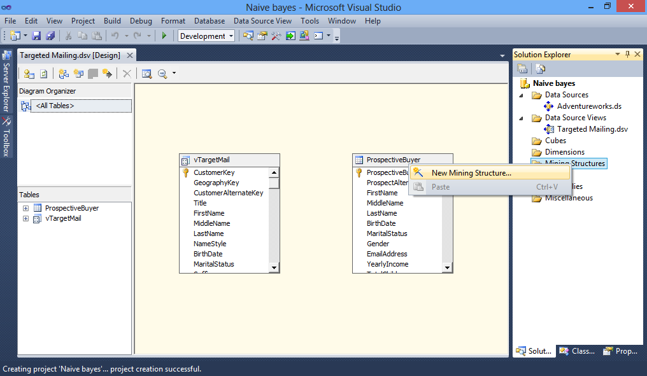

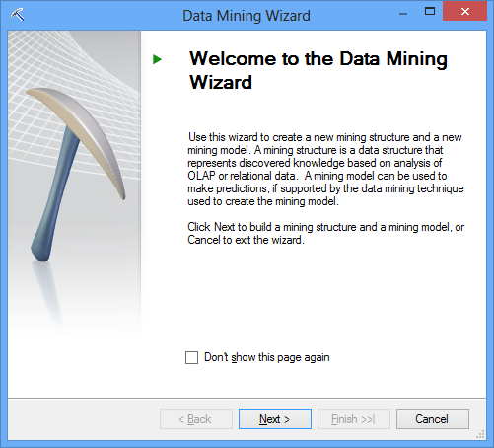

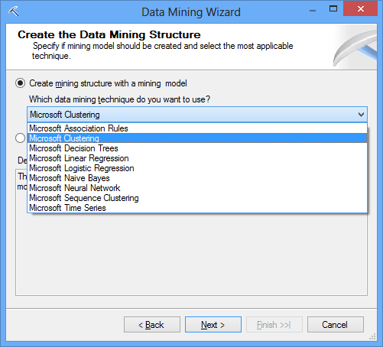

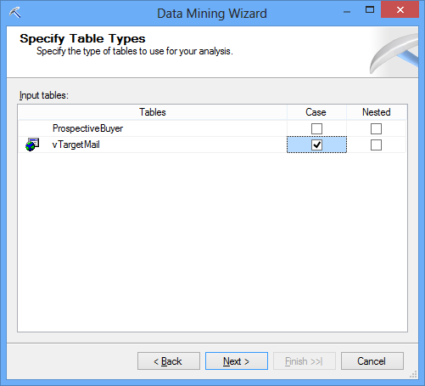

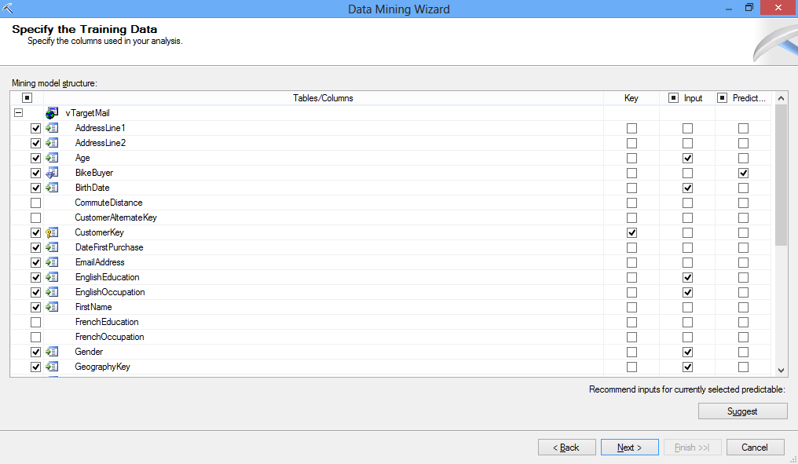

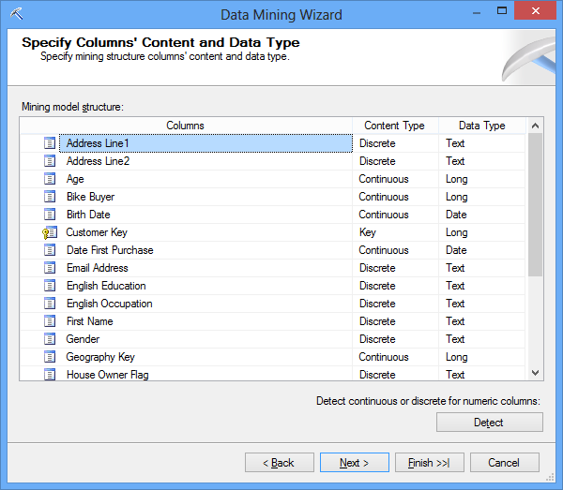

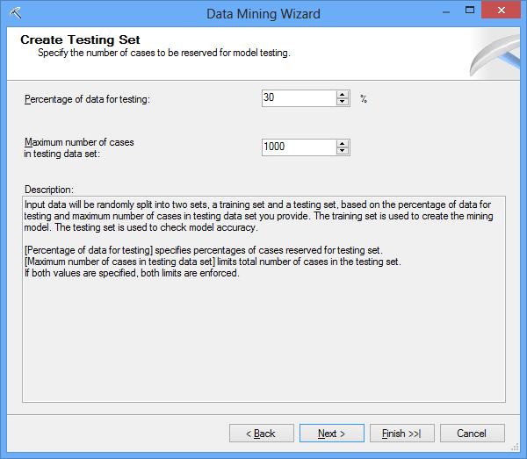

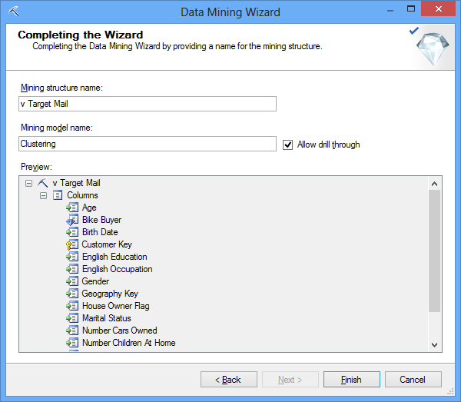

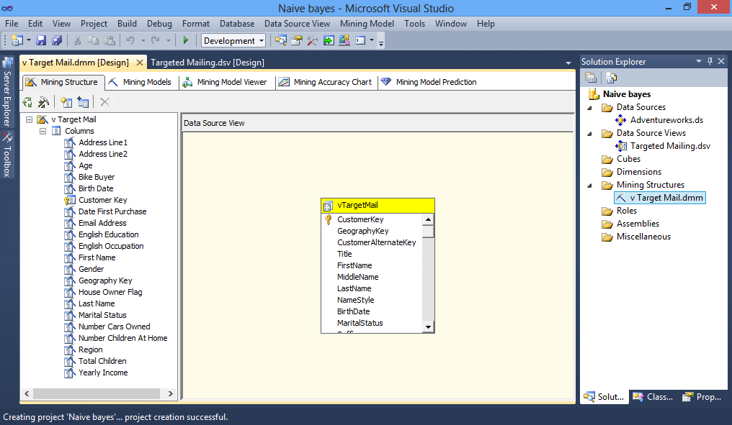

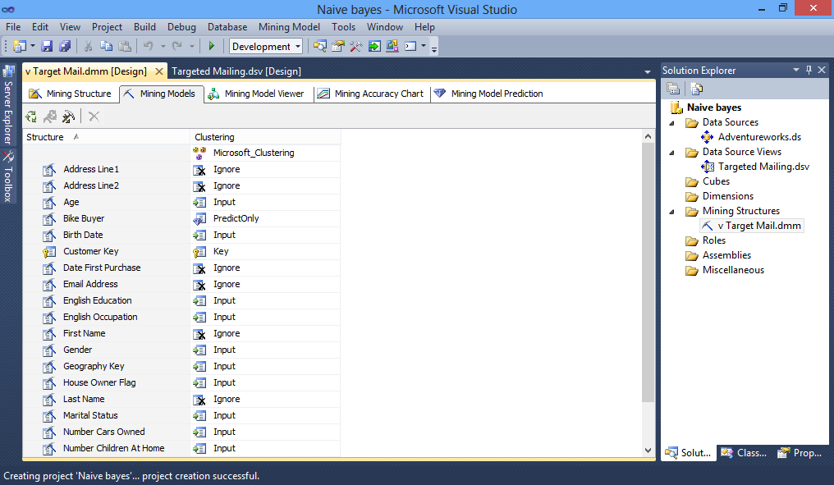

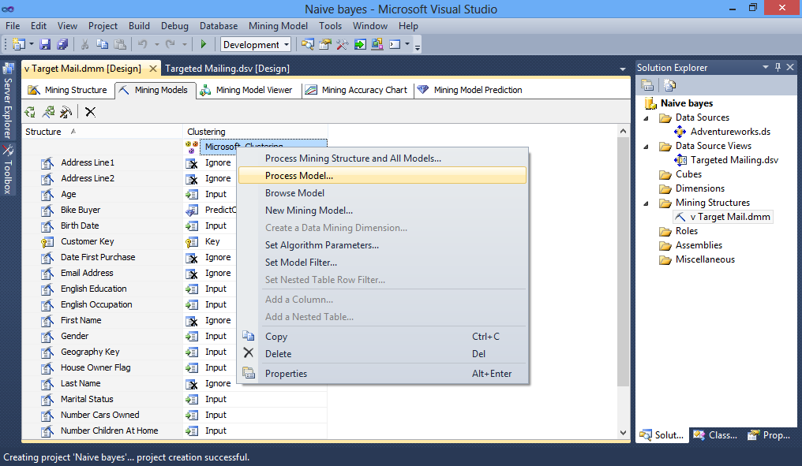

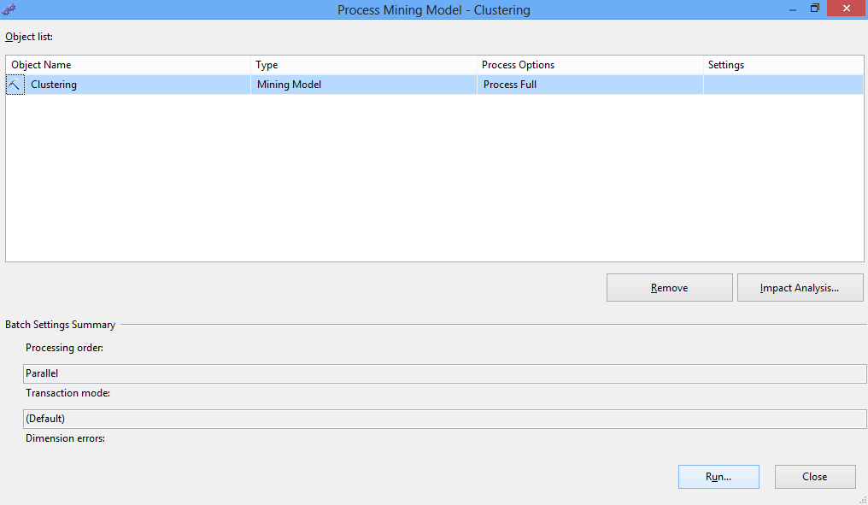

**Conclusion:** Using analysis services, we have thus implemented the clustering algorithm successfully.

**Practical No: 4**

**Aim:Prepare the analysis services for Adventure Work cycles or (any other database). Built the basic time series model structure and create the predictions.**

1. **Adding a Data Source View for Forecasting (Intermediate Data Mining Tutorial)**

To add a data source view:

1. In Solution Explorer, right-click **Data Source Views**, and then **select New Data Source View.**

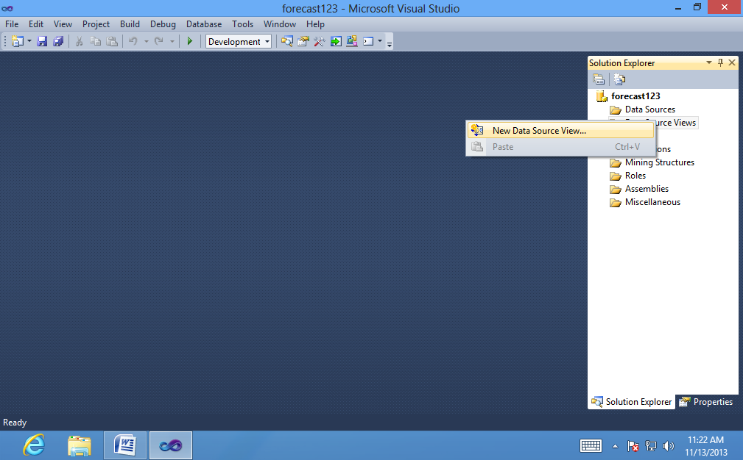

1. On the **Welcome to the Data Source View Wizard** page, click **Next**.

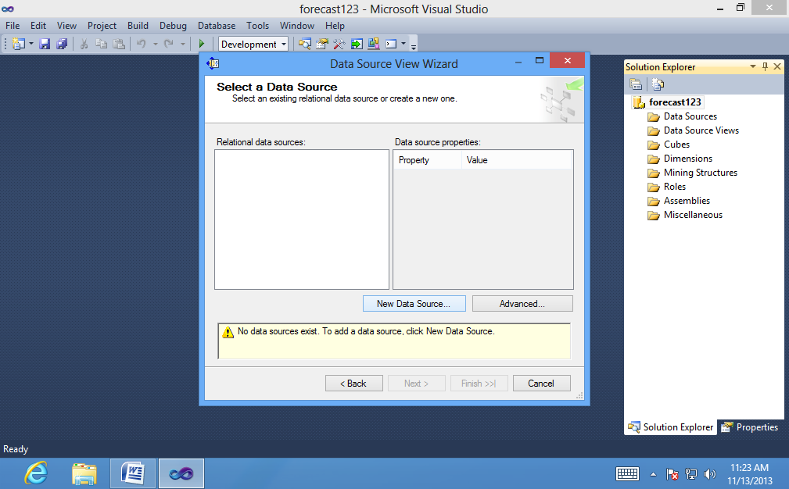

1. On the **Select a Data Source** page, under **Relational data sources**, select the data source. Click **Next**.

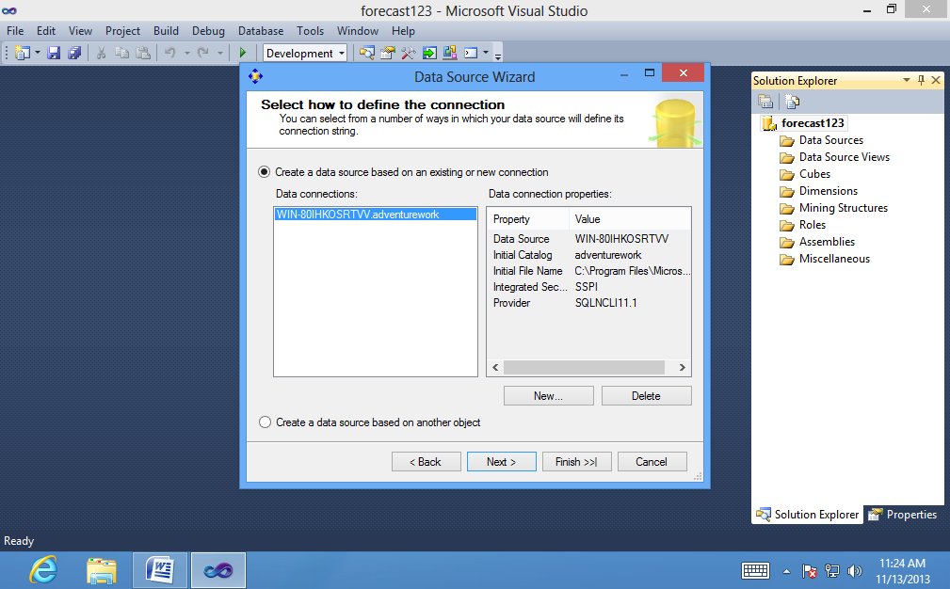

1. On the **Select Tables and Views** page, select the table, vTimeSeries (dbo), and then click the right arrow to add it to the data source view.

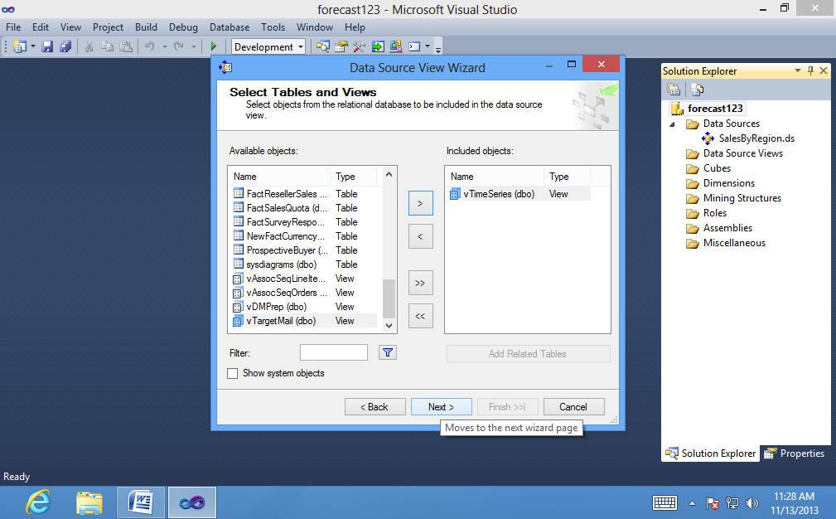

5. Click **Next.**

6. On the **Completing the Wizard** page, by default the data source view is named Adventure Works DW Multidimensional 2012 . Change the name to

**SalesByRegion**, and then click **Finish**.

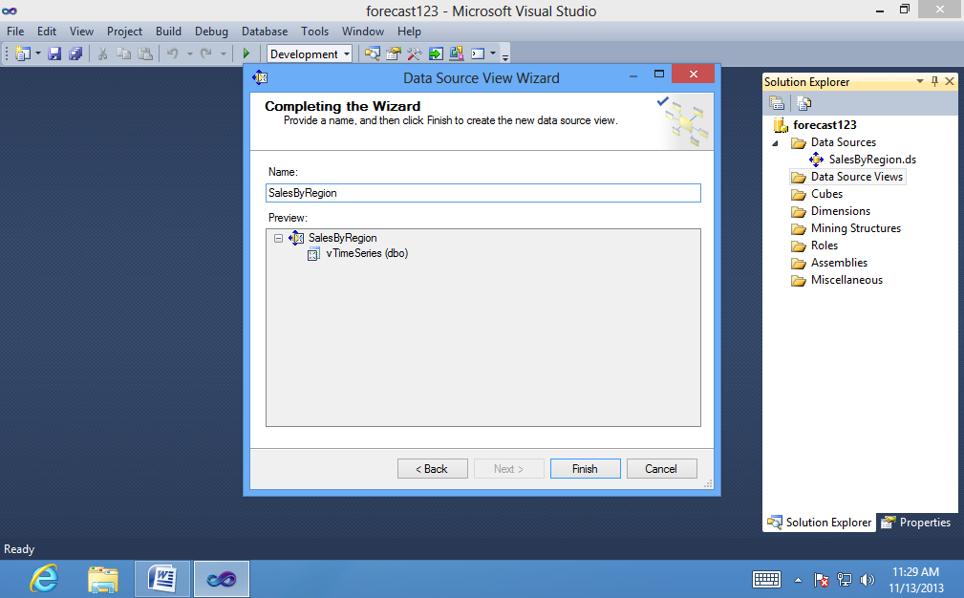

Data Source View Designer opens and the **SalesByRegion** data source view

appears.

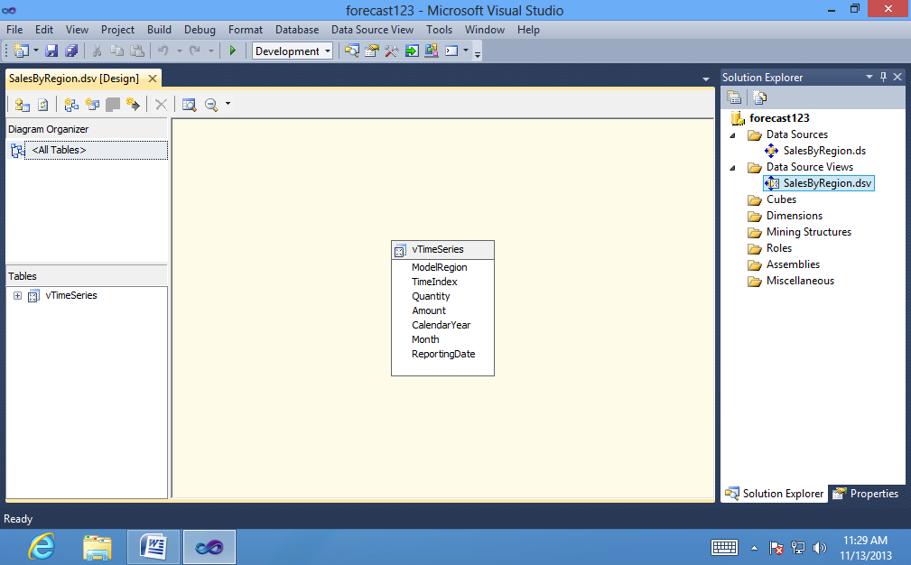

To set the key in the data source view:

1. In the pane **SalesByRegion.dsv**, select the vTimeSeries table.

2. Right-click the column, Reporting Date, and select **Set Logical Primary Key.**

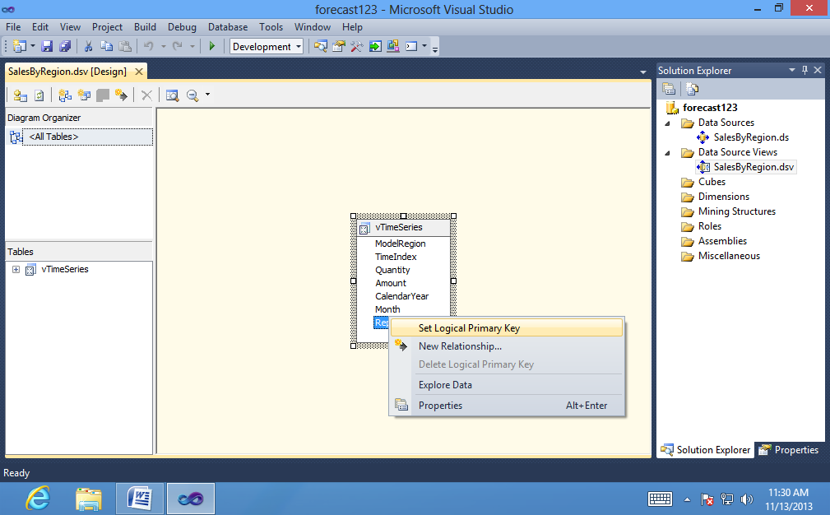

1. **Creating a Forecasting Mining Model Structure (Data Mining Tutorial)**

To create a forecasting mining structure:

1. In Solution Explorer in SQL Server Data Tools (SSDT), right-click **Mining Structures** and select **New Mining Structure**.

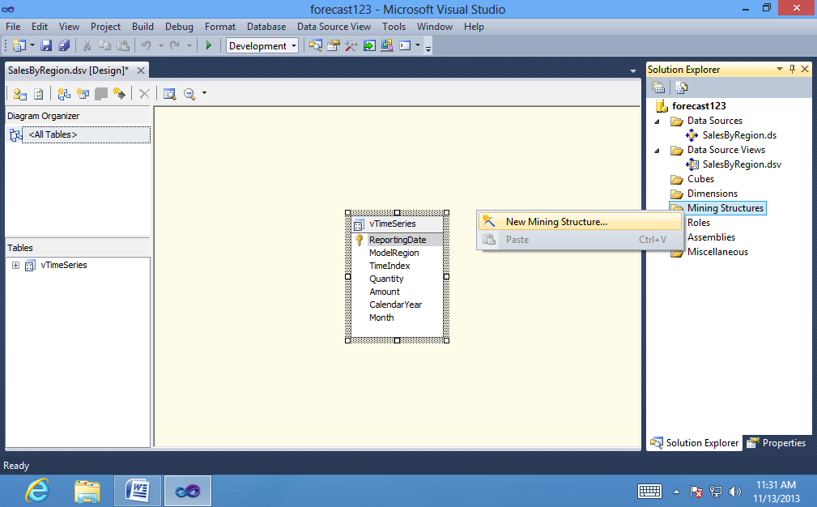

1. On the **Welcome to the Data Mining Wizard** page, click Next.
2. On the Select **the Definition Method** page, verify that **From existing relational database or data warehouse** is selected, and then click **Next**.

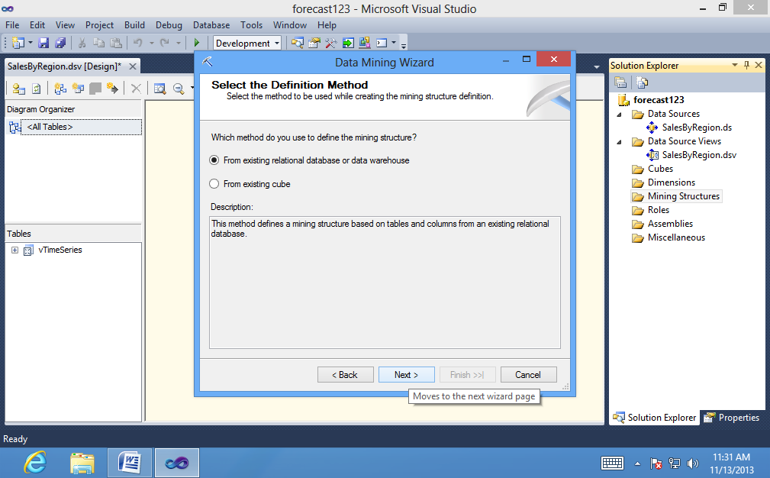

1. On the **Create the Data Mining Structure** page, under **Which data miningtechnique do you want to use?**, select **Microsoft Time Series**, and then click **Next.**

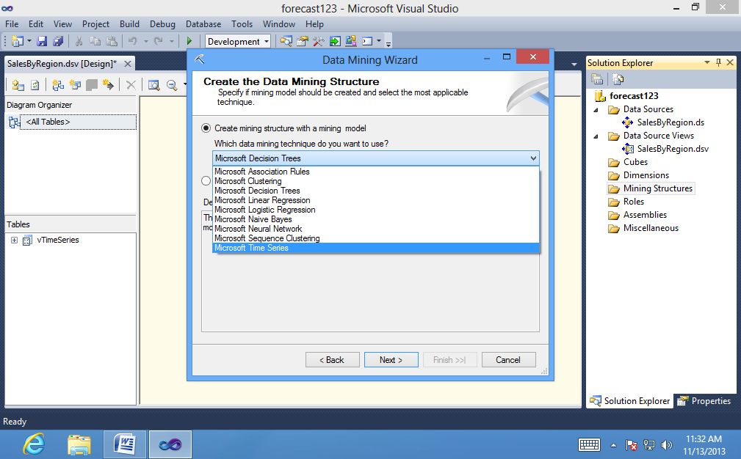

1. On the **Select Data Source View** page, **under Available data source views**,select**SalesByRegion**.

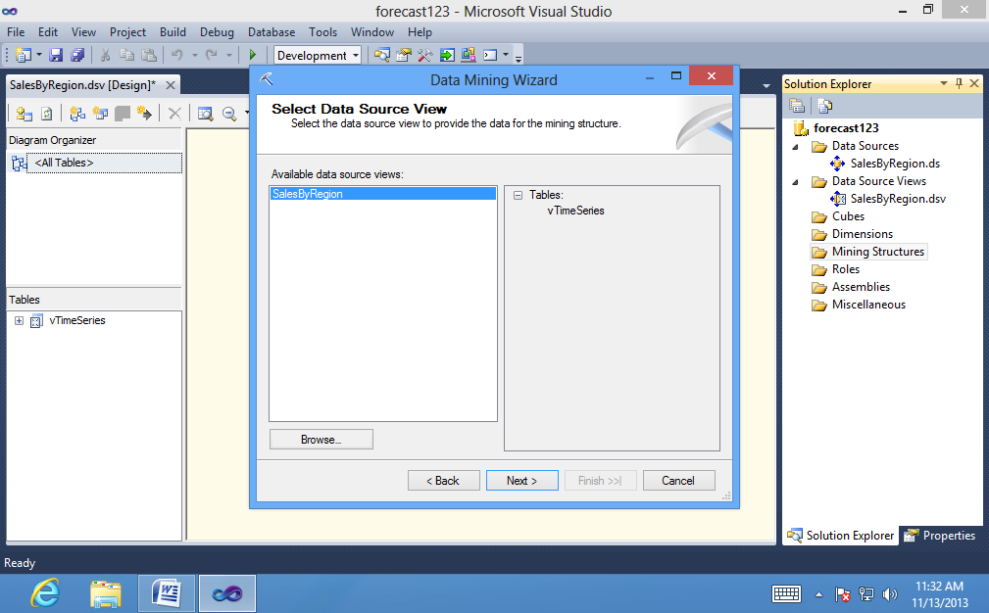

1. Click **Next**.
2. On the **Specify Table Types** page, ensure that the check box in the **Case** column for the vTimeSeries table is selected, and then click **Next**.

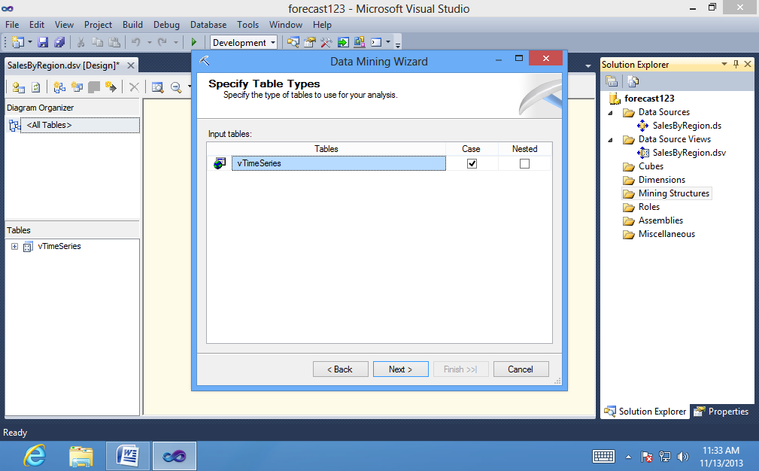

1. On the **Specify the Training Data** page, select the check boxes in the **Key** column for the **ModelRegion** and **ReportingDate** columns.

ReportingDate should be selected by default, because you specified this column as the logical primary key when you created the data source view. By adding **ModelRegion** as a **second key**, you are telling the algorithm to create a separate time series for each combination of model and region listed in this field.

1. Select the check boxes in the **Input** and **Predictable** columns for the Quantity, column, and then click **Next**.

By selecting **Predictable**, you indicate that you want to create forecasts on the data in this column. However, because you want to base the forecasts on past data, you must also add the column as an input.

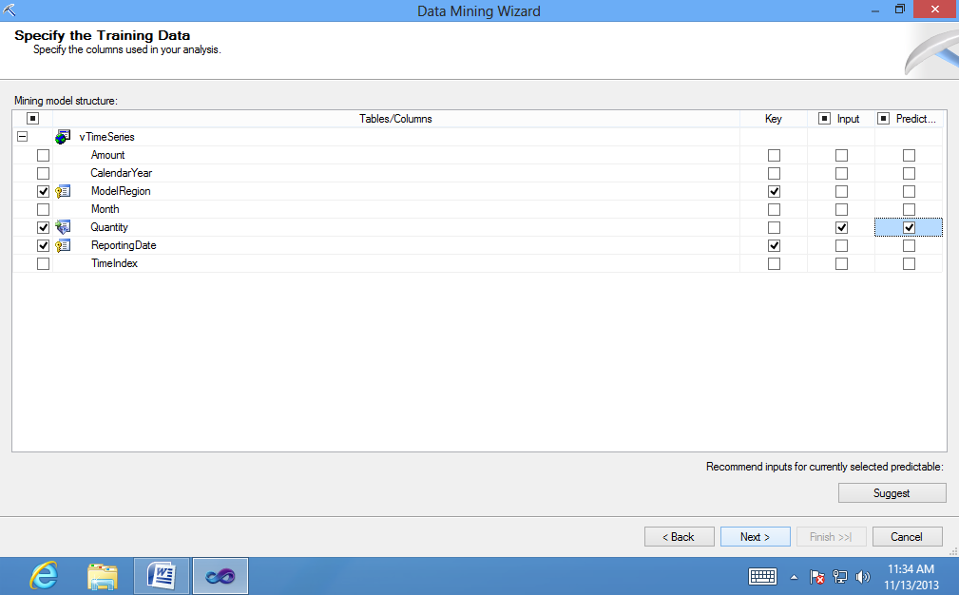

10. On the page **Specify Columns' Content and Data Type,** review the selections.

The ModelRegion column is designated as a **Key** column and the ReportingDate column is automatically designated as a **Key Time** column. You can have only one of each type of key.

1. Click **Next**.

12. On the **Completing the Wizard** page, for **Mining structure name**, type

**Forecasting**.

13. In **Mining model name**, type **Forecasting**, and then click **Finish**.

Data Mining Designer opens to display the Forecasting mining structure that

you just created.

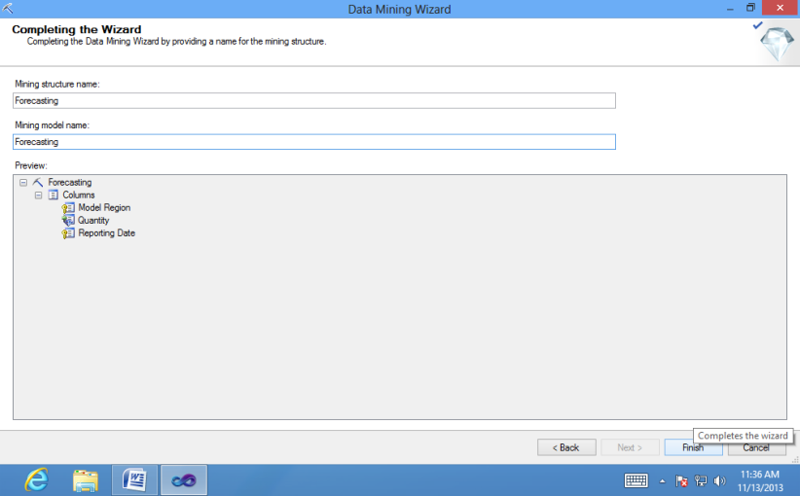

1. **Modifying the Forecasting Structure (Data Mining Tutorial)**

To add the Amount column to the Forecasting mining structure:

1. On the **Mining Structure** tab of Data Mining Designer, in the **Data Source View** pane, select the Amount column in the vTimeSeries table.

2. Drag the Amount column from the **Data Source View** pane into the list of

columns for the **Forecasting** structure.

The Amount column is now included in the **Forecasting** mining structure.

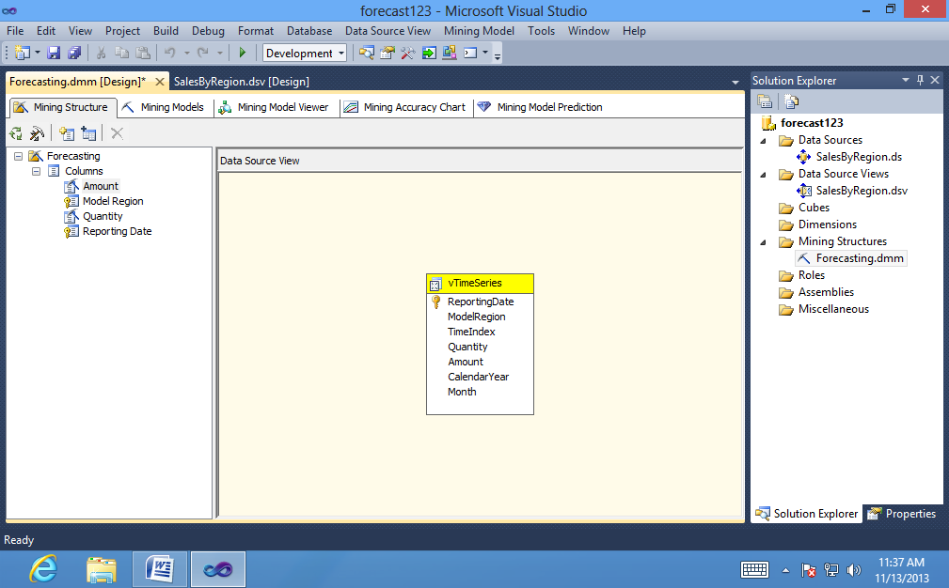

To define how the Amount column will be used:

1. In the **Forecasting** column of the grid on the Mining Models tab, click the cell in the Amount row.

2. Select **Predict** from the list.

The Amount column is now both an input column and a predictable column.

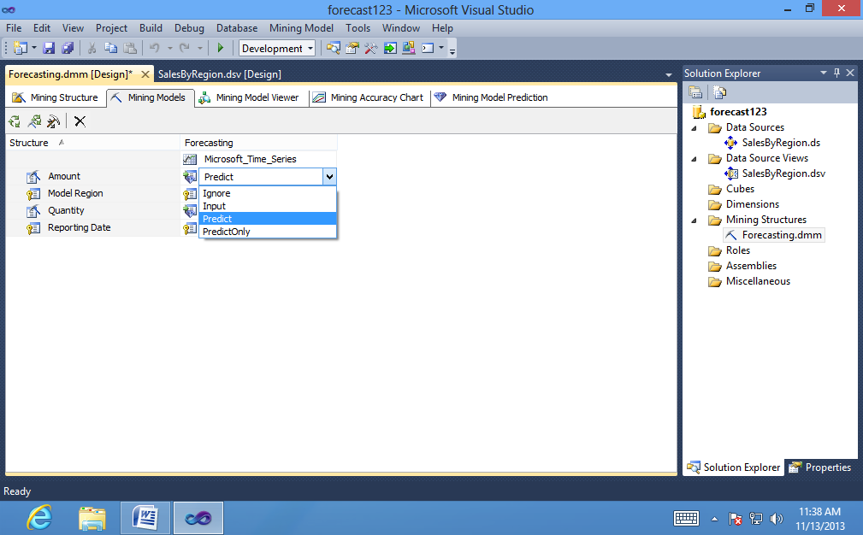

1. **Customizing and Processing the Forecasting Model (Intermediate Data Mining Tutorial)**

To change the algorithm parameters:

1. On the **Mining Models** tab, right-click **Forecasting**, and select **Set Algorithm Parameters**.

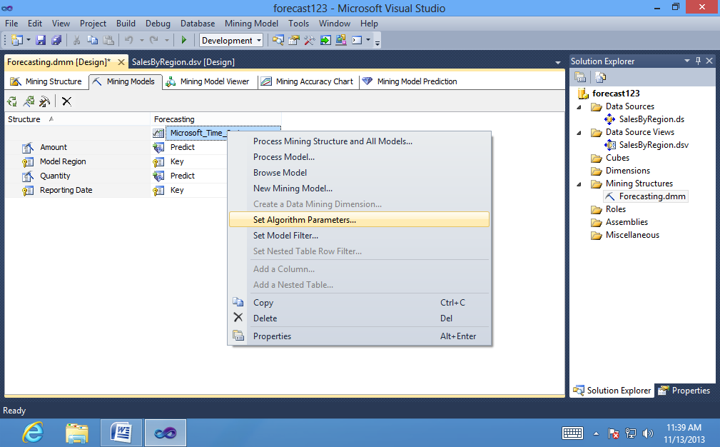

2. In the **PERIODICITY_HINT** row of the **Algorithm Parameters** dialog box, click the **Value** column, then type **{12},** including the braces.

By default, the algorithm will also add the value {1}.

3. In the **FORECAST_METHOD** row, verify that the **Value** text box is either blank or set to **MIXED**. If a different value has been entered, type MIXED to change the parameter back to the default value.

4. In the **PREDICTION_SMOOTHING** row, verify that the **Value** text box is either blank or set to **0.5**. If a different value has been entered, click Value and type 0.5 to change the parameter back to the default value.

To specify that gaps be filled by averaging values:

1. On the **Mining Models** tab, right-click the **Forecasting** column, and select **Set Algorithm Parameters**.

2. In the **Algorithm Parameters** dialog box, in the **MISSING_VALUE_SUBSTITUTION** row, click the **Value** column, and type **Mean**.

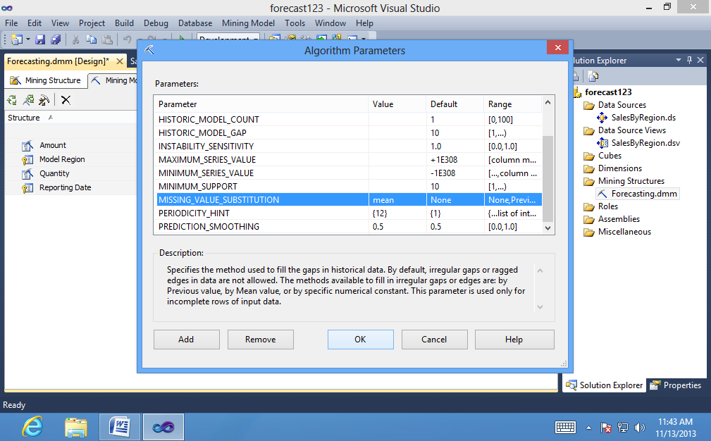

To process the forecasting model:

1. On the **Mining Model** menu of SQL Server Data Tools, select **Process Mining Structure and All Models**.

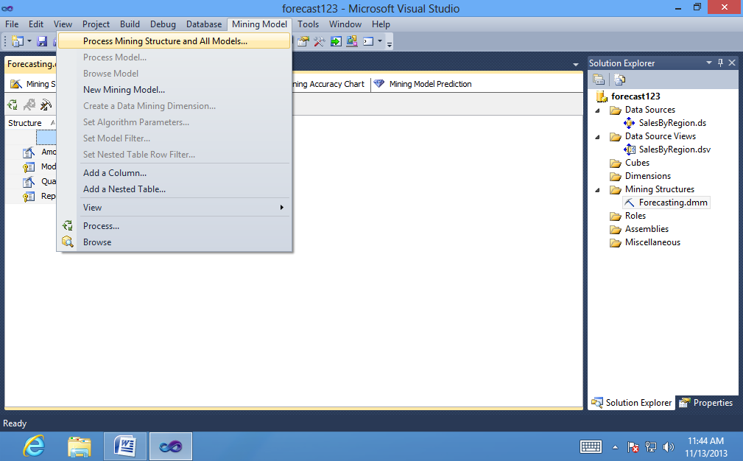

2. At the warning asking whether you want to build and deploy the project, click **Yes**.

3. In the **Process Mining Structure - Forecasting** dialog box, click **Run**.

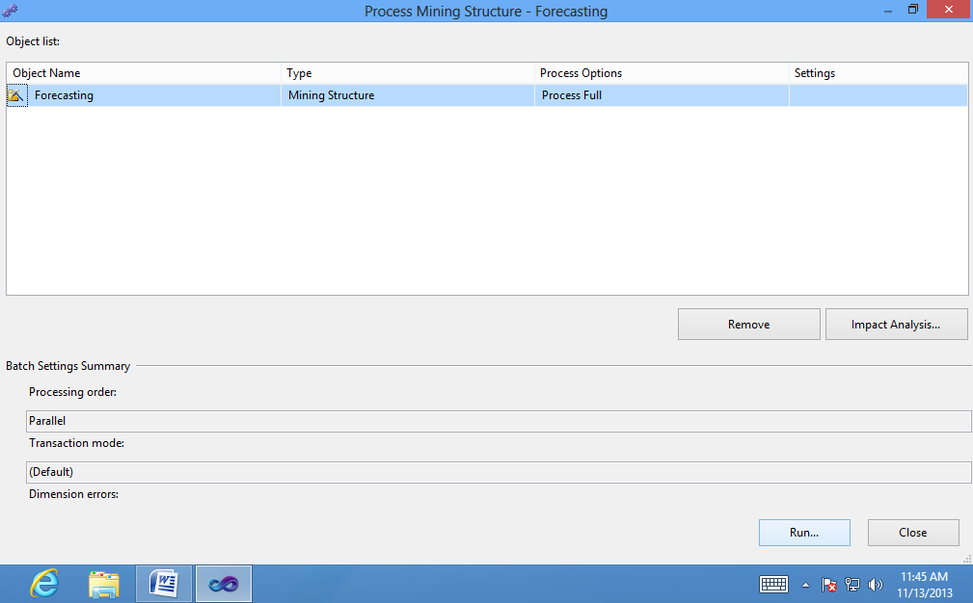

The Process Progress dialog box opens to display information about model

processing. Model processing may take some time.

4. After processing is complete, click **Close** to exit the **Process Progress** dialog box.

5. Click **Close** again to exit the **Process Mining Structure - Forecasting** dialog box.

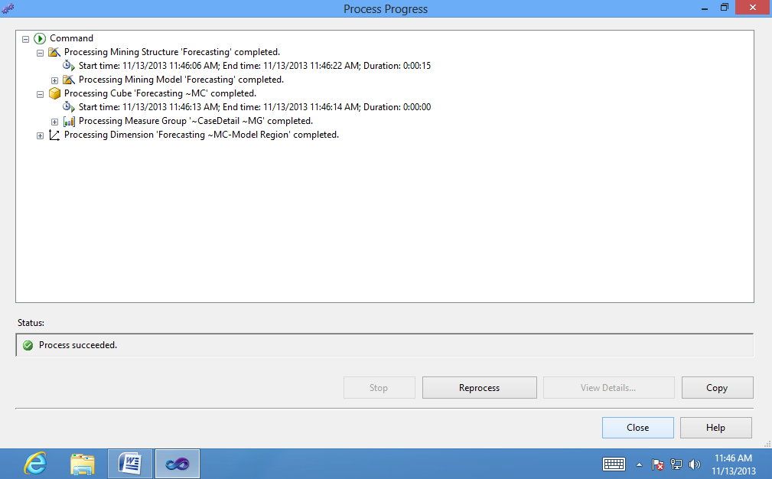

1. **Exploring the Forecasting Model (Data Mining Tutorial)**

To select a time series:

1. Click the **Charts** tab of the **Mining Model Viewer** tab, if it is not visible.

2. Click the drop-down list to the right of the chart view, and select all the checkboxes.

Click .

The chart should now contain 24 different series lines.

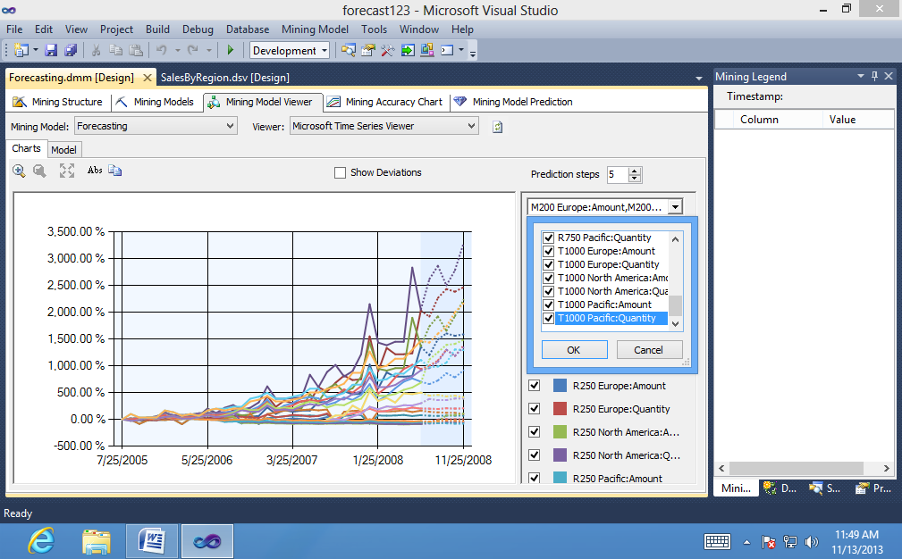

3. In the check boxes to the right of the chart, clear the boxes to temporarily hide the lines for all series that are based on Amount.

Now, clear the check boxes related to the R750 and R250 bicycles.

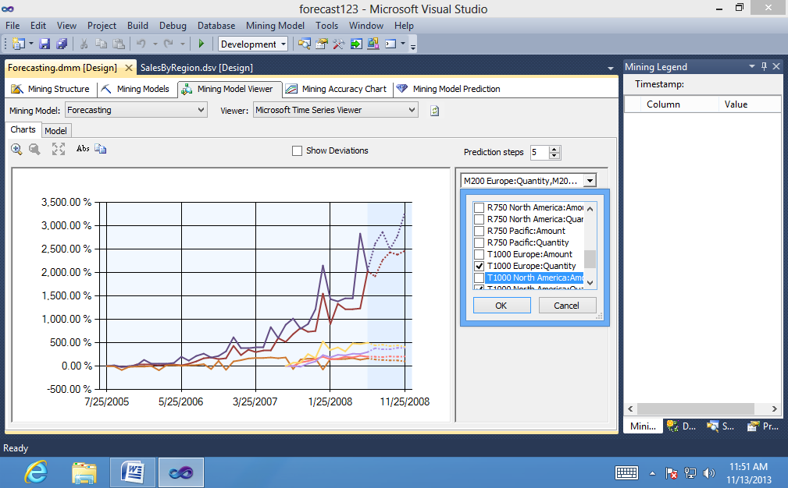

To change prediction and display options in the Chart view:

1. Try changing the value for **Prediction Steps** gradually, increasing it from **5 to 10,**and then back to **6**.

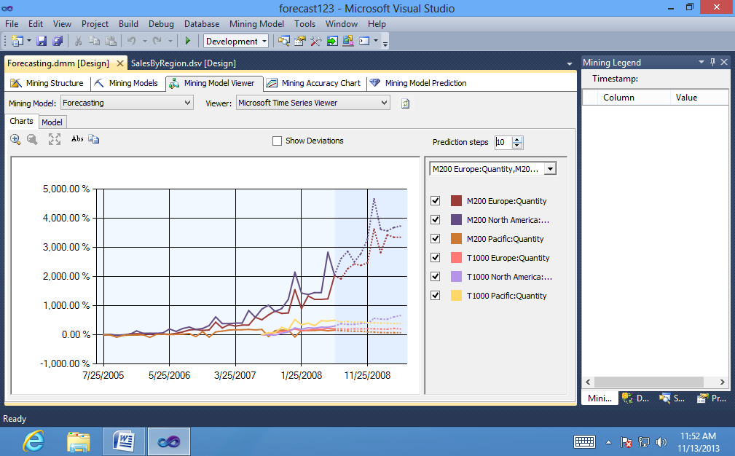

When the historical data has large fluctuations, the fluctuations tend to be

repeated or even amplified as you increase the number of predictions. You

probably need to do some research at this point, to understand the cause of the big increase in the historical data and then decide whether to accept these

results, seek some kind of correction in the source data, or apply some kind of smoothing in the model.

2. Select the **Show Deviations** check box.

This option displays the estimated error for each predicted value.

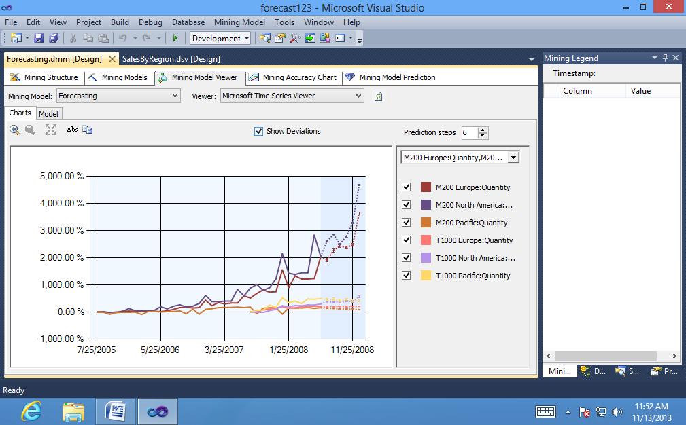

3. Note the scale of the X-axis. The changes over both historical and predicted data are always expressed as a percentage, but the actual values are adjusted automatically to fit all values onto the graph. Therefore you need to be careful when comparing models to not rely on visuals alone. To get the exact value, or the percentage increase and value for predictions, pause the mouse over the dotted line or solid lines, or click the lines to view the values in the **Mining Legend**.

To explore the decision tree for a time series model:

1. In the **Tree** list on the **Model tab** of the viewer, select the **T1000 Europe:**

**Amount** series.

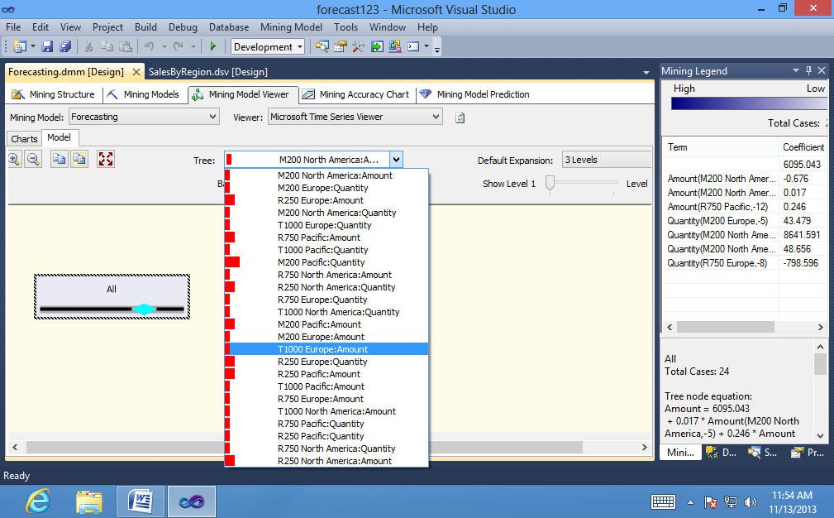

Click the node labeled**All.**

For an **All** node, the ToolTip that appears includes information such as, the

number of cases in the entire series, and time series equations derived from

analysis of the data.

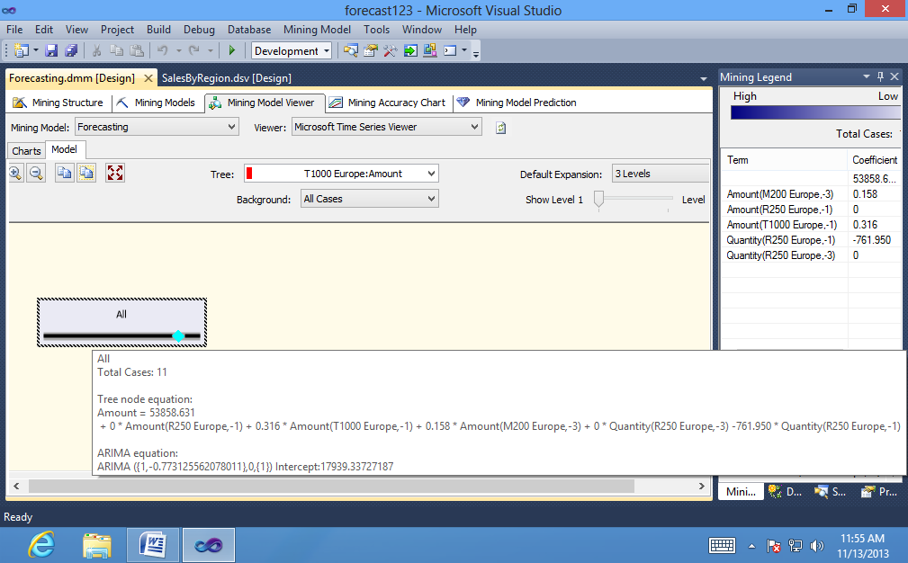

2. If the **Mining Legend** is not visible, right-click the node and select **Show Legend.**

The **Mining Legend** provides much the same information that is in the Tooltip. If any of your independent variables are discrete, you will also see a histogram that shows the distribution of variables in the node.

3. Now select a different time series to view. Using the **Tree** list on the **Model tab** of the viewer, select the **M200 North America: Amount** series.

The tree graph now contains an**All** node and two child nodes. By looking at the labels on the child nodes, you can understand at what point the trend line

changed.

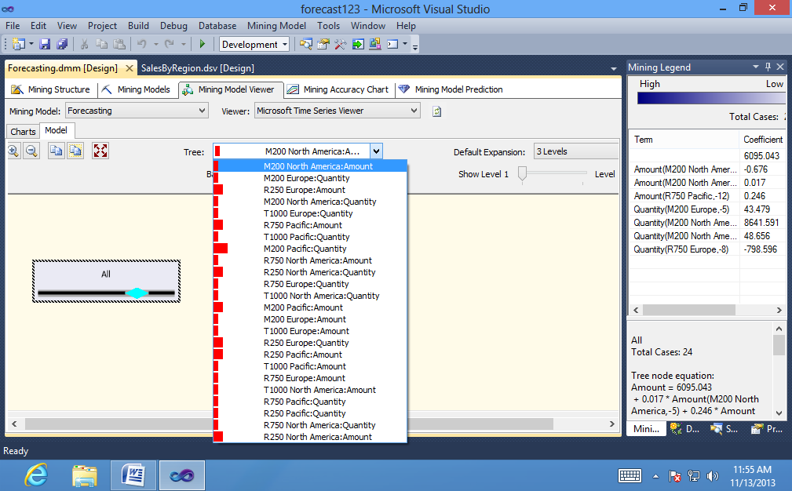

For each child node, the description in the **Mining Legend** also includes the

count of cases in each branch of the tree.

The following list describes some additional features in the tree viewer:

• You can change the variable that is represented in the chart by using the

**Background** control. By default, nodes that are darker contain more cases, because the value of **Background** is set to **Population**. To see just how many cases there are in a node, pause the mouse over a node and view the ToolTip that appears, or click the node and view the numbers in the Node Legend window.

To view details for a particular data series in the generic content viewer:

1. In the **Mining Model Viewer** tab, select **Microsoft Generic Content Tree Viewer** from the Viewer drop-down list.

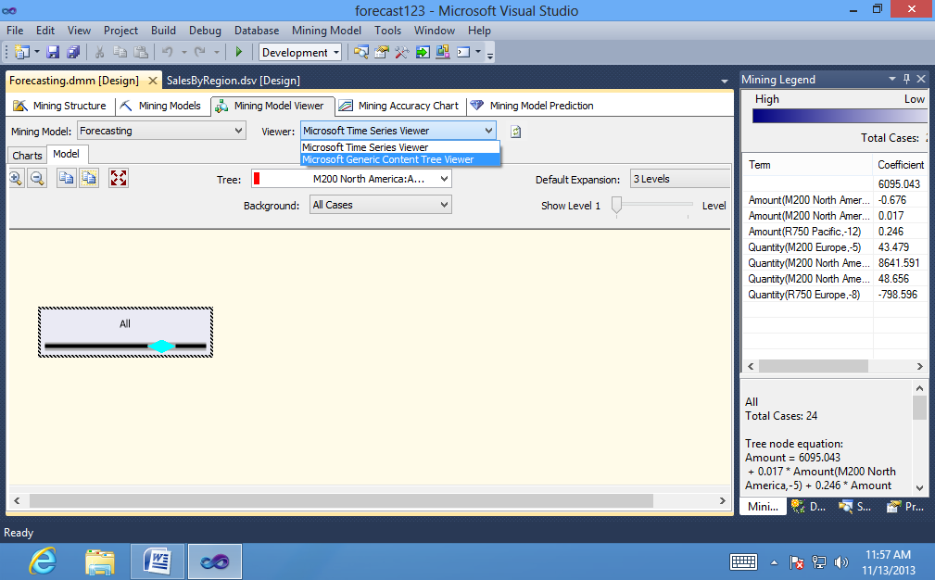

2. In the **Node Caption** pane, click the **topmost (All)** node.

3. In the **Node Details** pane, view the value for **ATTRIBUTE_NAME**.

This value shows you which series, or combination of product and region, is

contained in this node. In the AdventureWorks example, the topmost node is for the M200 Europe series.

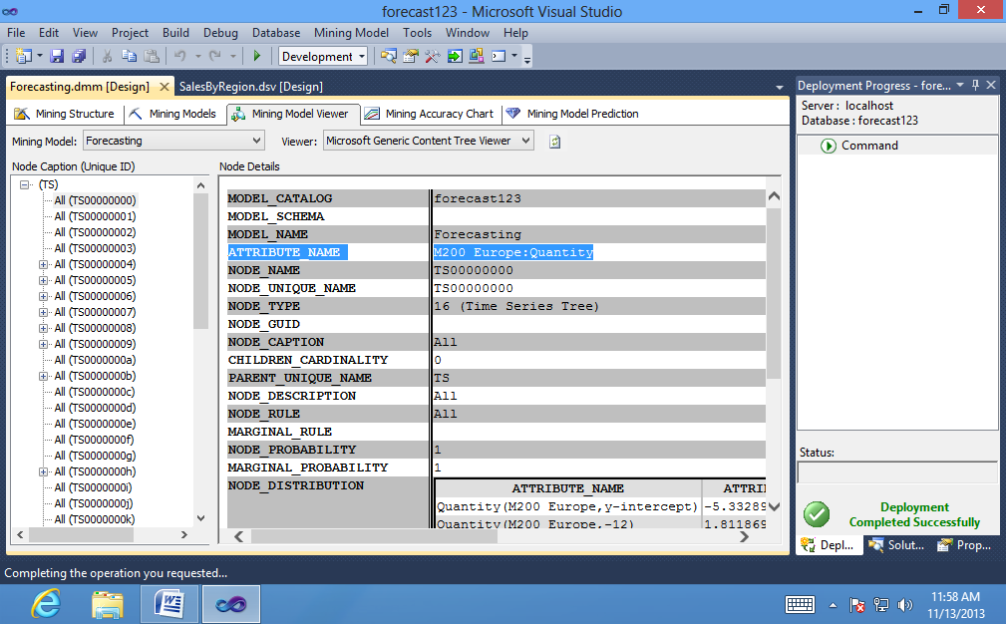

4. In the **Node Caption** pane, locate the first node that has child nodes.

If a series node has children, the tree view that appears on the Model tab of the Microsoft Time Series Viewer will also have a branching structure.

5. Expand the node and click one of the child nodes.

The **NODE_DESCRIPTION** column of the schema contains the condition that caused the tree to split.

6. In the **Node Caption** pane, click the **topmost ARIMA** node, and expand the node until all child nodes are visible.

7. In the **Node Details** pane, view the value for **ATTRIBUTE_NAME**.

This value tells you which time series is contained in this node. The topmost node in the ARIMA section should match the topmost node in the (All) section. In the AdventureWorks example, this node contains the ARIMA analysis for the series, M200 Europe.

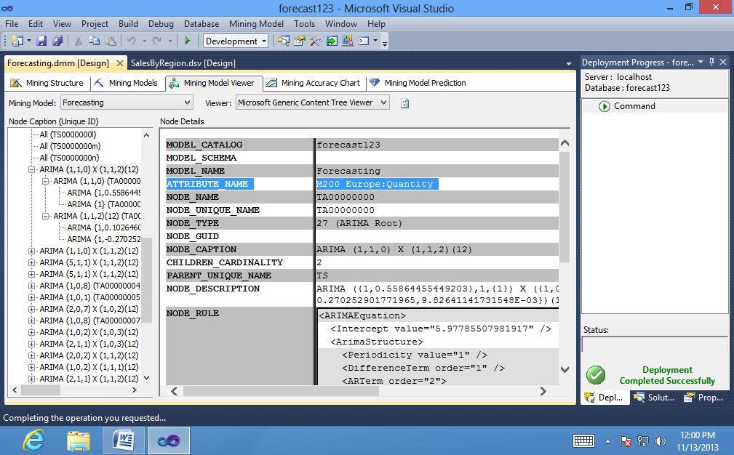

1. **Creating Time Series Predictions (Intermediate Data Mining Tutorial)**

To select a model and input table:

1. On the **Mining Model Prediction** tab of the Data Mining Designer, in the

**Mining Model** box, click **Select Model**.

1. In the **Select Mining Model** dialog box, expand the **Forecasting** structure, select the **Forecasting model** from the list, and then click **OK**.

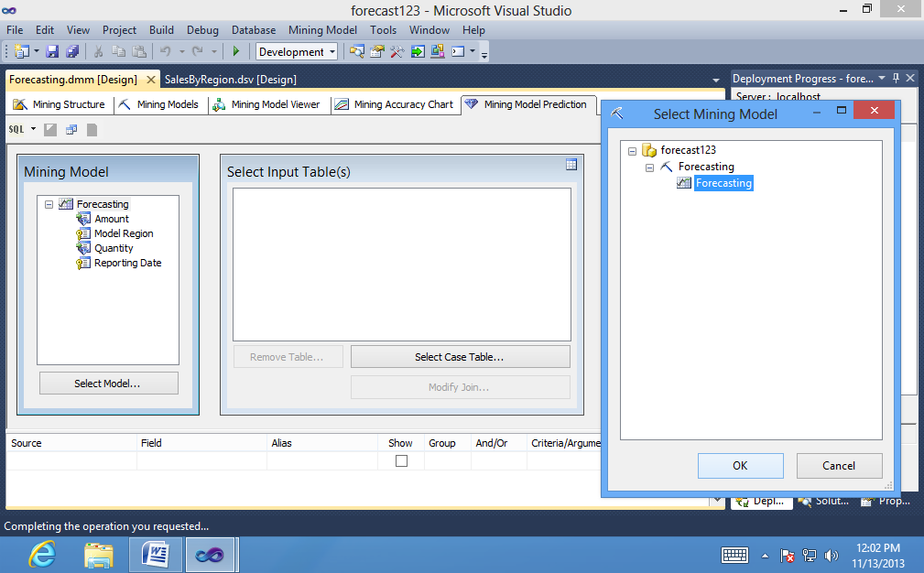

3. Ignore the **Select Input Table(s)** box.

4. In the **Source** column, in the grid on **the Mining Model Prediction** tab, click the cell in the first empty row, and then select Forecasting mining model.

5. In the **Field** column, select **Model Region**.

This action adds the series identifier to the prediction query to indicate the

combination of model and region to which the prediction applies.

6. Click the next empty row in the **Source** column, and then select **Prediction Function**.

7. In the **Field** column, select **PredictTimeSeries**.

8. In the **Mining Model** pane, select the mining model column, Amount. Drag **Amount** to the **Criteria/Arguments** box for the PredictTimeSeries function that you added earlier.

9. Click the **Criteria/Arguments** box, and type a comma, followed by 5, after the field name.

The text in the Criteria/Arguments box should now display the following:

**[Forecasting].[Amount],5**

10. In the **Alias** column, type **PredictAmount.**

11. Click the next empty row in the **Source** column, and then select **Prediction Function** again.

12. In the **Field** column, select **PredictTimeSeries**.

13. In the **Mining Model** pane, select the column **Quantity**, and then drag it into the Criteria/Arguments box for the second PredictTimeSeries function.

14. Click the Criteria/Arguments box, and type a comma, followed by 5, after the field name.

The text in the Criteria/Arguments box should now display the following:

**[Forecasting].[ Quantity],5**

15. In the Alias column, type **PredictQuantity.**

16. Click **Switch** to query result view.

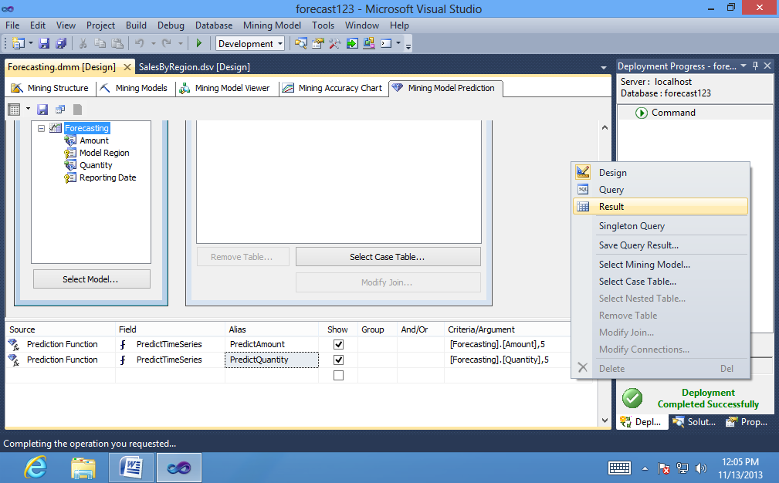

The results of the query are displayed in tabular format

.

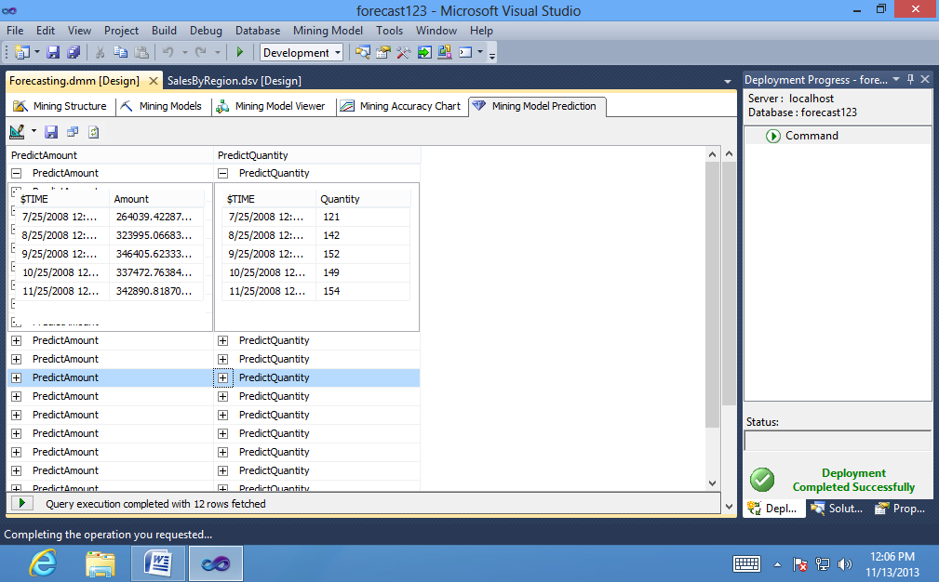

To flatten the results in the Results pane”

1. In the **Prediction Query Builder**, click **Switch** to query design view.

The view changes to allow manual editing of the DMX query text.

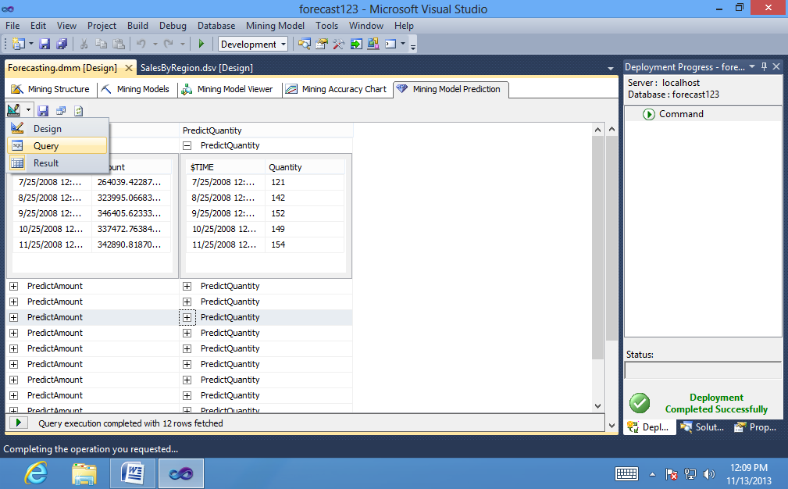

Type the **FLATTENED** keyword after the **SELECT** keyword. The complete query text should be as follows:

**SELECT FLATTENED**

**[Forecasting].[Model Region],**

**(PredictTimeSeries([Forecasting].[Amount],5)) as**

**[PredictAmount],**

**(PredictTimeSeries([Forecasting].[Quantity],5)) as**

**[PredictQuantity]**

**FROM**

**[Forecasting]**

3. Optionally, you can type a clause to restrict the results, such as the following example:

**SELECT FLATTENED**

**[Forecasting].[Model Region],**

**(PredictTimeSeries([Forecasting].[Amount],5)) as**

**[PredictAmount],**

**(PredictTimeSeries([Forecasting].[Quantity],5)) as**

**[PredictQuantity]**

**FROM**

**[Forecasting]**

**WHERE [Forecasting].[Model Region] = 'M200 North America'**

**OR [Forecasting].[Model Region] = 'M200 Europe'**

1. Click **Switch** to query result view.

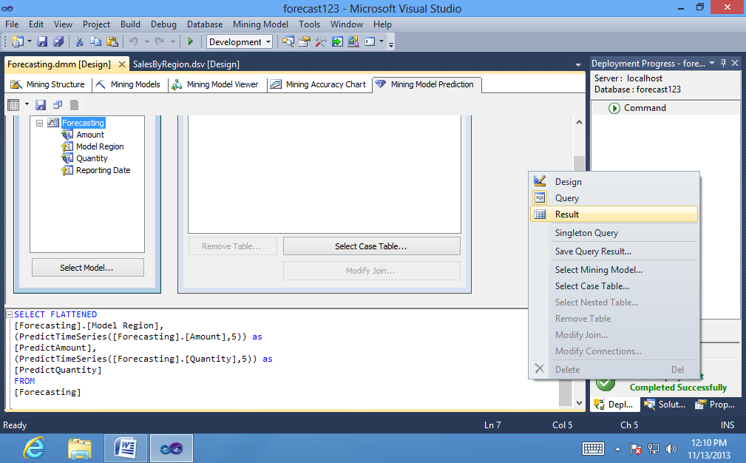

To export prediction query results:

1. Click Save query results.

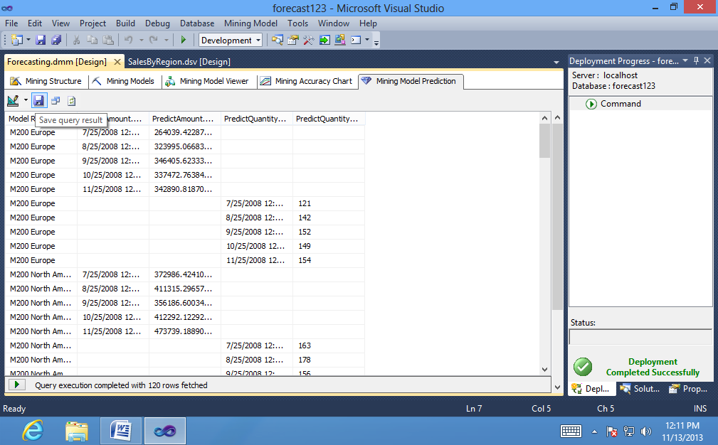

1. In the Save Data Mining Query Result dialog box, for Data Source, select You can also create a data source if you want to save the data to a different relational database.
2. In the Table Name column, type a new temporary table name, such as Test Predictions.
3. Click Save.

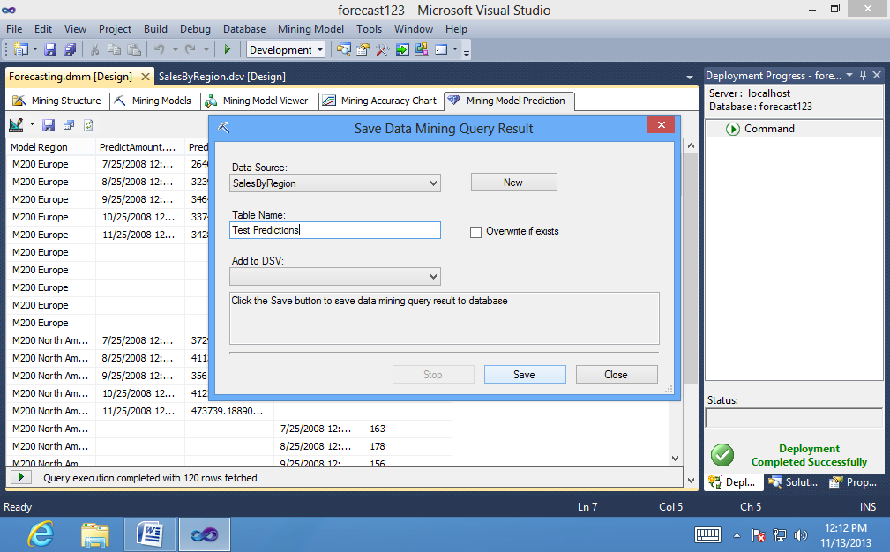

**Conclusion:** Using analysis services, we have thus implemented the time series model successfully.

**Practical No:5**

**Aim: Prepare the analysis services for Adventure Work cycles or (any other database). Built the basic data mining model and show the implementation of association algorithm and also apply the DMX queries.**

1. **Adding a Data Source View with Nested Tables (Intermediate Data Mining Tutorial)**

**To add a data source view:**

1. In **Solution Explorer**, right-click **Data Source Views**, and then select **New Data Source View**.

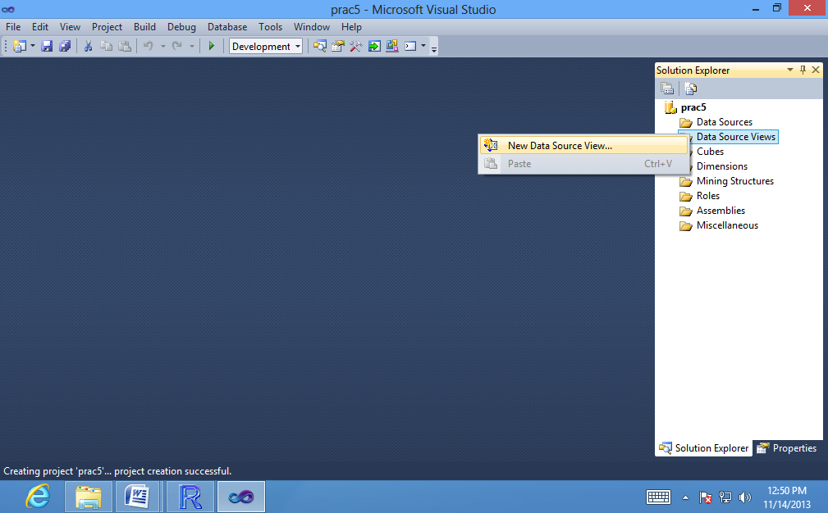

The Data Source View Wizard opens.

2. On the **Welcome to the Data Source View Wizard** page, click **Next**.

3. On the **Select a Data Source** page, under **Relational data sources**, select the **Adventure Works DW Multidimensional 2012 data source** that you created in the Basic Data Mining Tutorial. Click **Next**.

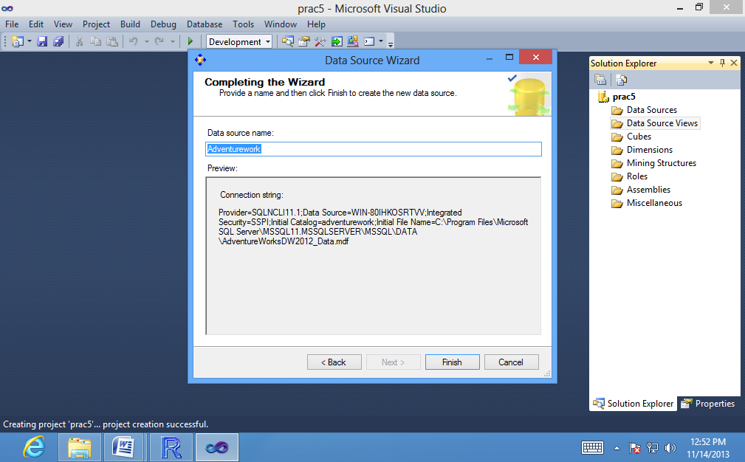

4. On the **Select Tables and Views** page, select the following tables, and then click the right arrow to include them in the new data source view:

• **vAssocSeqOrders**

**• vAssocSeqLineItems**

1. Click **Next.**

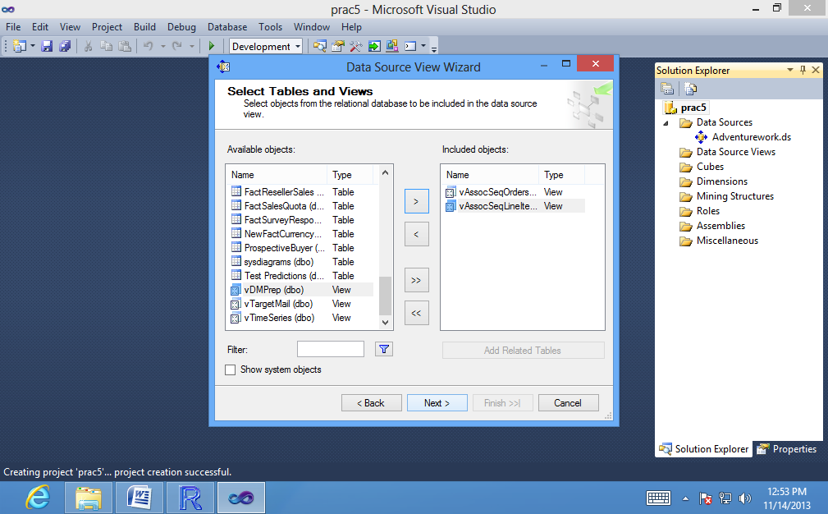

6. On the **Completing the Wizard** page, by default the data source view is named **Adventure Works DW Multidimensional 2012** . Change the name to **Orders**, and then click **Finish**.

**Data Source View Designer** opens and the **Orders data source view appears**.

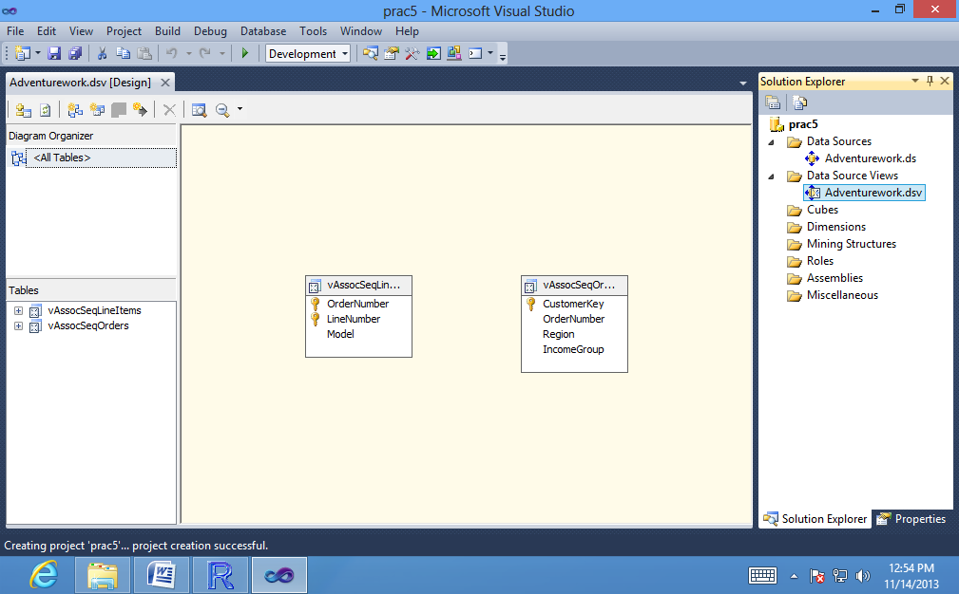

**To create a relationship between tables:**

1. In **Data Source View Designer**, position the two tables so that the tables

are aligned horizontally, with the **vAssocSeqLineItems** table on the left side and the **vAssocSeqOrders** table on the right side.

2. Select the **OrderNumbe**r column in the **vAssocSeqLineItems** table.

3. Drag the column to the **vAssocSeqOrders** table, and put it on the **OrderNumber** column.

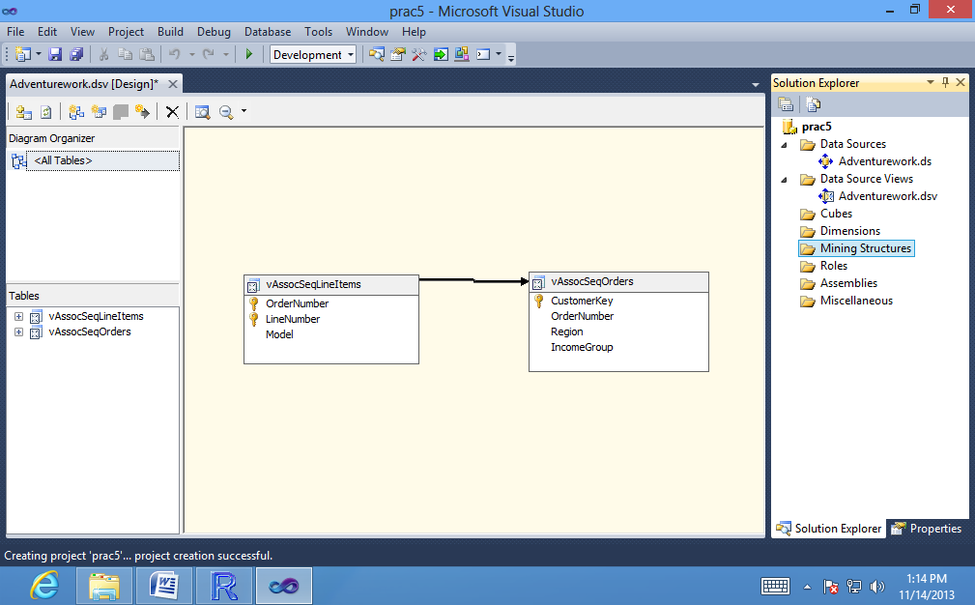

1. **Creating a Market Basket Structure and Model (Intermediate Data Mining Tutorial)**

**To create an association mining structure:**

1. In **Solution Explorer** in **SQL Server Data Tools (SSDT),** right-click **Mining Structures** and select **New Mining Structure** to open the **Data Mining Wizard**.

2. On the **Welcome to the Data Mining Wizard** page, click **Next**.

3. On the **Select the Definition Method** page, verify that From existing relational database or data warehouse is selected, and then click **Next**.

4. On the **Create the Data Mining Structure** page, under Which data mining technique do you want to use?, select **Microsoft Association Rules** from the list, and then click **Next**. The Select Data Source View page appears.

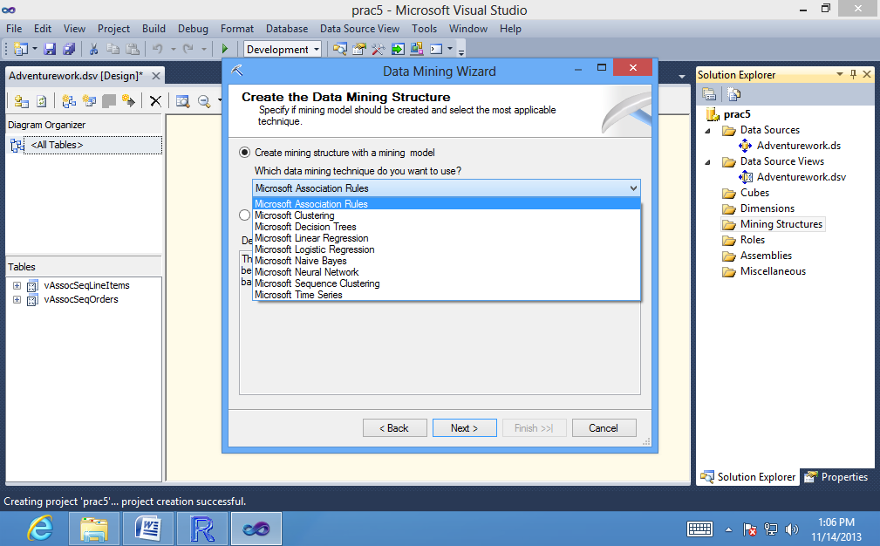

5. Select **Orders** under Available data source views, and then click**Next**.

6. On the **Specify Table Types** page, in the row for the **vAssocSeqLineItems**table, select the Nested check box, and in the row for the nested table **vAssocSeqOrders**, select the Case check box. Click **Next**.

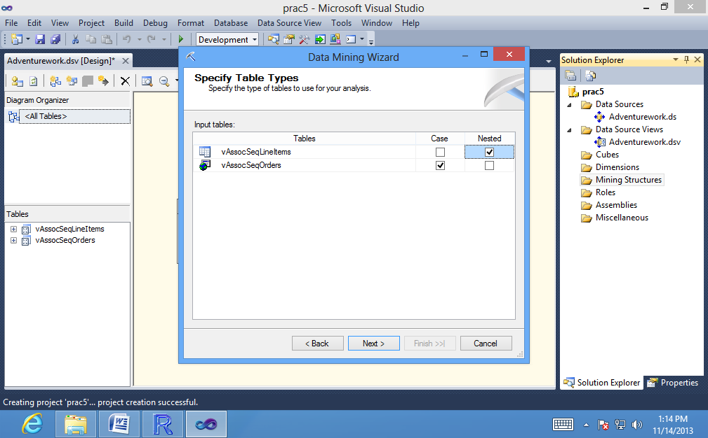

7. On the **Specify the Training Data** page, clear any boxes that might be checked.Set the **key** for the case table, **vAssocSeqOrders**, by selecting the **Key** check box next to **OrderNumber**.

Because the purpose of the market basket analysis is to determine which products are included in a single transaction, you do not have to use the CustomerKey field.

8. Set the **key** for the nested table, **vAssocSeqLineItems**, by selecting the Key checkbox next to **Model**. The Input check box is also automatically selected when you do this. Select the Predictable check box for Model as well.

In a market basket model, you do not care about the sequence of products in the shopping basket, and therefore you should not include LineNumber as a key for the nested table. You would use LineNumber as a key only in a model where the sequence is important. You will create a model that uses the Microsoft SequenceClustering algorithm in Lesson 4.

1. Select the check box to the **left** of **IncomeGroup**and **Region**,but do not make any other selections. Checking the leftmost column adds the columns to the structure for later reference, but the columns will not be used in the model. Your selections should look like the following:

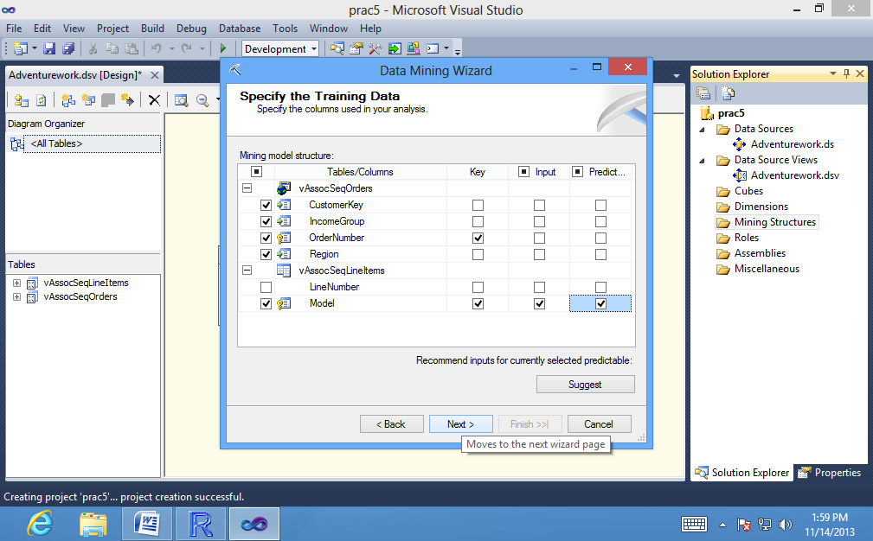

Click Next.

11. On the Specify Columns' Content and Data Type page, review the selections, which should be as shown in the following table, and then click Next.

12. On the Create testing set page, the default value for the option Percentage of data for testing is 30 percent. Change this to 0. Click Next.

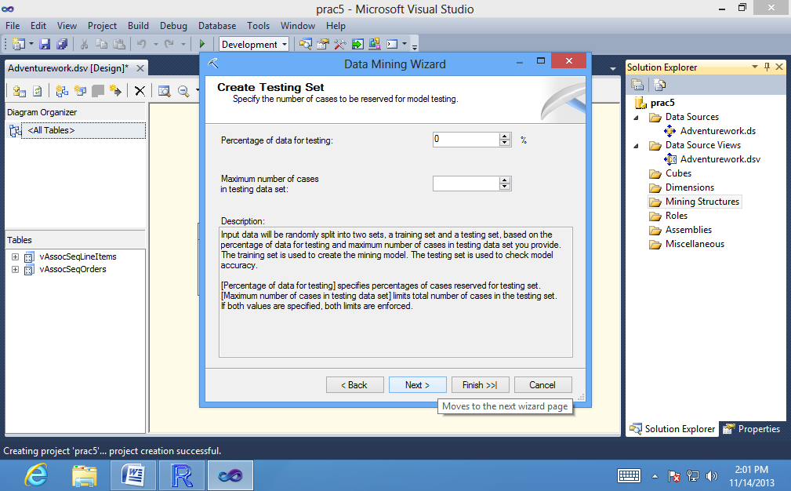

13. On the Completing the Wizard page, in Mining structure name, type Association.

14. In Mining model name, type Association.

15. Select the option Allow drill through, and then click Finish.

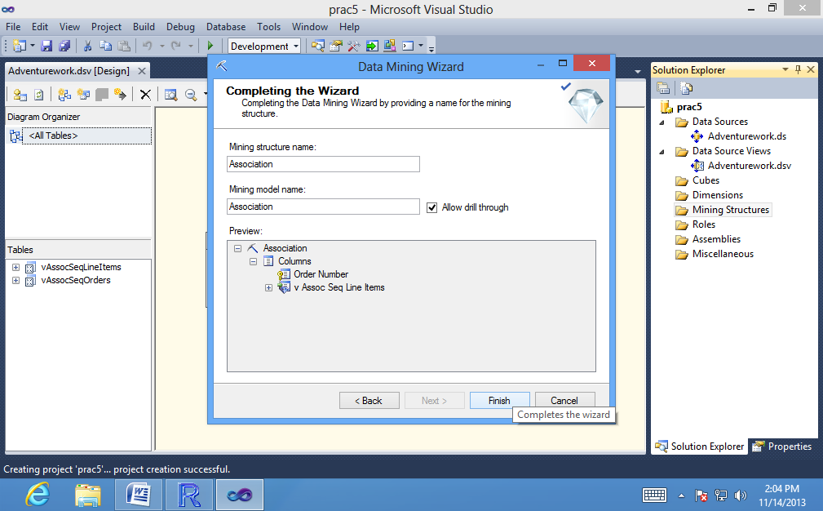

Data Mining Designer opens to display the Association mining structure that you just created.

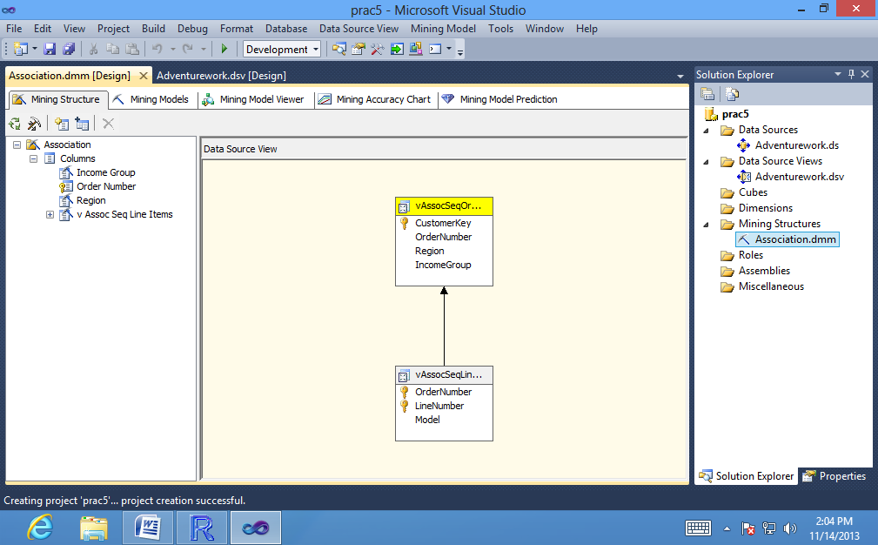

1. **Modifying the Market Basket Model (Intermediate Data Mining Tutorial)**

* **To adjust the parameters of the Association model:**

1. Open the **Mining Models tab** of Data Mining Designer.

2. Right-click the **Association** column in the grid in the designer and select **Set Algorithm Parameters** to open the **Algorithm Parameters dialog box.**

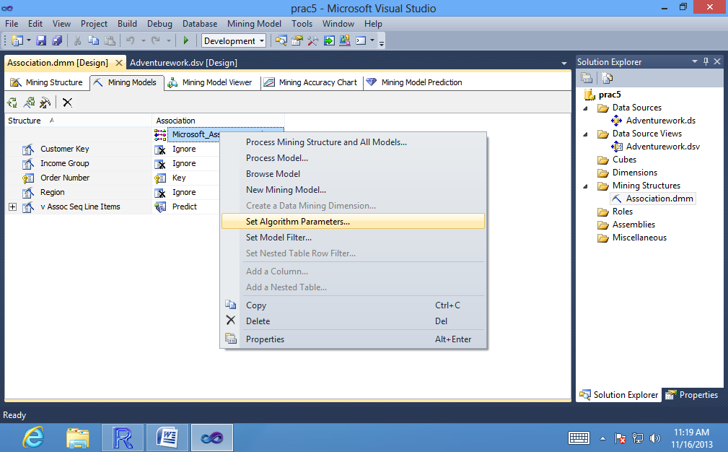

3. In the **Value** column of the **Algorithm Parameters** dialog box, set the following parameters:

**MINIMUM_PROBABILITY = 0.1**

**MINIMUM_SUPPORT = 0.01**

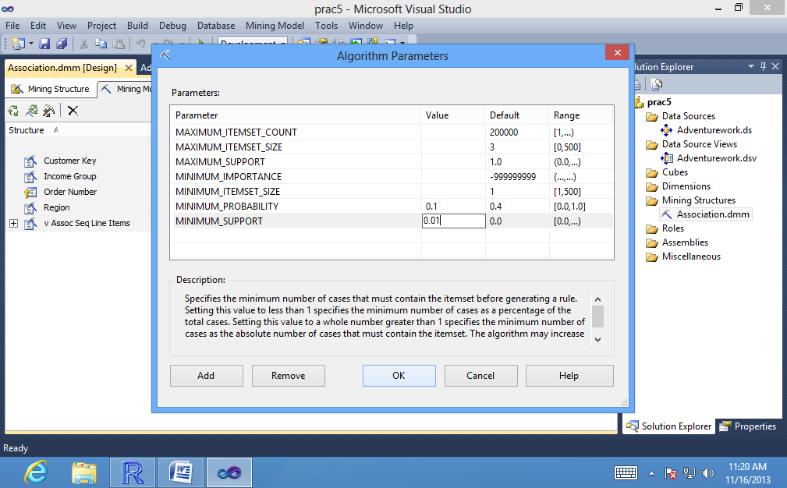

4.Click .

* **To process the mining model:**

1. On the **Mining Model** menu of **SQL Server Data Tools (SSDT),** select **Process Mining Structure and All Models**.

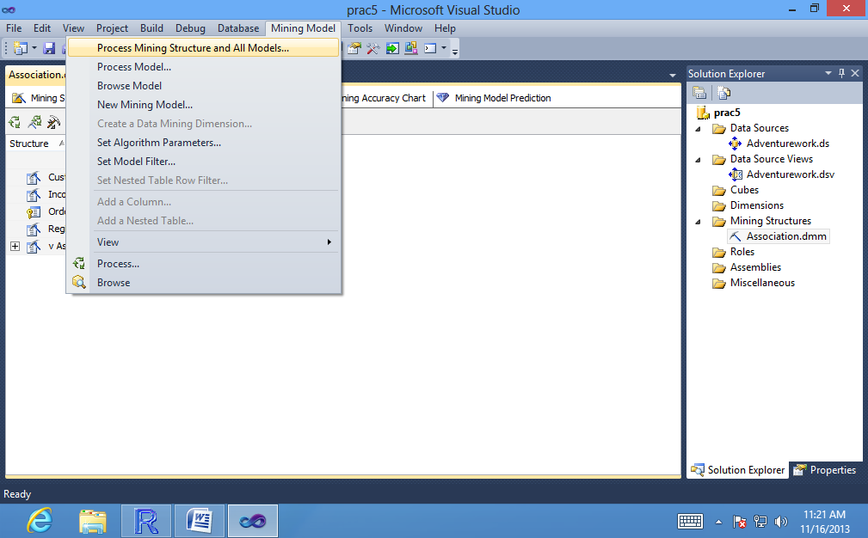

2. At the warning asking whether you want to build and deploy the project, click **Yes.**

The Process Mining Structure - Association dialog box opens.

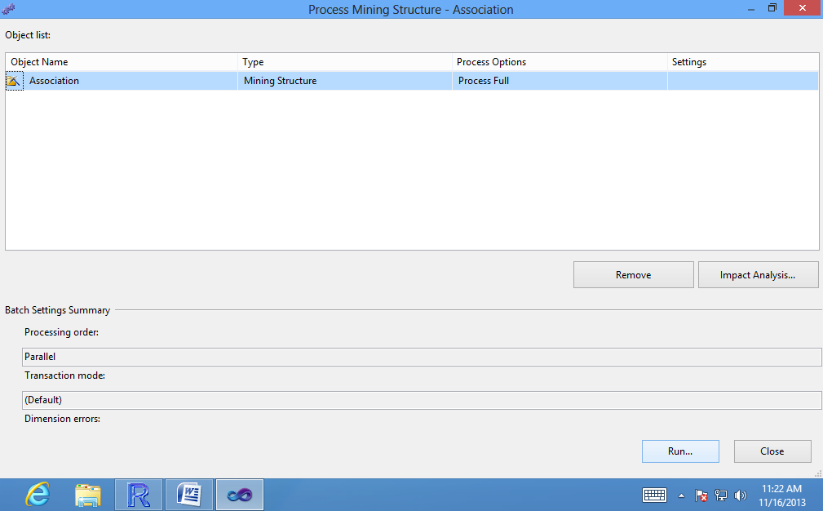

1. Click **Run**.

The **Process Progress** dialog box opens to display information about model processing. Processing of the new structure and model might take some time.

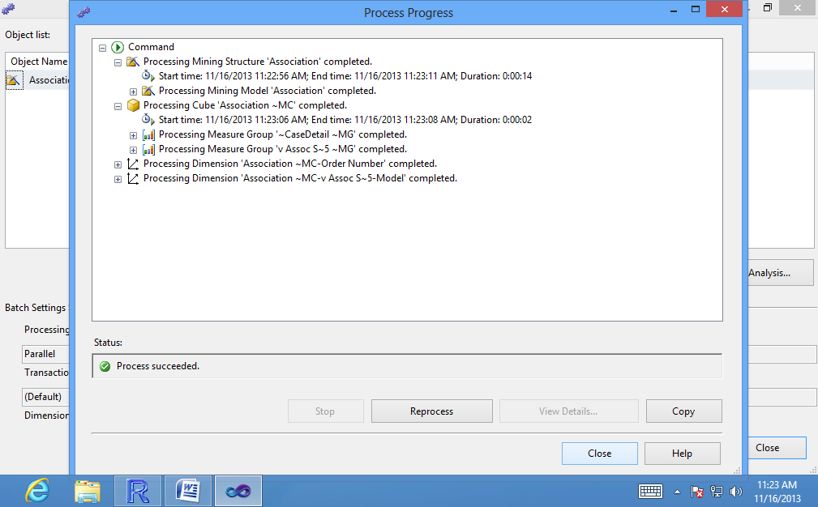

4. After processing is complete, click **Close** to exit the Process Progress dialog box.

5. Click Close again to exit the Process Mining Structure - Association dialog box.

1. **Exploring the Market Basket Models (Intermediate Data Mining Tutorial)**

**To open the Association mode in the Microsoft Assocaition Rules Viewer:**

1. In **Solution Explorer**, double-click the **Association** structure.

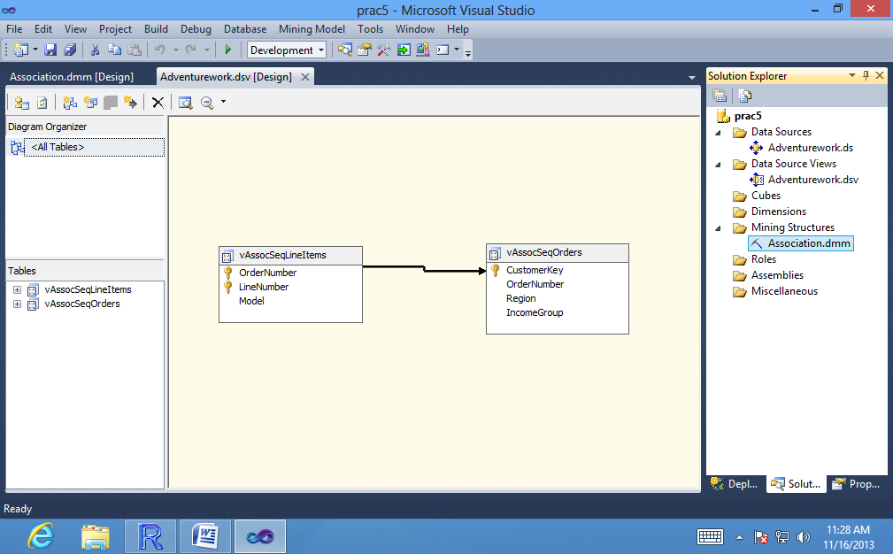

1. In **Data Mining Designer**, click the **Mining Model Viewer** tab.

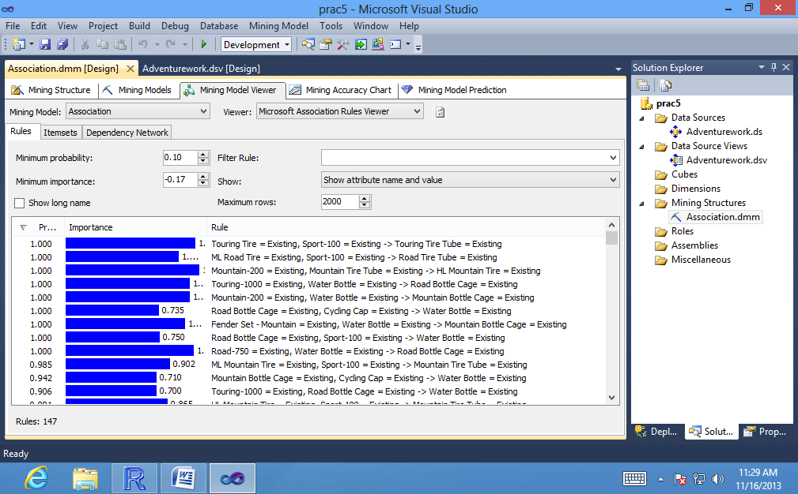

3. Select **Association** from the list of mining models in the **Mining Model** dropdown list.

**To navigate the dependency graph and locate specific nodes:**

1. In the **Mining Model Viewer** tab, click the **Dependency Network** tab.

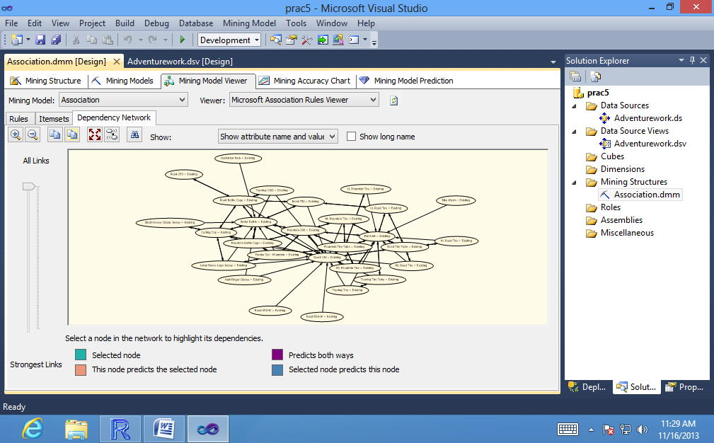

2. Click **Zoom** In several times, until you can easily view the labels for each node.

By default, the graph displays with all nodes visible. In a complex model, there may be many nodes, making each node quite small.

1. Click the **+** sign in the lower right-hand corner of the viewer and hold down the mouse button to pan around the graph.

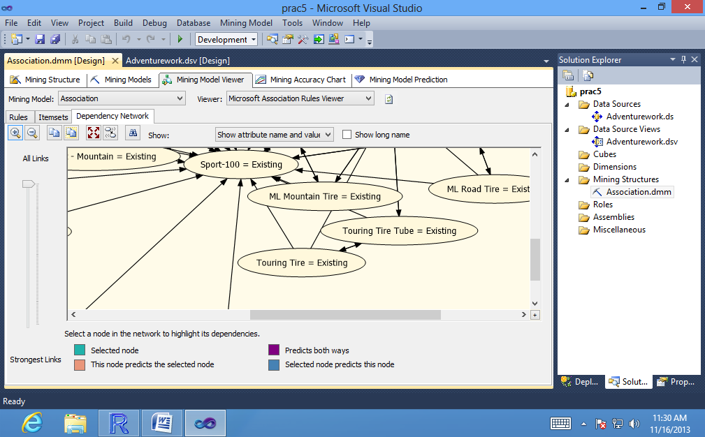

4. On the left side of the viewer, **drag the slider down**, moving it from **All Links** (the default) to the bottom of the slider control.

5. The viewer updates the graph to now show only the strongest association,between the **Touring Tire** and **Touring Tire Tube** items.

6. Click the node labeled**Touring Tire Tube = Existing.**

The graph is updated to highlight only items that are strongly related to this item. Note the direction of the arrow between the two items.

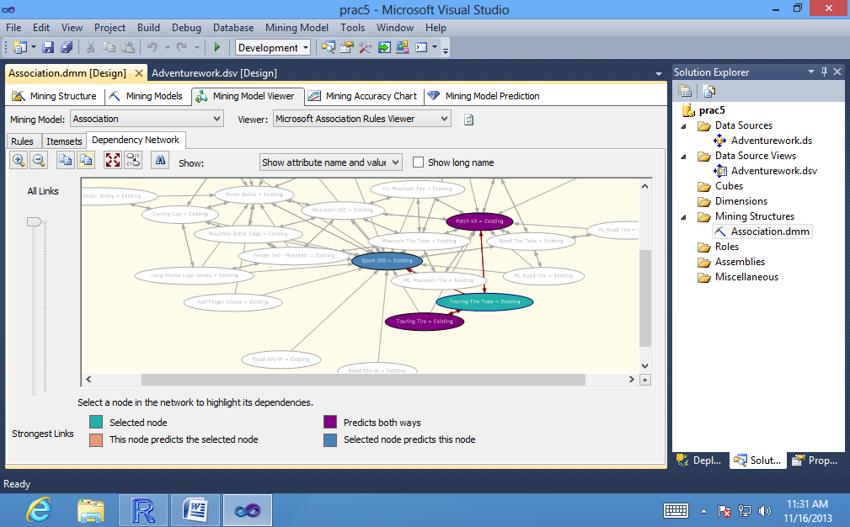

7. On the left side of the viewer, drag the slider up again, moving it from the bottom to around the middle.

Note the changes in the arrow that connects the two items.

8. Select **Show attribute name only** from the dropdown list at the top of the **Dependency Network** pane.

The text labels in the graph are updated to show only the model name.

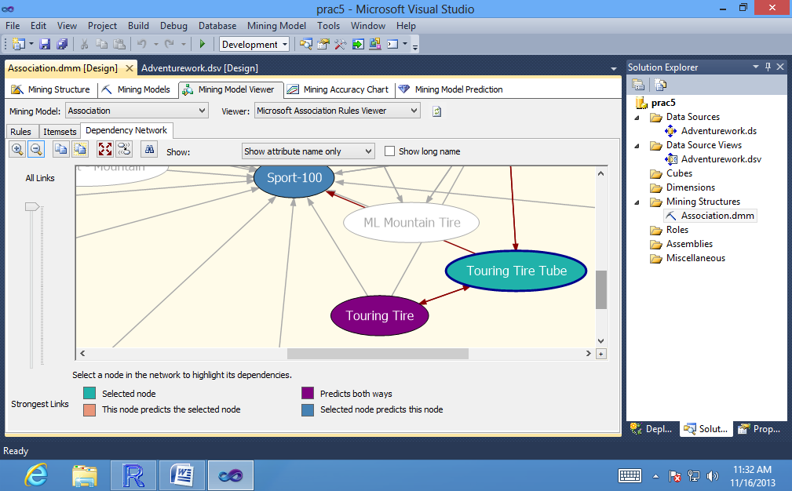

**To view details for an itemset:**

1. In the list of **itemsets**, click the **Itemset** column heading to **sort by name.**

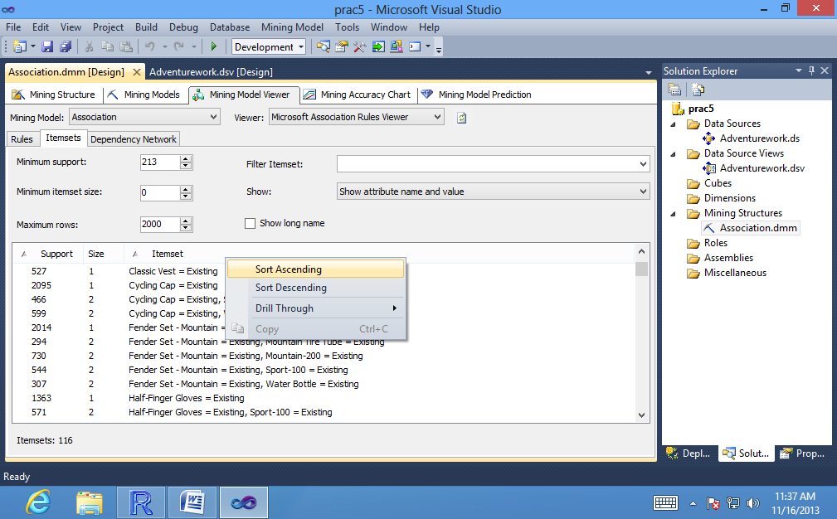

1. Locate the item, **Touring Tire** (with no second item).

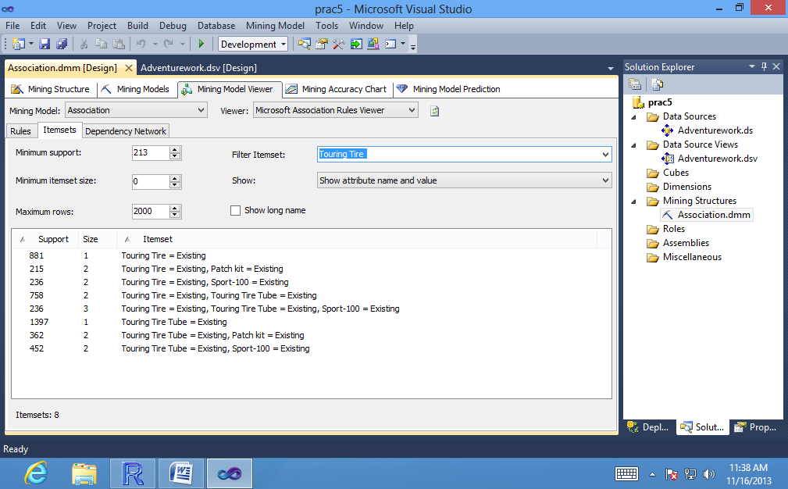

1. Right-click the item, **Touring Tire**, select**Drill Through**, and then select **Model and Structure Columns**.

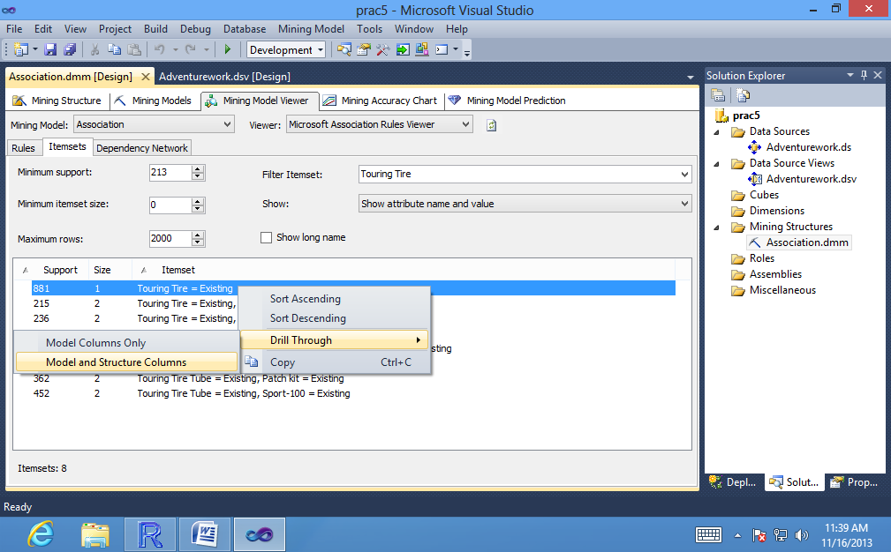

The **Drill Through dialog box** displays the individual transactions used as support for this itemset.

1. Expand the nested table, **vAssocSeqLineItems**, to view the actual list of purchases in the transaction.

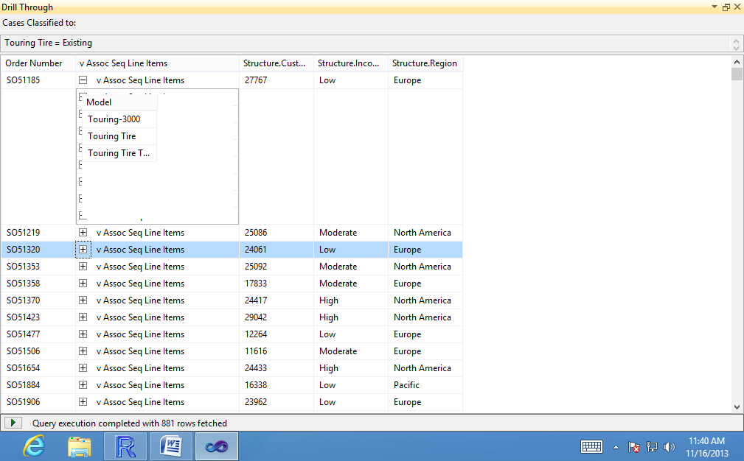

**To filter itemsets by support or size:**

1. Clear any text that might be in the **Filter Itemset** box. You cannot use a text filter together with a numeric filter.

2. In the **Minimum support** box, type **100**, and then click the background of the viewer.

The list of itemsets is updated to show only itemsets with support of at least 100.

**To see only rules that include the Mountain-200 bicycle:**

1. In the **Mining Model Viewer** tab, click the **Rules** tab

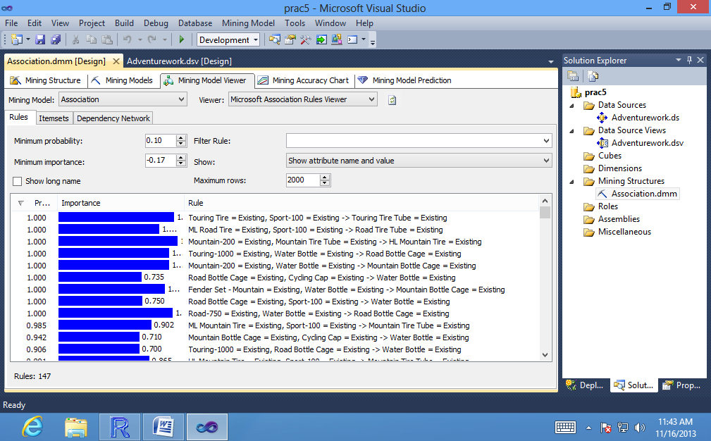

2. In the **Filter Rule** box, enter **Mountain-200**.

**Clear the Show long name** check box.

3. From the **Show** list, select **Show attribute name only**.

The viewer will then display only the rules that contain the words "**Mountain-200**". The probability of the rule tells you how likely it is that when someone buys a Mountain-200 bicycle, that person will also buy the other listed product.

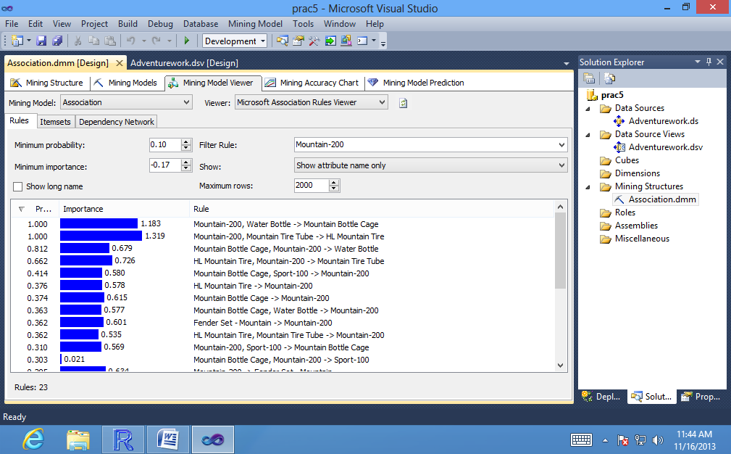

**To view cases that support a particular rule**

1. In the **Rules** tab, right-click the rule that you want to view.

2. Select **Drill Through**, and then select **Model Columns Only**, or **Model and Structure Columns**.

The **Drill Through** dialog box provides a summary of the rule at the top of the pane, and a list of all cases that were used as supporting data for the rule.

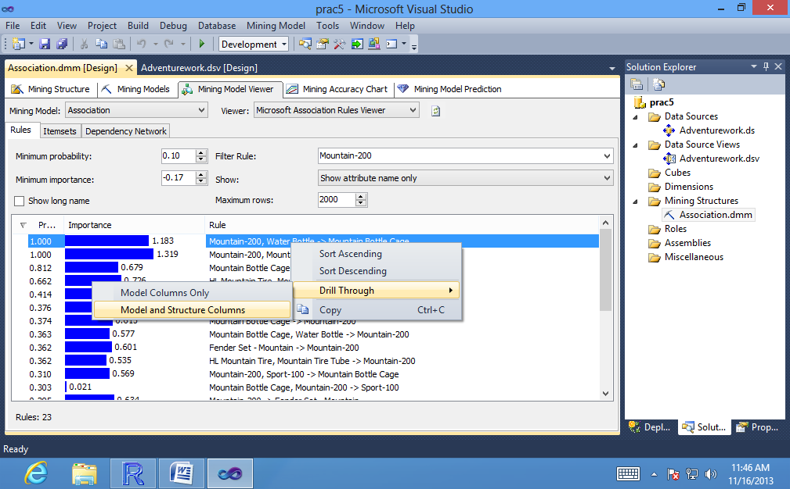

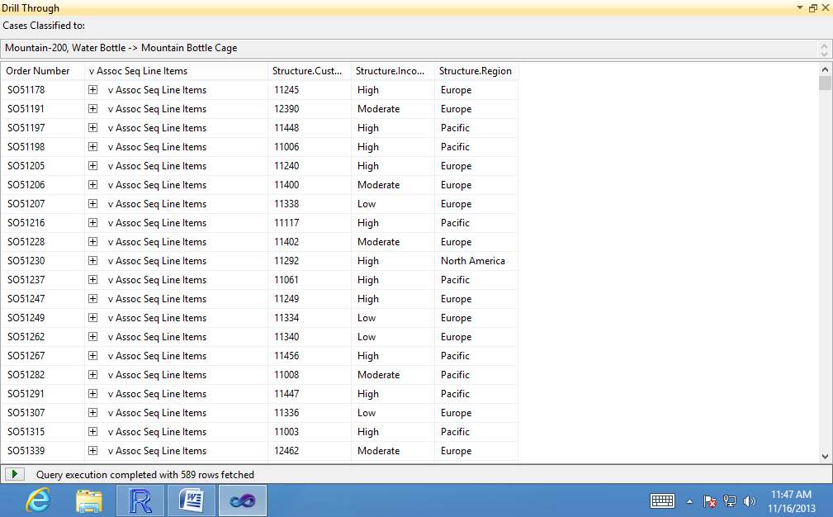

1. **Filtering a Nested Table in a Mining Model (Intermediate Data Mining Tutorial)**

**To create and modify a copy of the Association model:**

1. In the **Mining Models** tab of **SQL Server Data Tools (SSDT),right-click the Association** model, and select **New Mining Model**.

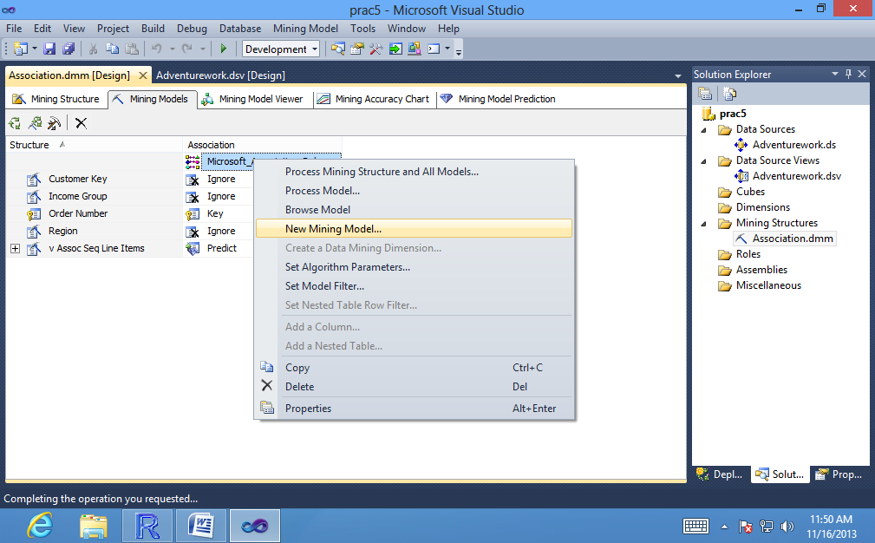

1. For **Model** Name, type **Association Filtered**. For **Algorithm Name**, select **Microsoft Association Rules**. Click **OK**.

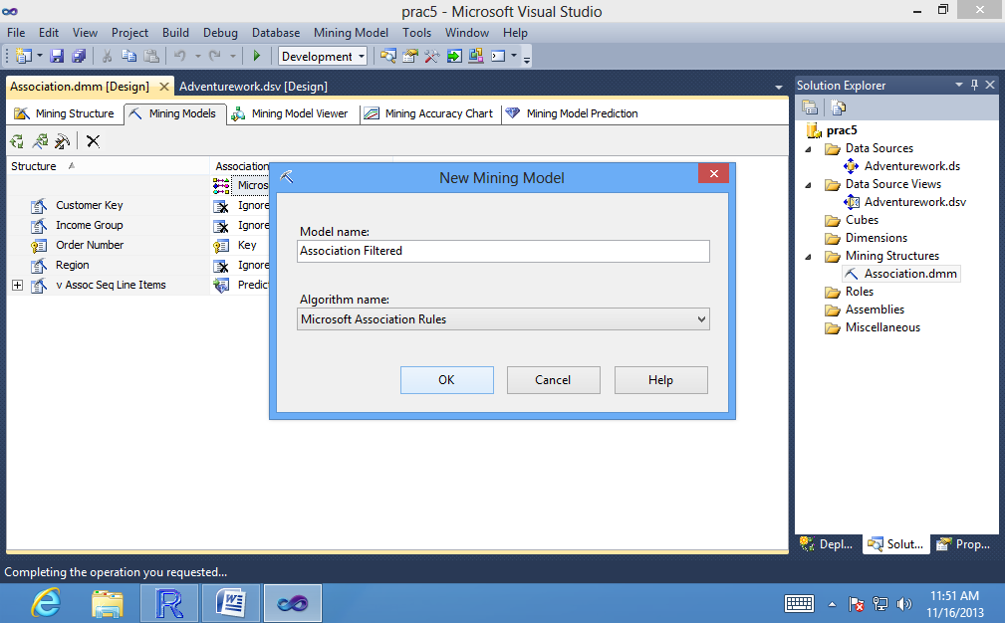

1. In the column for the **Association Filtered** model, click the **IncomeGroup**row and change the value from **Ignore to Input.**

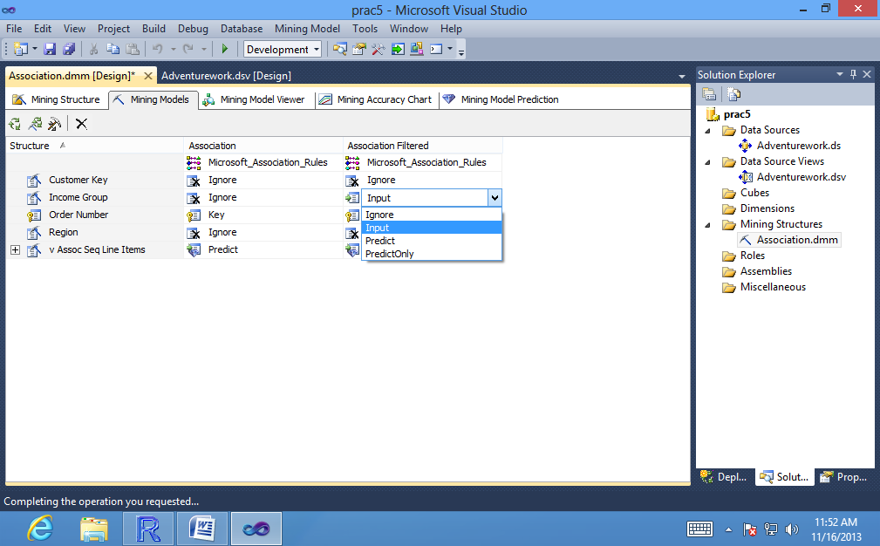

**To add a filter to a mining model:**

1. In the **Mining Models** tab, right-click the model, and select

**Set Model Filter**.

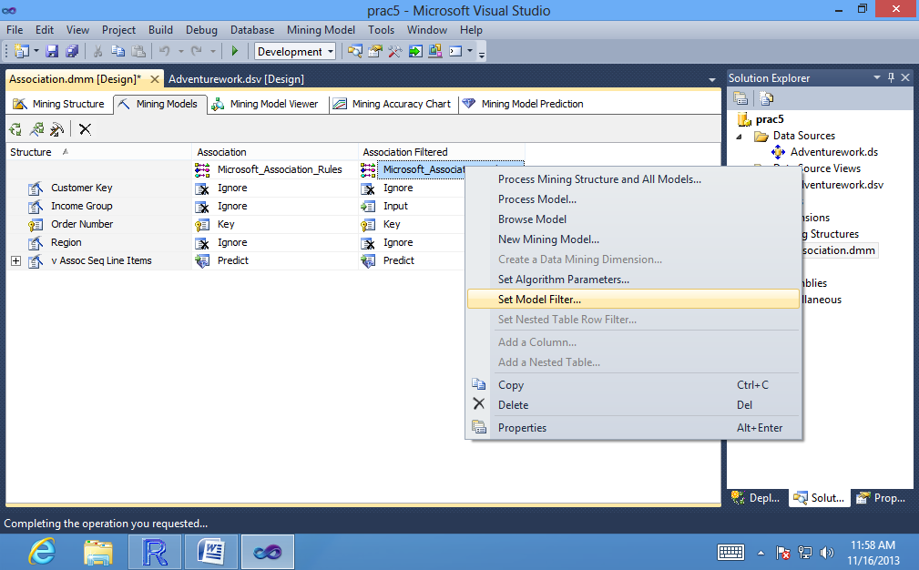

1. In **Model Filter** dialog box, click the top row in the grid, in the **Mining Structure Column** text box.

3. In the **Mining Structure Column** text box, select **IncomeGroup**.

The icon at the left side of the text box changes to indicate that the selected item is a column.

4. Click the **Operator** text box and select the **=** operator from the list.

5. Click the **Value** text box, and type **High** in the box.

6. **Click the next row** in the grid.

7. Click the **AND/OR** text box in the next row of the grid and select **OR**.

8. In the **Mining Structure Column** text box, select **IncomeGroup**. In the **Value** textbox, type **Moderate**.

The filter condition that you created is automatically added to the **Expression** text box, and should appears as follows:

**[IncomeGroup] = 'High' OR [IncomeGroup] = 'Moderate'**

9. Click the next row in the grid, leaving the operator as the default, **AND.**

10. For **Operator**, leave the **default value, Contains**. Click the **Value** text box.

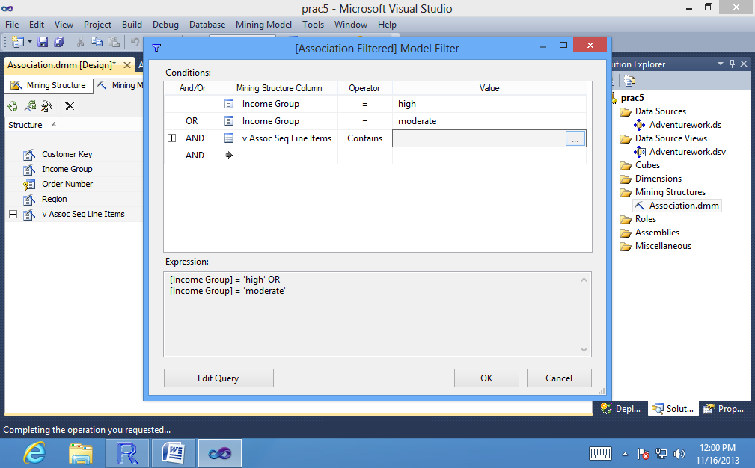

11. In the Filter dialog box, in the first row under **Mining Structure Column,** select **Model**.

12. For **Operator,** select **IS NOT NULL**. Leave the **Value** text box blank. Click **OK**.

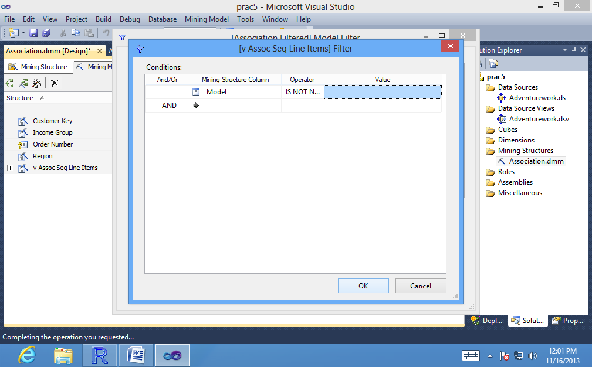

The filter condition in the Expression text box of the Model Filter dialog box is automatically updated to include the new condition on the nested table. The completed expression is as follows:

**[IncomeGroup] = 'High' OR [IncomeGroup] = 'Moderate' AND EXISTS**

**SELECT * FROM [vAssocSeqLineItems] WHERE [Model] <> NULL).**

Click .

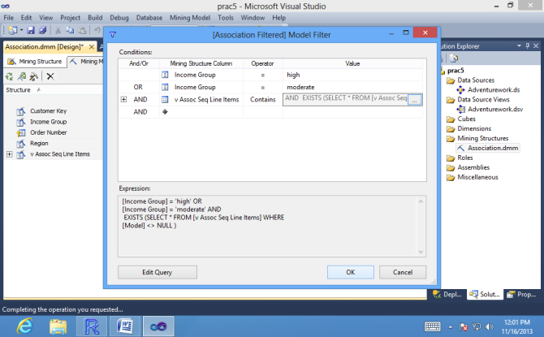

**To enable drillthrough and to process the filtered model:**

1. In the **Mining Models** tab, right-click the **Association Filtered model**, and select **Properties.**

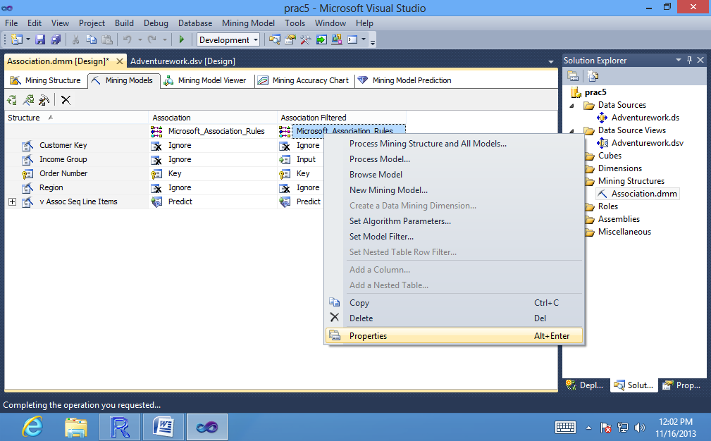

1. Change the **AllowDrillThrough**property to **True**.

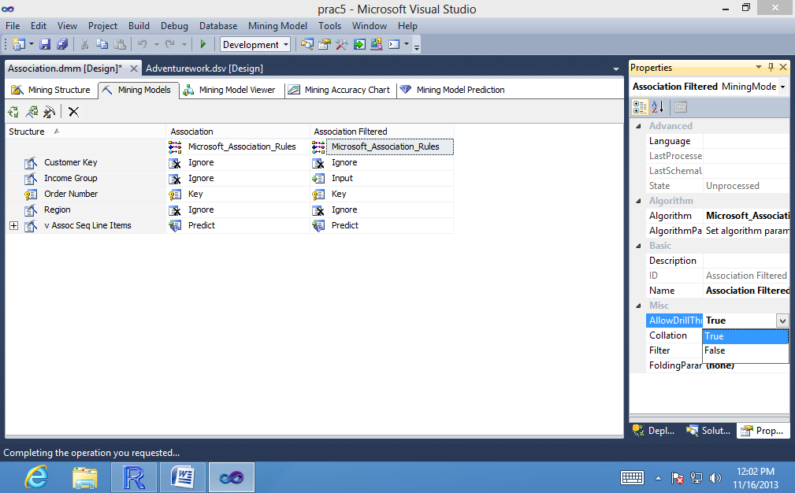

1. Right-click the **Association Filtered mining**model, and select **Process Model.**

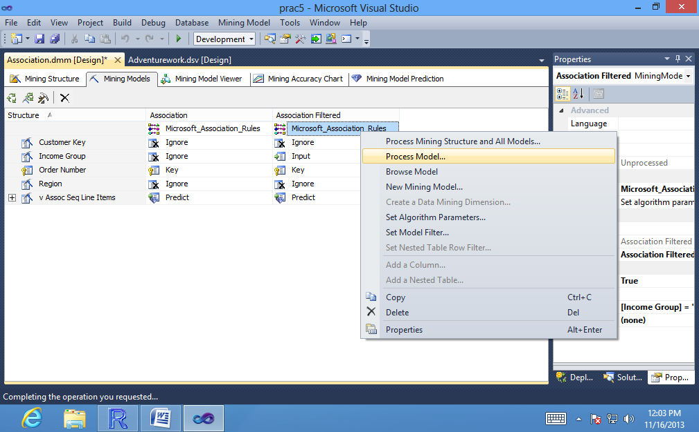

4. Click **Yes** in the error message to deploy the new model to the **Analysis Services database.**

5. In the **Process Mining Structure** dialog box, click **Run.**

6. When processing is complete click Close to exit the Process Progress dialog box, and click Close again to exit the Process Mining Structure dialog box.

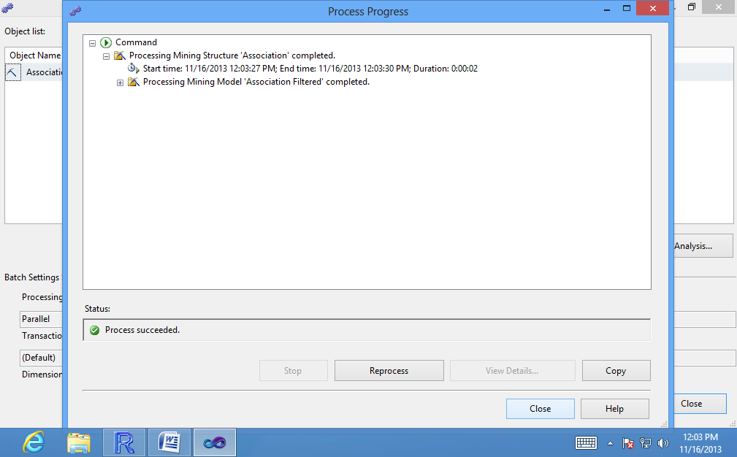

1. **Creating Recommendations and Predicting Associations:**

**To create a prediction query on an association model**

1. Click **the Mining Model Prediction** tab of **Data Mining Designer.**

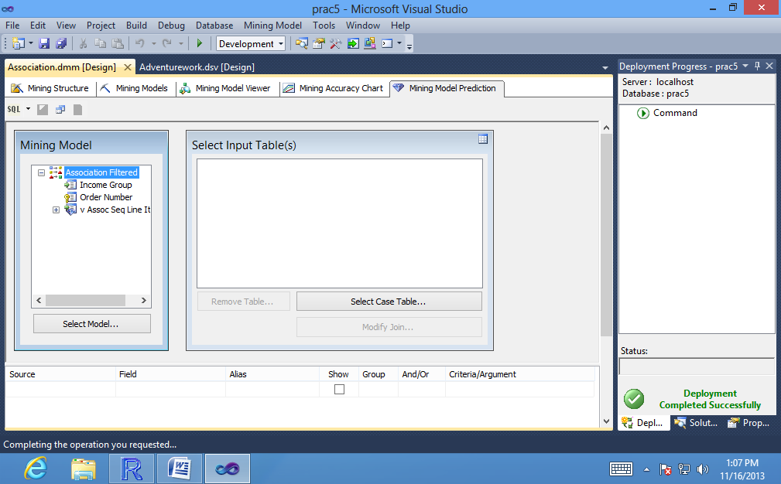

2. In the **Mining Model** pane, click Select **Model.**

3. In the **Select Mining Model** dialog box, expand the node that represents the **mining structure Association**, and select the **model Association**. Click OK.

For now, you can ignore the input pane.

4. In the grid, click the empty cell under **Source** and select **Prediction Function**. In the cell under **Field,** select **PredictAssociation.**

You can also use the Predict function to predict associations. If you do, be sure to choose the version of the Predict function that takes a table column as argument.

5. In the **Mining Model** pane, select the nested table **vAssocSeqLineItems,** and drag it into the grid, to the Criteria/Argument box for **the PredictAssociation**

**function.**

Dragging and dropping table and column names lets you build complex statements without syntax errors. However, it replaces the current contents of the cell, which include other optional arguments for the PredictAssociationfunction.

To view the other arguments, you can temporarily add a second instance of the function to the grid for reference.

6. Click the **Criteria/Argument** box and type the following text after the **table name: ,3**

The complete text in the Criteria/Argument box should be as follows:

1. **[Association].[v AssocSeq Line Items],3**

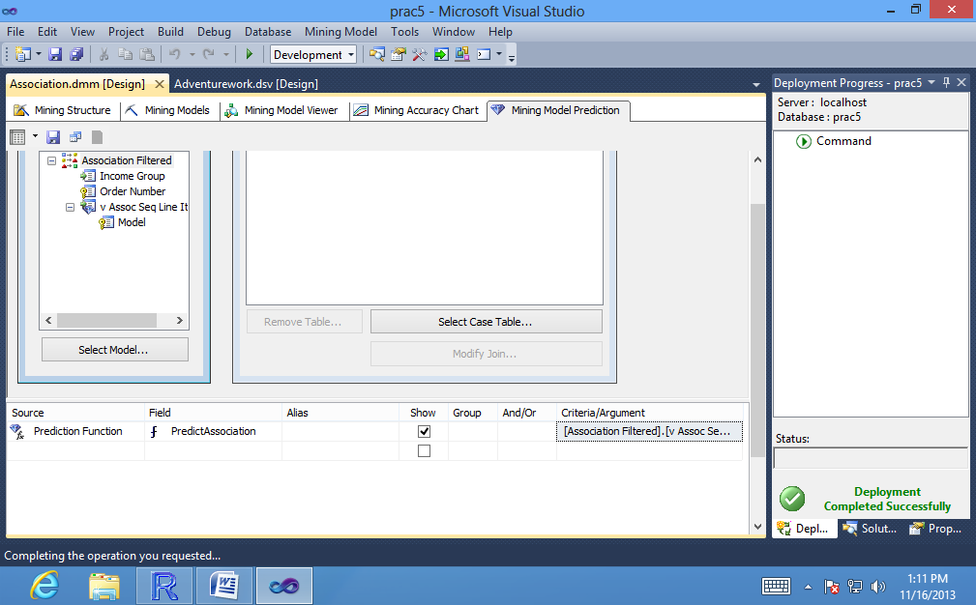

Click the **Results** button in the upper corner of the Prediction Query Builder.

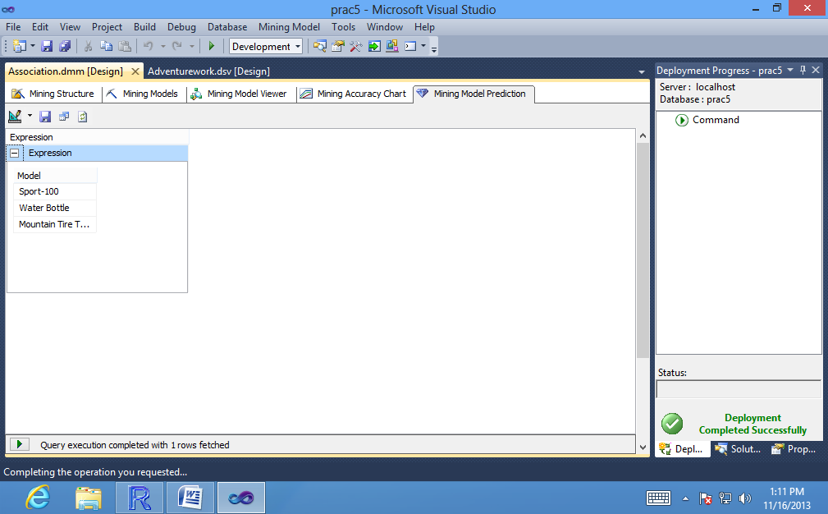

**To create a singleton prediction query with nested table inputs:**

1. Click the **Design** button in the corner of the **Prediction Query Builder** to switch back to the query building grid.
2. On the **Mining Model** menu, select **Singleton Query**.

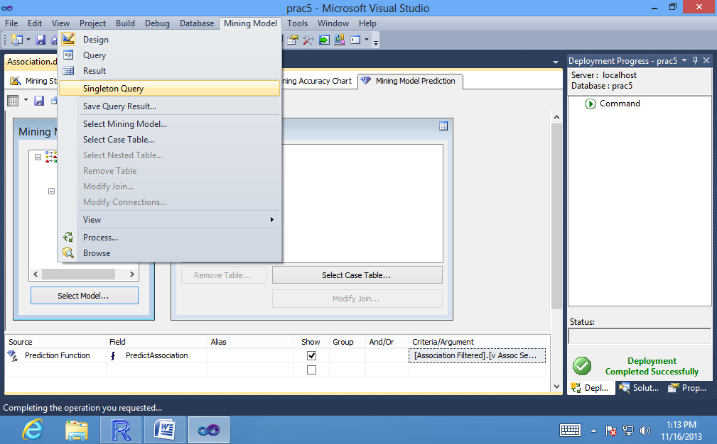

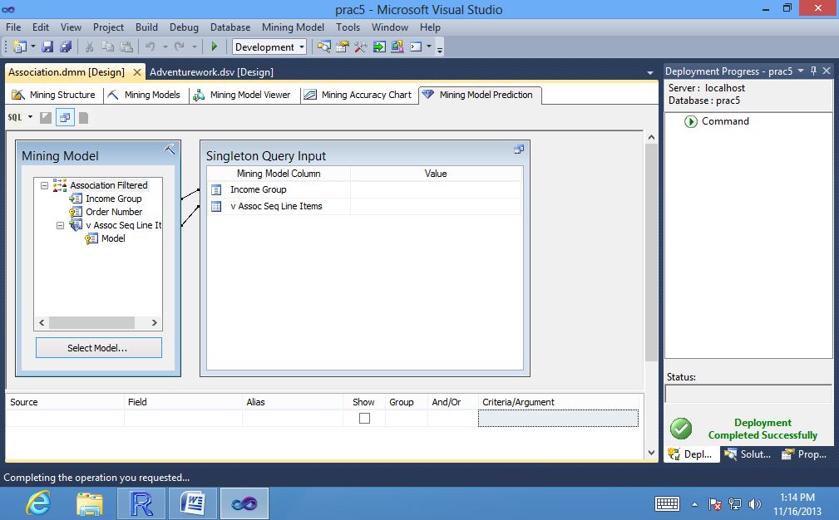

1. In the **Mining Model** dialog box, select the **Association model**.

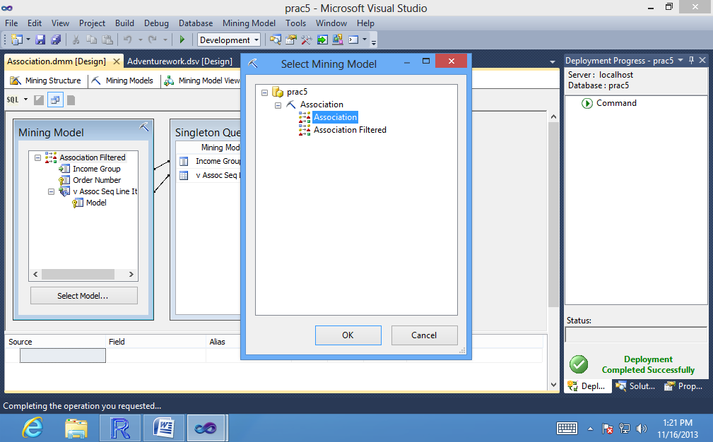

4. In the grid, click the empty cell under **Source** and select **Prediction Function**. In the cell under **Field**, select **PredictAssociation**.

5. In the **Mining Model** pane, select the nested table **vAssocSeqLineItems**,

and drag it into the grid, to the **Criteria/Argument box** for the **PredictAssociation**

function. **Type ,3** after the nested table name just as in the previous procedure.

6.In the **Singleton Query Input** dialog box, click the **Value** box next to **vAssocSeqLine Items**, and then **click the (...) button.**

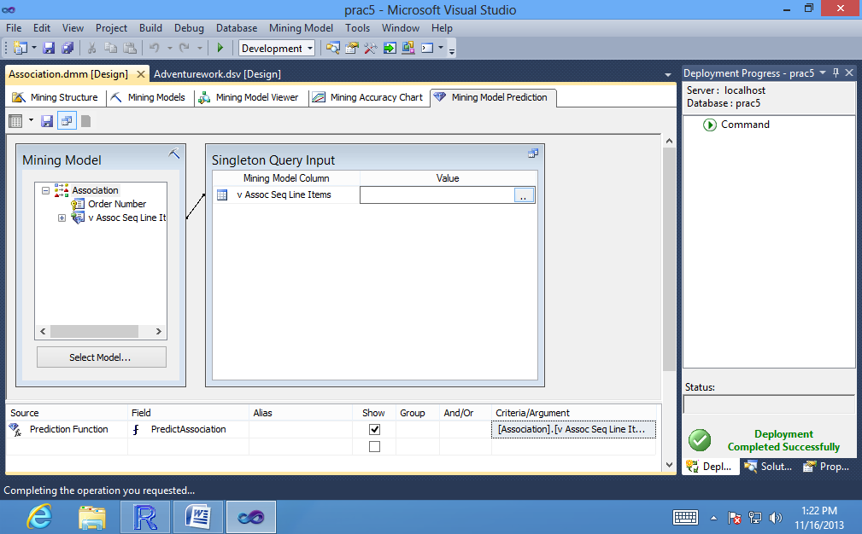

1. In the **Nested Table Input** dialog box, select **Touring Tire** in the **Key** column pane, and then click **Add.**

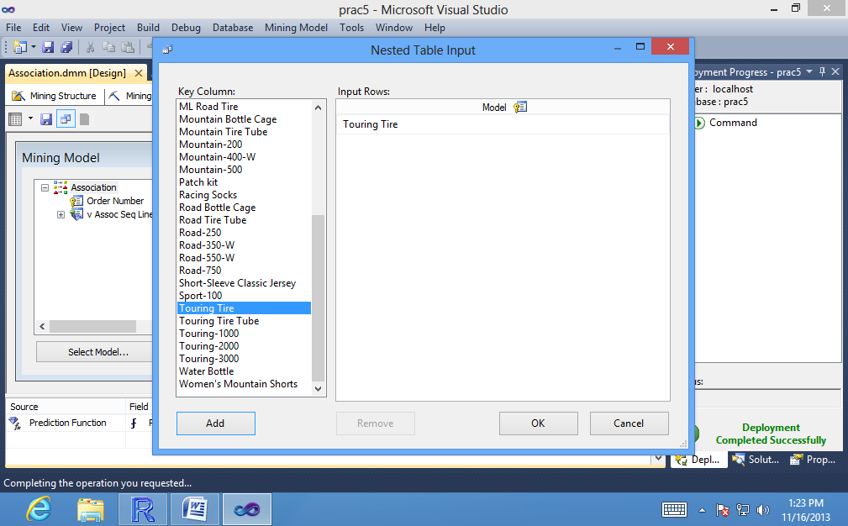

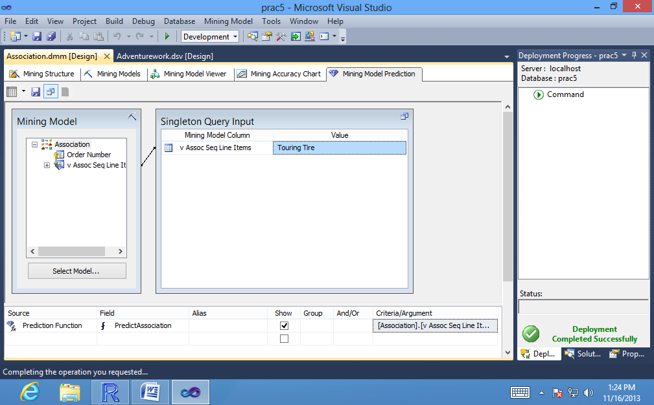

1. Click the **Results** button.

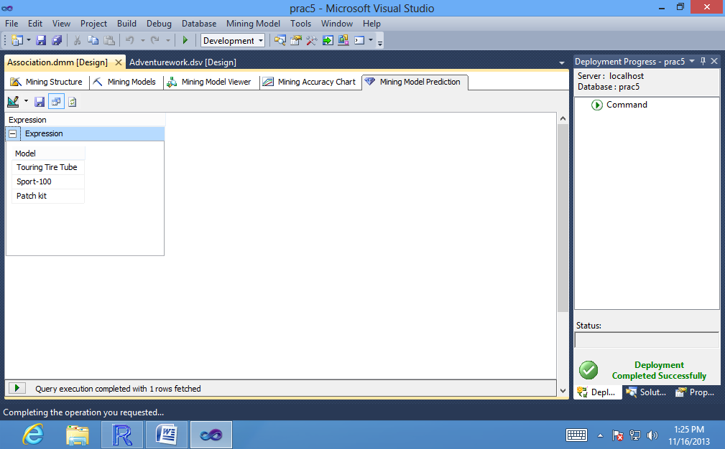

**To add inputs and probabilities to the singleton prediction query:**

1. Click the **Design** button in the corner of the **Prediction Query Builder** to switch back to the query building grid.

2. In the **Singleton Query Input** dialog box, click the **Value** box next to **vAssocSeqLine Items**, and then click the **(...)** button.

3. In the **Key** column pane, select **Touring Tire**, and then click **Add**.

4. In the grid, click the empty cell under **Source** and select **Prediction Function**. In the cell under **Field,** select **PredictAssociation**.

5. In the **Mining Model** pane, select the nested table **vAssocSeqLineItems**, and drag it into the grid, to the **Criteria/Argument box** for the **PredictAssociation** function. **Type ,3** after the nested table name just as in the previous procedure.

6. In the **Nested Table Input** dialog box, select **Touring Tire Tube** in the **Key** column pane, and then click **Add.**

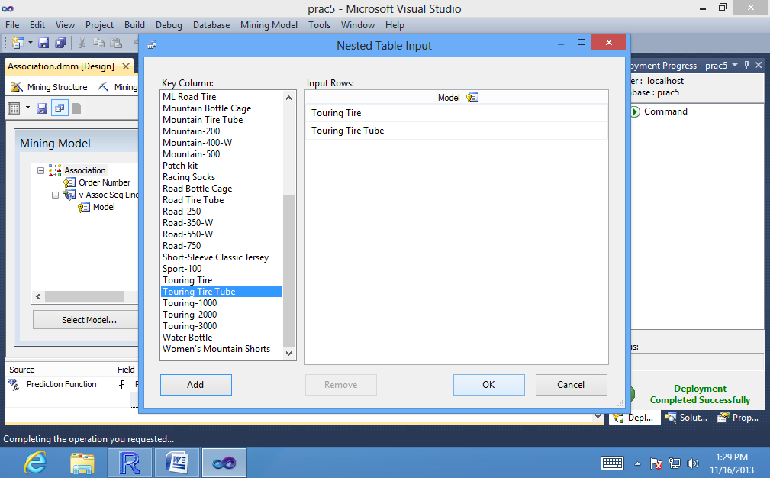

7. In the grid, in the row for the **PredictAssociation** function, click the **Criteria/Argument box**, and change the arguments to add the argument, **INCLUDE_STATISTICS.**

The complete text in the Criteria/Argument box should be as follows:

**[Association].[v AssocSeq Line Items], INCLUDE_STATISTICS, 3**

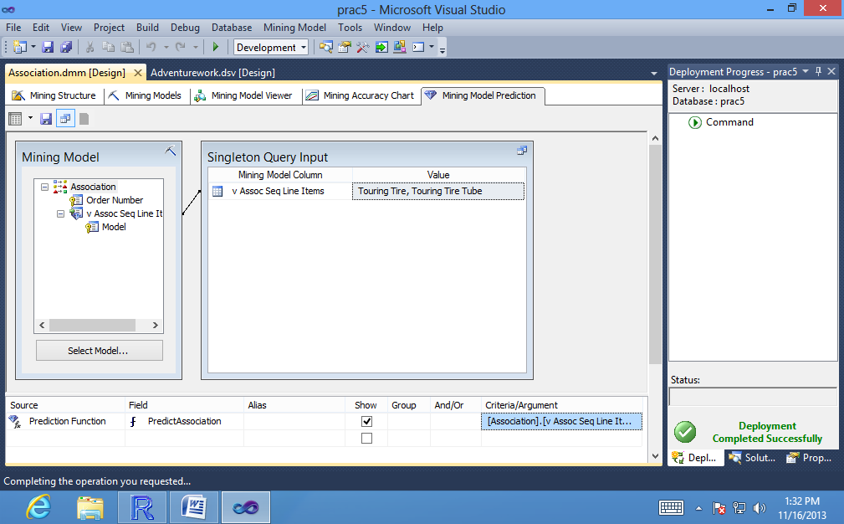

1. Click the **Results** button.

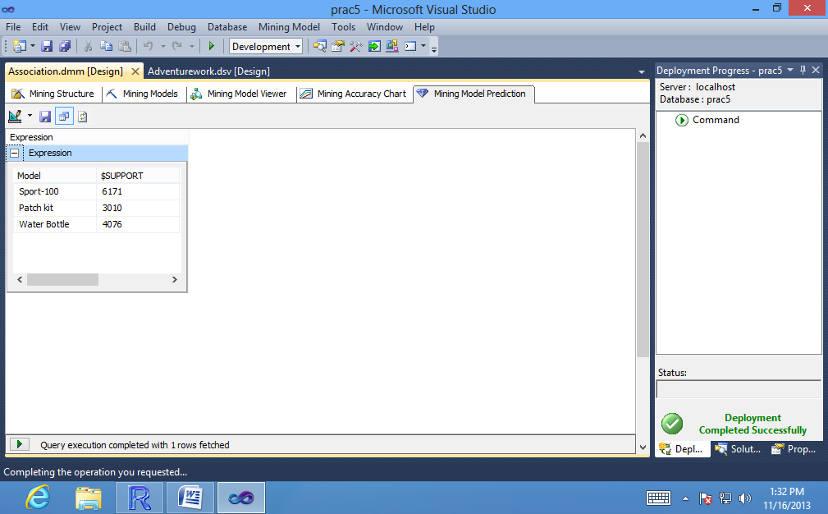

**To flatten nested rowsets in a prediction query:**

1. Click the **SQL button** in the corner of the **Prediction Query Builder**.

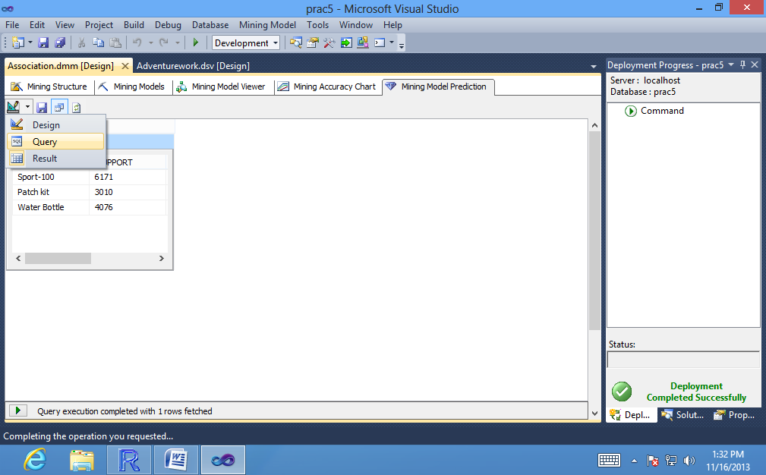

The grid changes to an open pane where you can view and modify the DMX

statement that was created by the **Prediction Query Builder**.

2. After the SELECT keyword, type **FLATTENED**.

The complete text of the query should be as follows:

**SELECT FLATTENED**

**PredictAssociation([Association].[v AssocSeq Line**

**Items],INCLUDE_STATISTICS,3)**

**FROM**

**[Association]**

**NATURAL PREDICTION JOIN**

**(SELECT (SELECT 'Touring Tire' AS [Model]**

**UNION SELECT 'Touring Tire Tube' AS [Model]) AS [v Assoc**

**Seq Line Items]) AS t**

1. Click the **Results** button in the upper corner of the Prediction Query Builder.

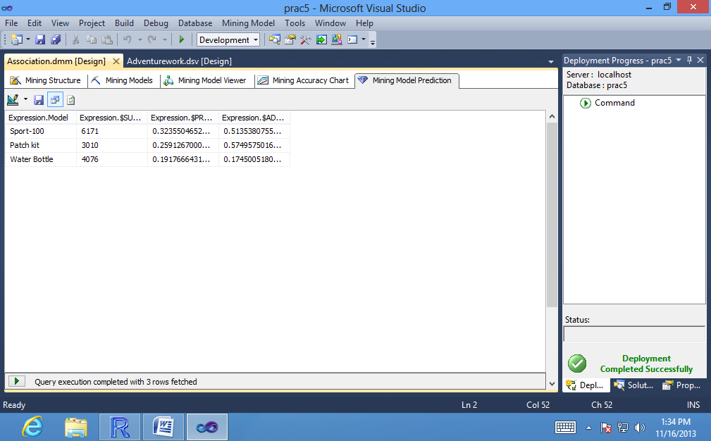

**To change the input method for the prediction query:**

1. In the **Mining Model** menu, select **Singleton Query** again, to clear the check mark.

2. An error message appears warning that your singleton query will be lost. **Click Yes.**

The name of the input dialog box changes to Select Input Table(s).

**To create a prediction query using nested table inputs:**

1. In the **Mining Model** pane, select the **Association Filtered model.**

2. In the **Select Input Table(s)** dialog box, click **Select Case Table**.

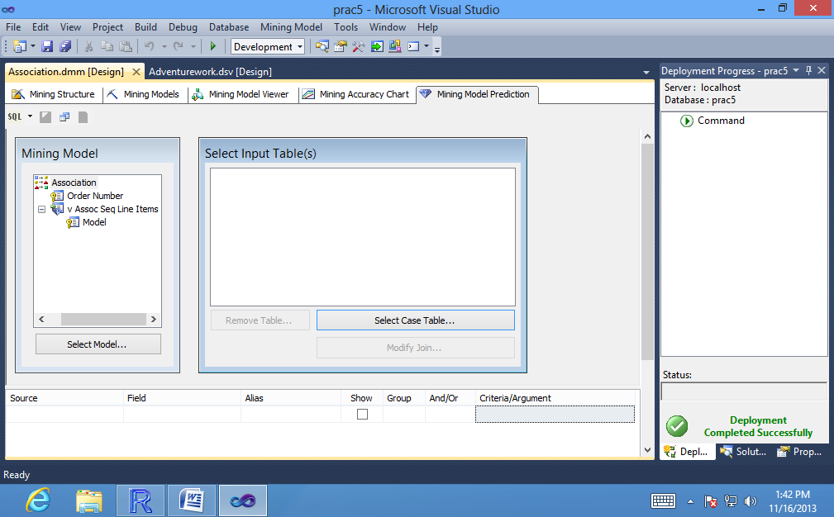

3. In the **Select Table dialog** box, for **Data Source**, select **AdventureWorksDW2008.**

In the **Table/View Name** list, select**vAssocSeqOrders**, and then click **OK.**

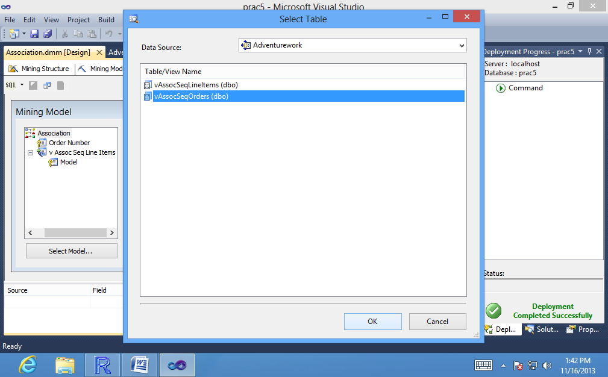

The table**vAssocSeqOrders**is added to the pane.

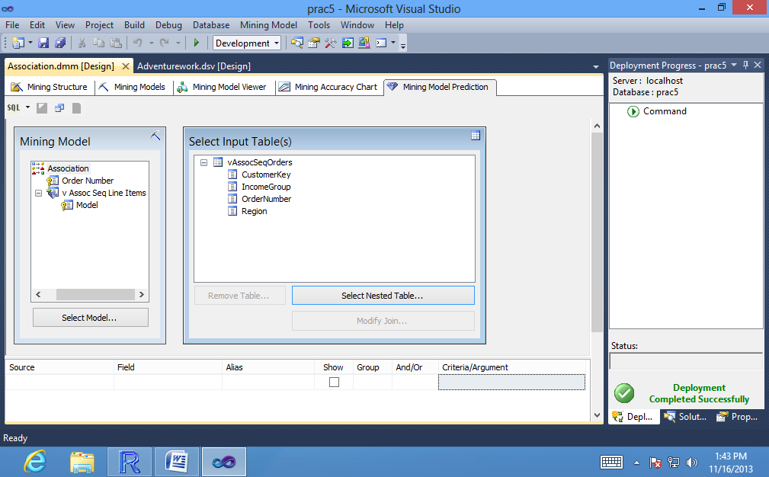

4. In the **Select Input Table(s)** dialog box, click **Select Nested Table**.

5. In the **Select Table dialog** box, for **Data Source,** select **AdventureWorksDW2008.**

In the **Table/View name** list, select **vAssocSeqLineItems**, and then click **OK.**

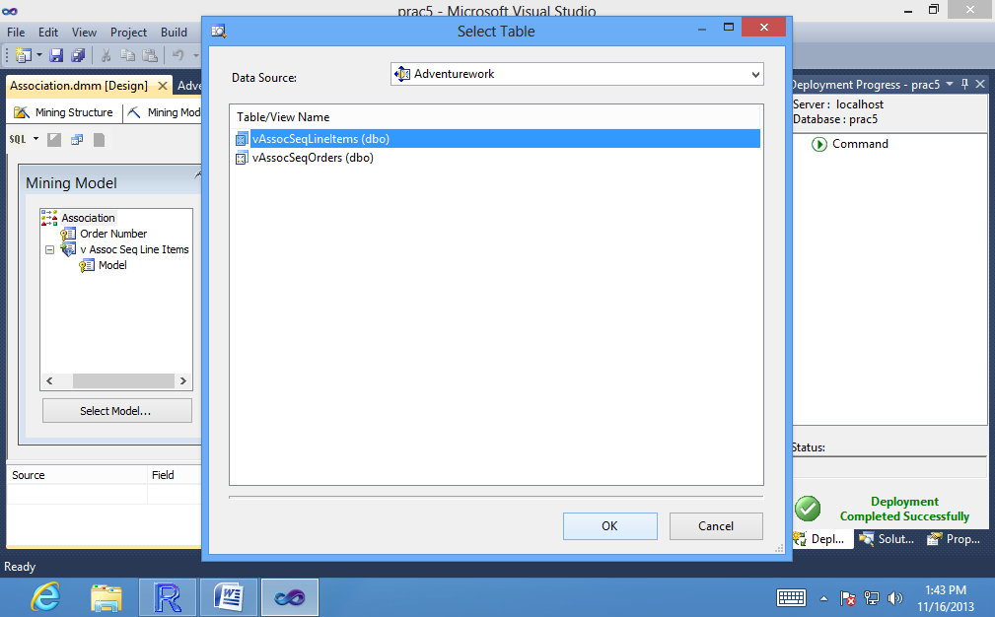

The table **vAssocSeqLineItems** is added to the pane.

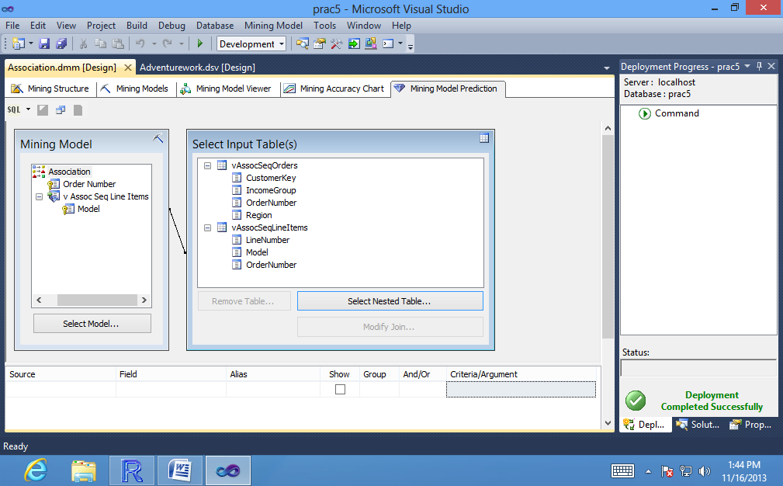

6. In the **Specify Nested Join dialog** box, drag the **OrderNumber** field from the case table and drop it onto the **OrderNumber** field in the nested table.

You can also click Add Relationship and create the relationship by selecting columns from a list.

7. In the **Specify Relationship dialog** box, verify that the **OrderNumber** fields are mapped correctly, and then click OK.

8. Click OK to close the Specify Nested Join dialog box.

The case and nested tables are updated in the design pane to show the joins connecting the external data columns to the columns in the model. If the relationships are wrong, you can right-click the join line and select Modify Connections to edit the column mapping, or you can right-click the join line and select Delete to remove the relationship completely.

9. **Add a new row** to the grid. **For Source**, select **vAssocSeqOrders table**. **For Field**, **select CustomerKey**.

10. Add a new row to the grid. For **Source**, **select vAssocSeqOrders table**.

**For Field**, select **Region.**

11. Add a new row to the grid. For **Source,** select **Prediction Function**, and **for Field**,select**PredictAssociation.**

12. Drag **vAssocSeqLineItems,** into the **Criteria/Argument box** of the **PredictAssociation** row. Click at the end of the Criteria/Argument box and then type the following text**: INCLUDE_STATISTICS,3**

The complete text in the Criteria/Argument box should be: **[Association].[vAssocSeq Line Items], INCLUDE_STATISTICS, 3**

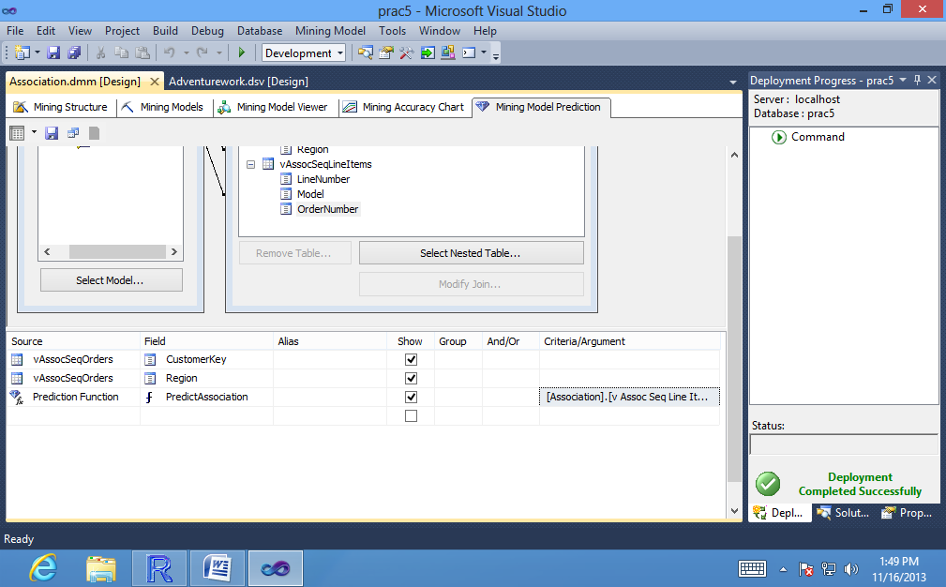

13. Click the **Result** button to view the predictions for each customer.

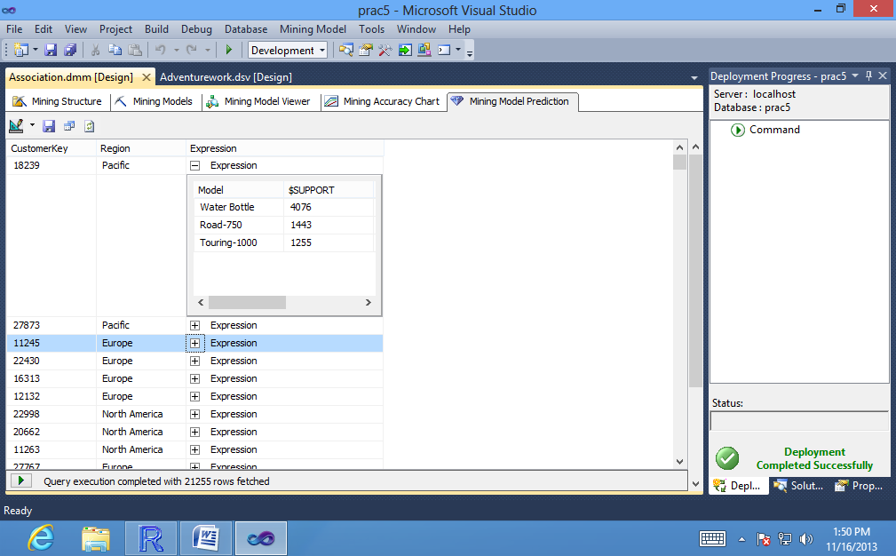

**Conclusion:** Thus, we have implemented the association algorithm successfully.

**Practical no : 6**

**Aim: Consider any suitable data for text mining and implement the text mining technique using R Tool.**

# AccessingrdmTweets - double click on rdmTweets.RData and type:

>rdmTweets

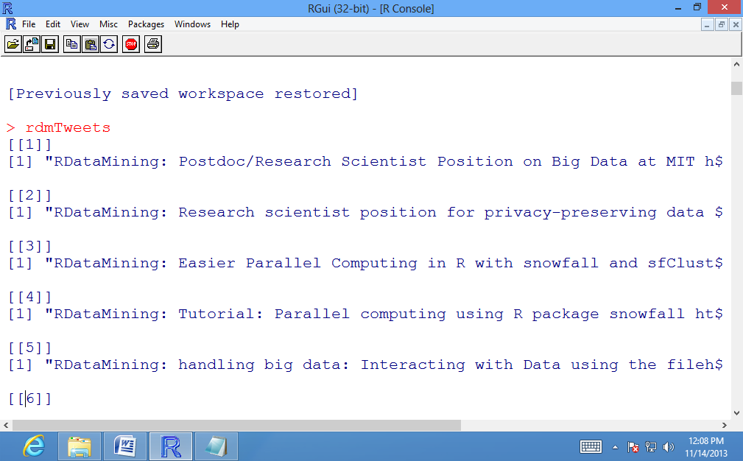

#Finding the number of documents in rdmTweet.RData:

> (nDocs<- length(rdmTweets))

[1] 154

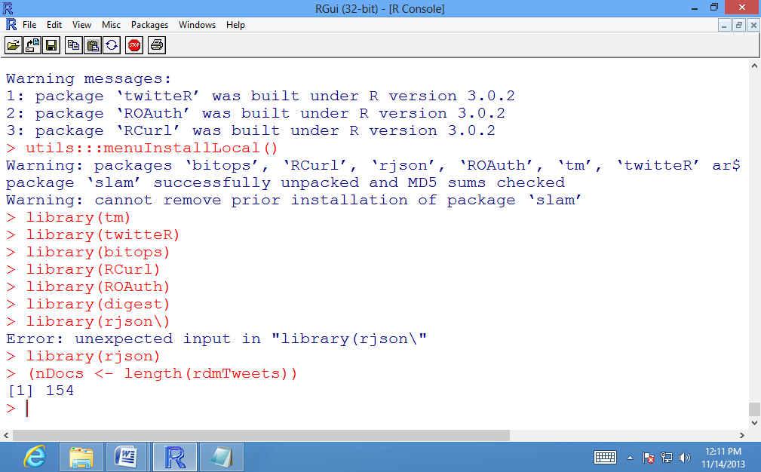

# Print any five tweets

>rdmTweets[5:10]

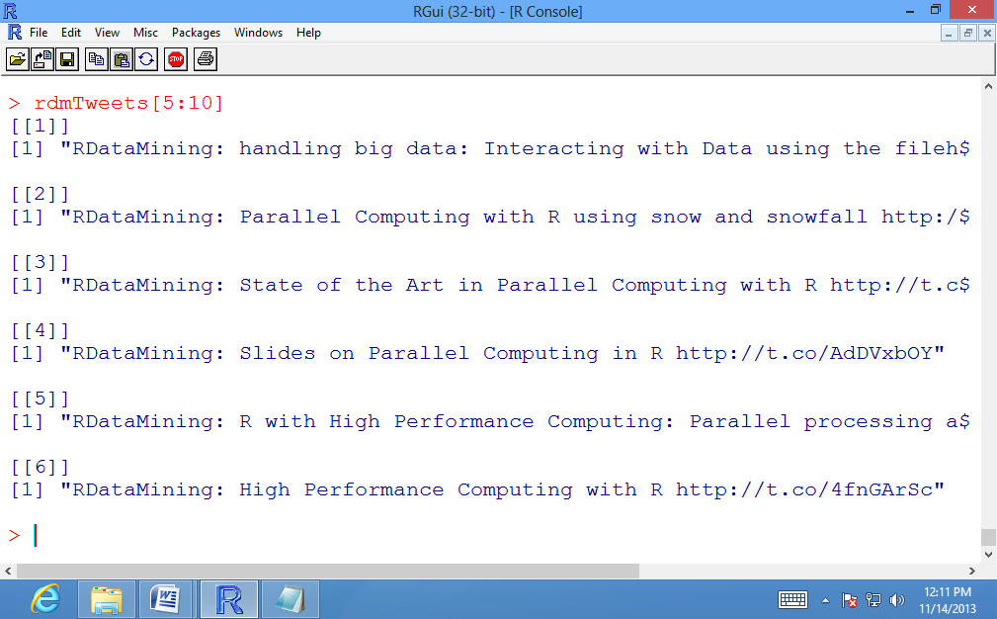

# Load Required Packages

>library(tm)

>library(twitteR)

>library(ROAuth)

>library(RCurl)

>library(bitops)

>library(digest)

>library(rjson)

>library(twitteR)

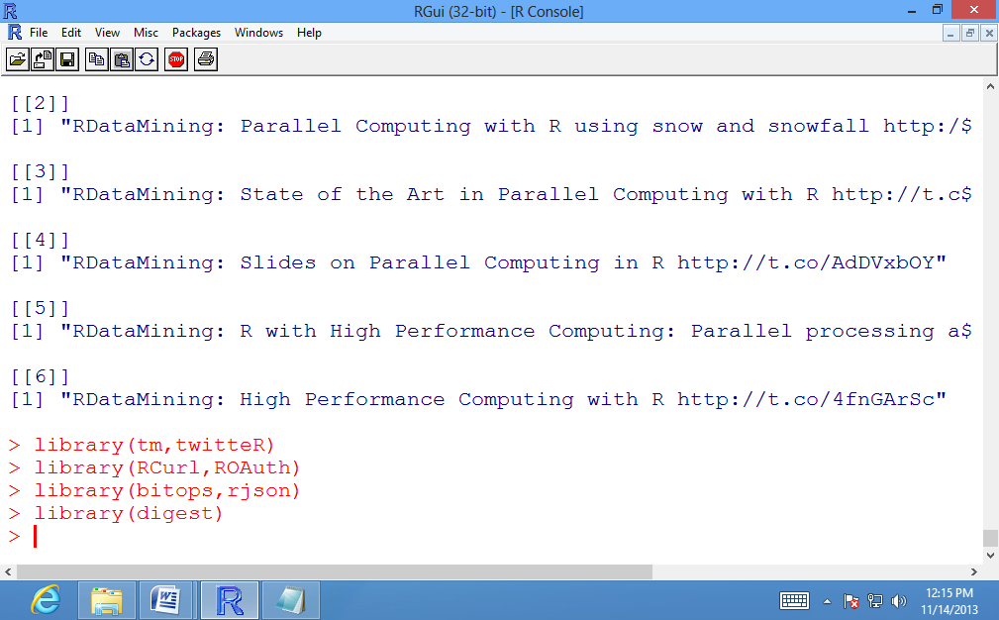

# Transforming Tweets to a dataframe

df<- do.call("rbind", lapply(rdmTweets, as.data.frame))

or

tweets.df<- twListToDF(rdmTweets)

# Verify the contents of df

>dim(df)

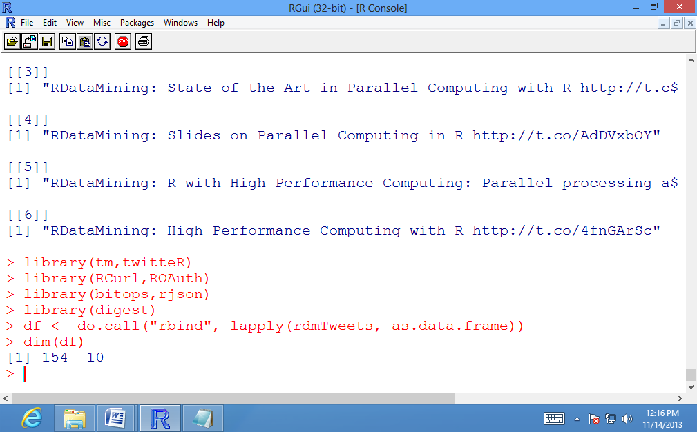

# build a corpus, and specify the source to be character vectors

>myCorpus<- Corpus(VectorSource(df$text))

# Verify the contents of myCorpus

>myCorpus

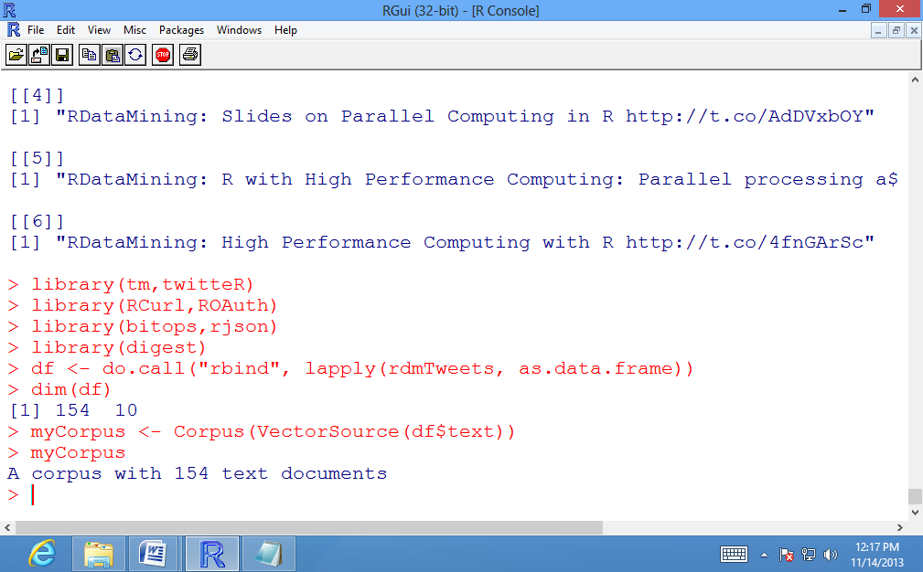

# Apply Transformations to convert to lower case

>myCorpus<- tm_map(myCorpus, tolower)

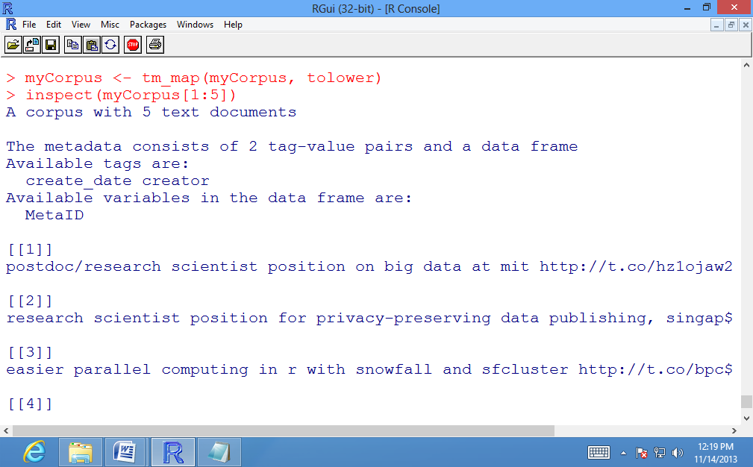

# Apply Transformations to remove punctuation

>myCorpus<- tm_map(myCorpus, removePunctuation)

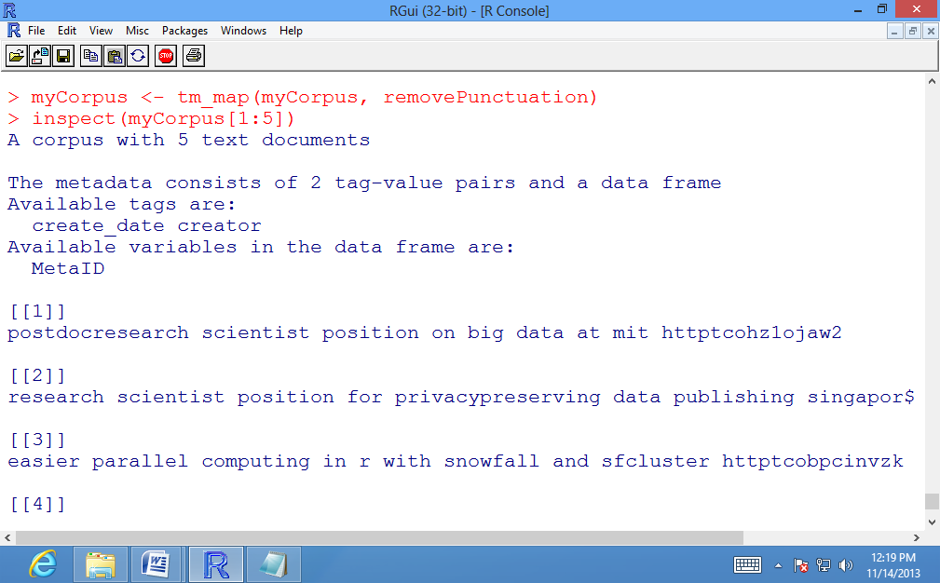

# Apply Transformations to remove numbers

>myCorpus<- tm_map(myCorpus, removeNumbers)

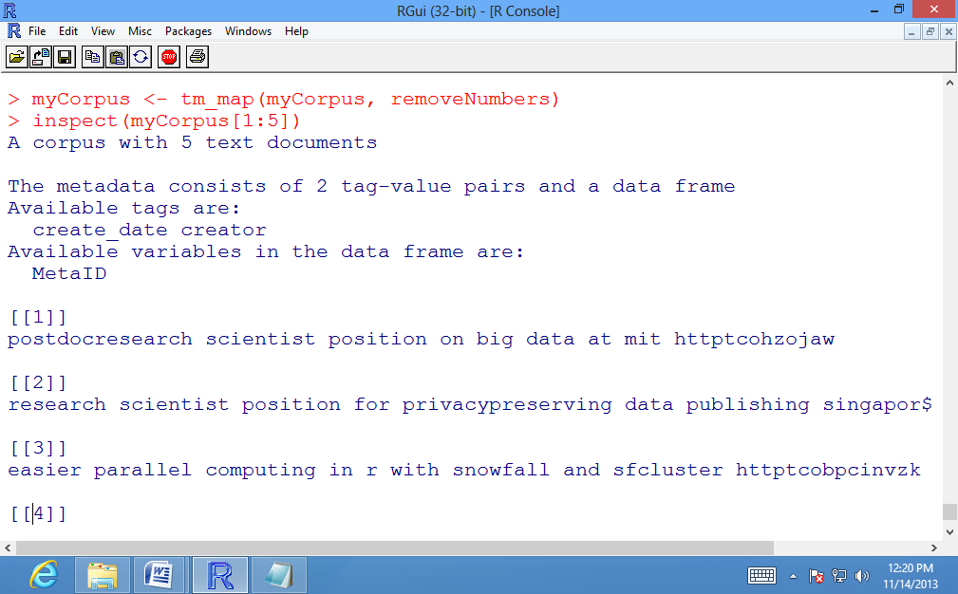

# keep a copy of corpus to use later as a dictionary for stem completion

>mycopyCorpus<- myCorpus

# Apply transformation to stem words

>myCorpus<- tm_map(myCorpus, stemDocument)

# Verify the results of Stemming Transformation on first five documents

>inspect(myCorpus[1:5])

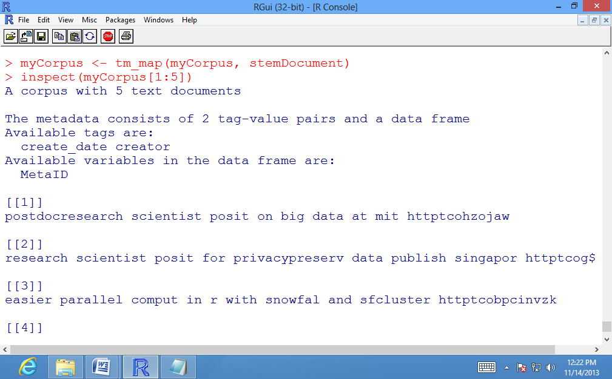

# Apply Transformation for stem completion

>myCorpus<- tm_map(myCorpus, stemCompletion, dictionary=mycopyCorpus)

# Verify the results of Stemming completion on first five documents

>inspect(myCorpus[1:5])

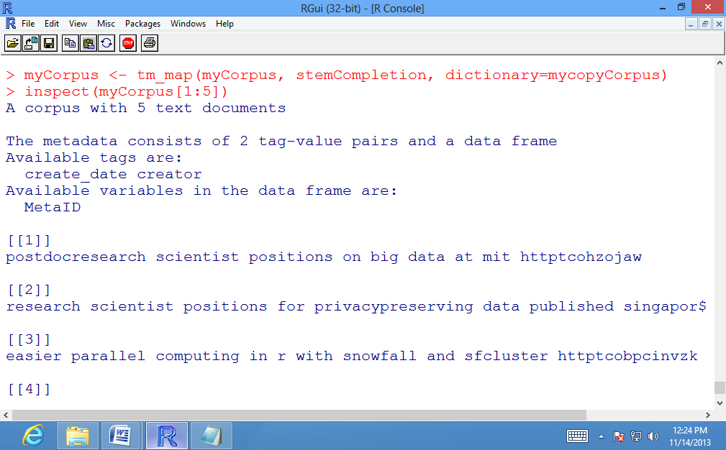

# Counting the frequency of the term "computing"

>computingCases<- tm_map(myCorpus, grep, pattern="\\<computing")

# Printing the frequency of the term "mining"

>sum(unlist(computingCases))

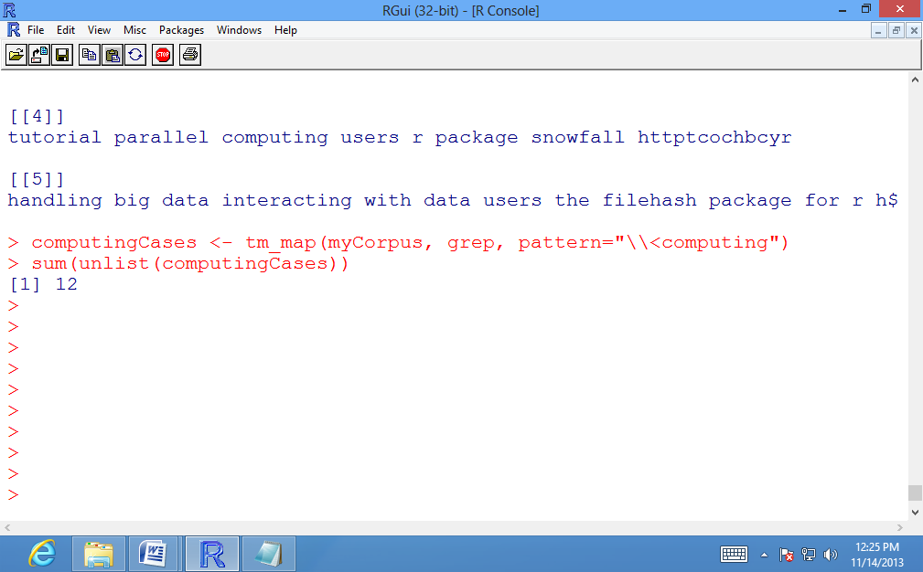

# Counting the frequency of the term "parallel"

>parallelCases<- tm_map(myCorpus, grep, pattern="\\<parallel")

# Printing the frequency of the term "parallel"

>sum(unlist(parallelCases))

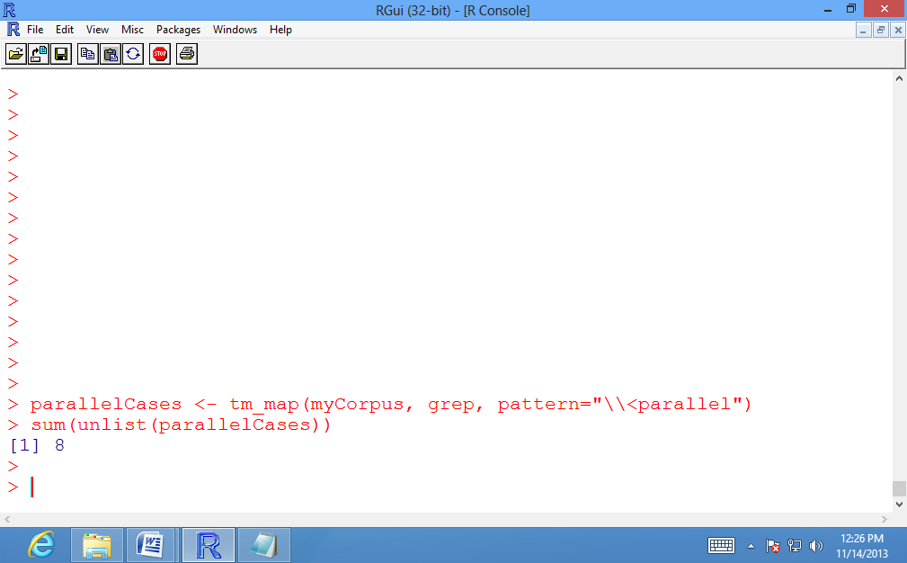

Building a Term-Document Matrix:

A term-document matrix represents the relationship between terms and documents, where each row stands for a term and each column for a document, and an entry is the number of occurrences of the term in the document.

myTdm<- TermDocumentMatrix(myCorpus, control=list(wordLengths=c(1,Inf)))

# Verifying the contents of Term-Document Matrix

>myTdm

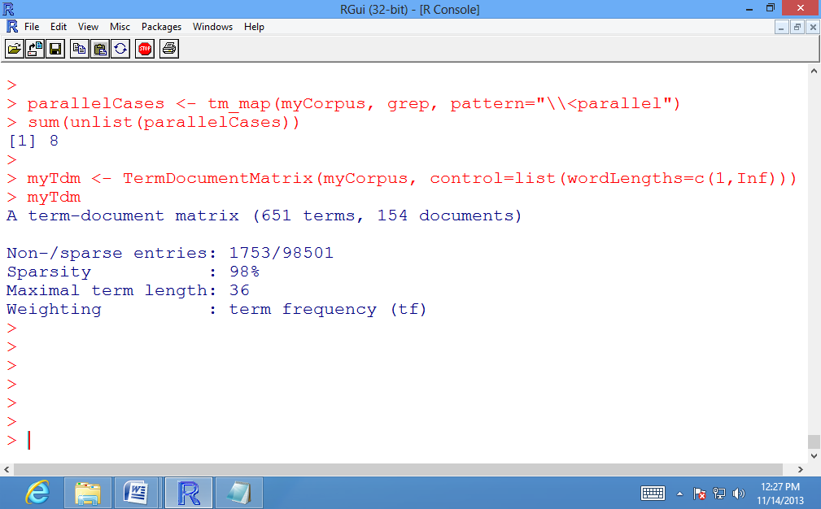

# Storing the first six terms starting with \r" and tweets numbered 101 to 110.

>idx<- which(dimnames(myTdm)$Terms == "r")

# Inspecting the first six terms starting with \r" and tweets numbered 101 to 110.

>inspect(myTdm[idx+(0:5),101:110])

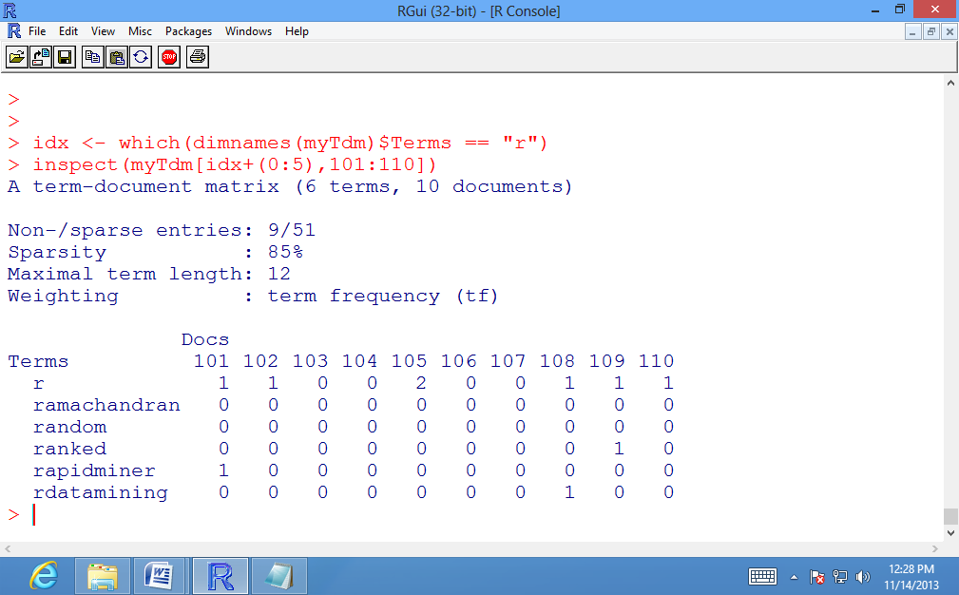

Finding Associations in Frequent terms:

# Finds frequent terms with frequency no less than ten.

>findFreqTerms(myTdm, lowfreq=10)

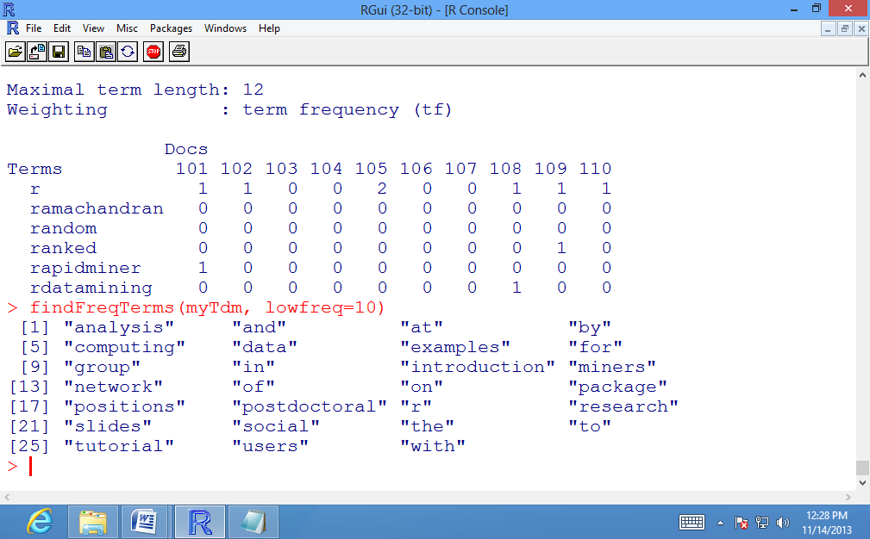

>termFrequency<- rowSums(as.matrix(myTdm))

>termFrequency<- subset(termFrequency, termFrequency>=10)

>termFrequency

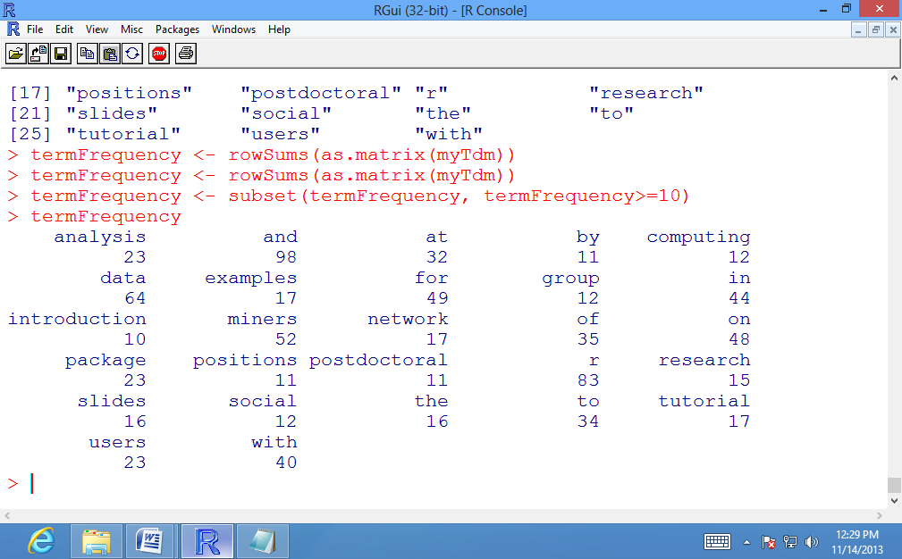

# which words are associated with "r"?

findAssocs(myTdm, 'r', 0.25)

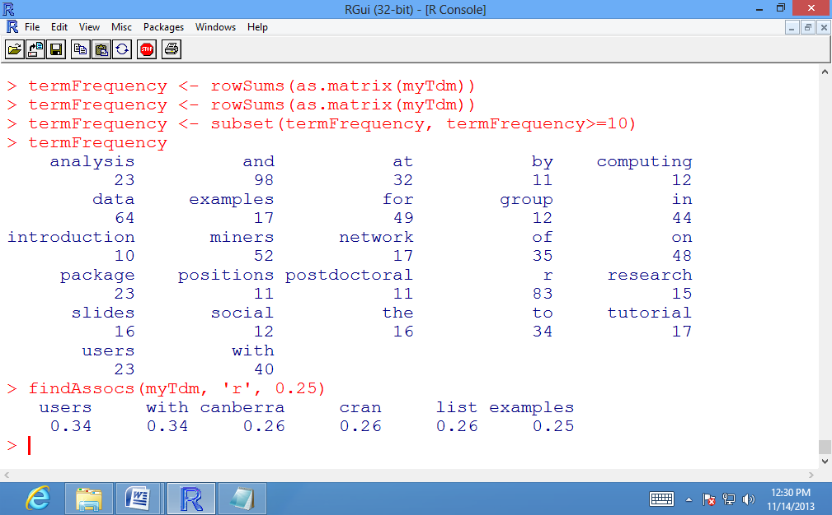

# which words are associated with "the"?

>findAssocs(myTdm, 'the', 0.25)

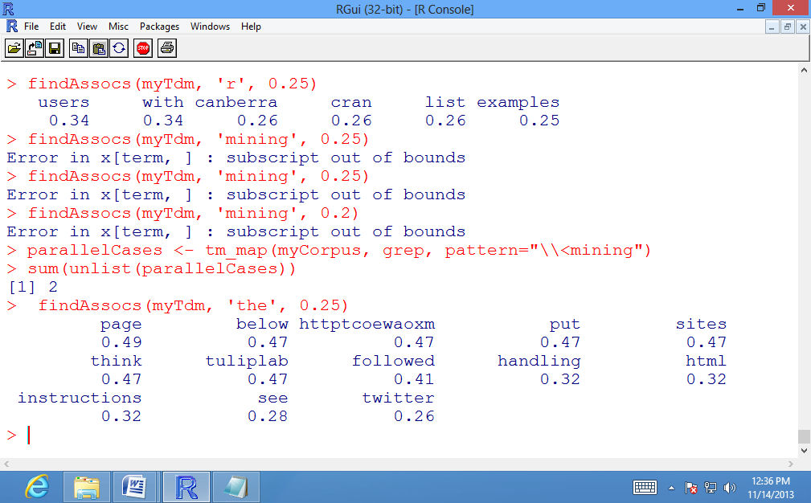

**Conclusion:** Using R-tool, we have thus implemented the text mining technique successfully.

**Practical No: 7**

**Aim: Using R-Tool, show the analysis for social networking sites.**

termDocMatrix[5:10,1:20]

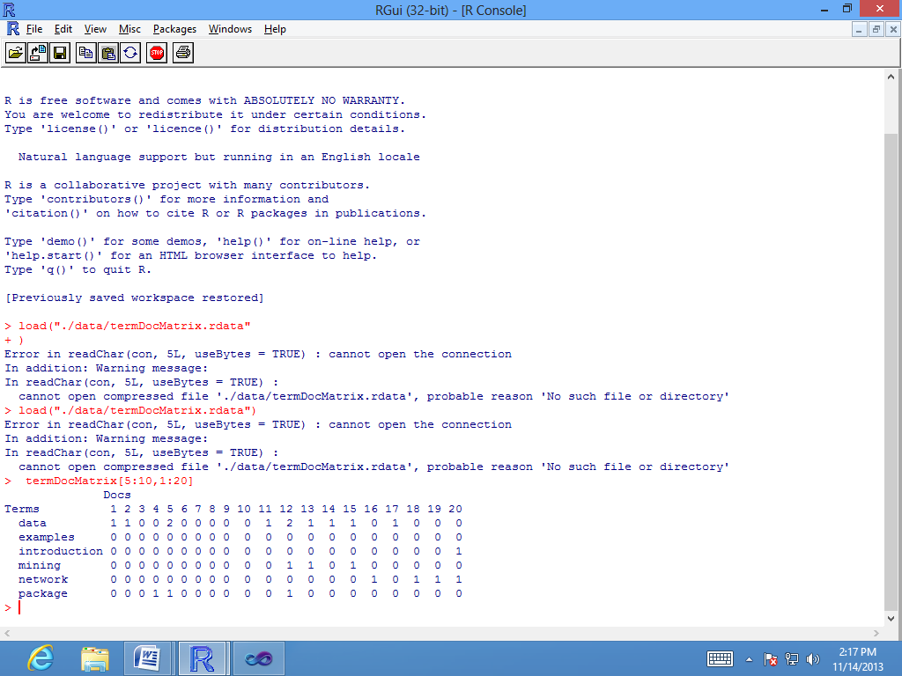

#change it to a Boolean matrix

>termDocMatrix[termDocMatrix>=1] <- 1

#transform into a term-term adjacency matrix

>termMatrix<- termDocMatrix %*% t(termDocMatrix)

#inspect terms numbered 5 to 10

>termMatrix[5:10,5:10]

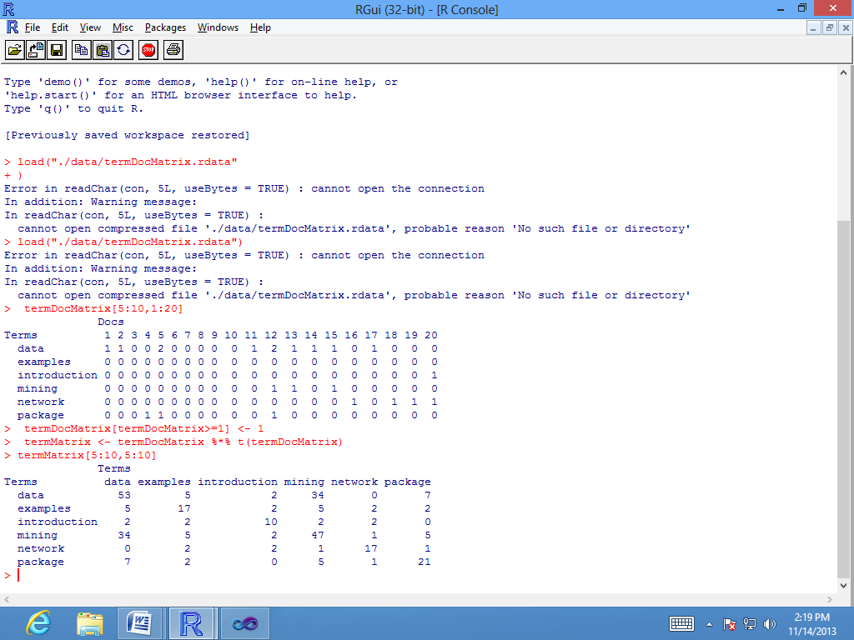

>library(igraph)

# build a graph from the above matrix

> g <- graph.adjacency(termMatrix, weighted=T, mode="undirected")

> # remove loops

> g <- simplify(g)

> # set labels and degrees of vertices

>V(g)$label <- V(g)$name

>V(g)$degree <- degree(g)

> # set seed to make the layout reproducible

>set.seed(3952)

> layout1 <- layout.fruchterman.reingold(g)

>plot(g, layout=layout1)

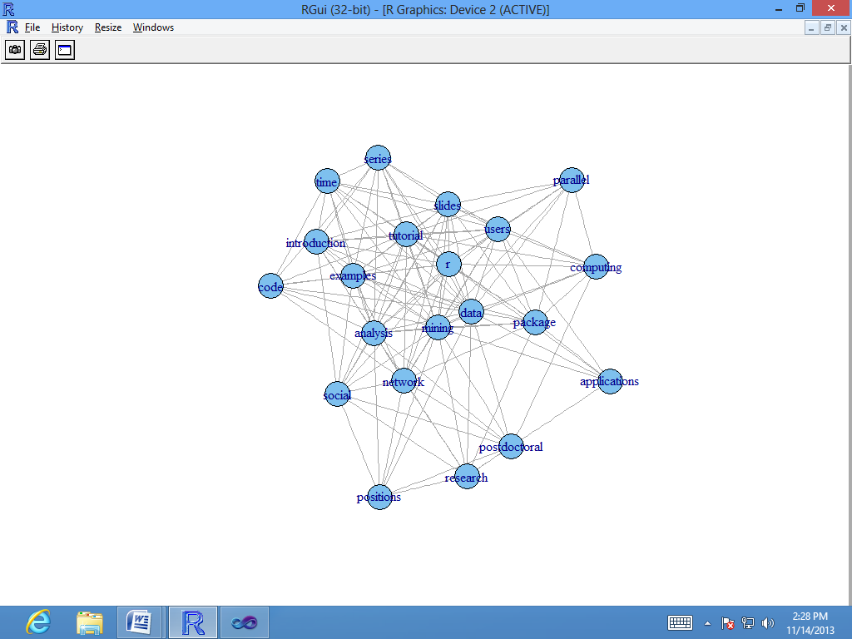

**Conclusion:** Using R-tool, we have analyzed the social networking sites successfully.

**Practical No: 8**

**Aim: Using R-Tool, built the data mining model and implement the Apriori algorithm.**

>str(Titanic)

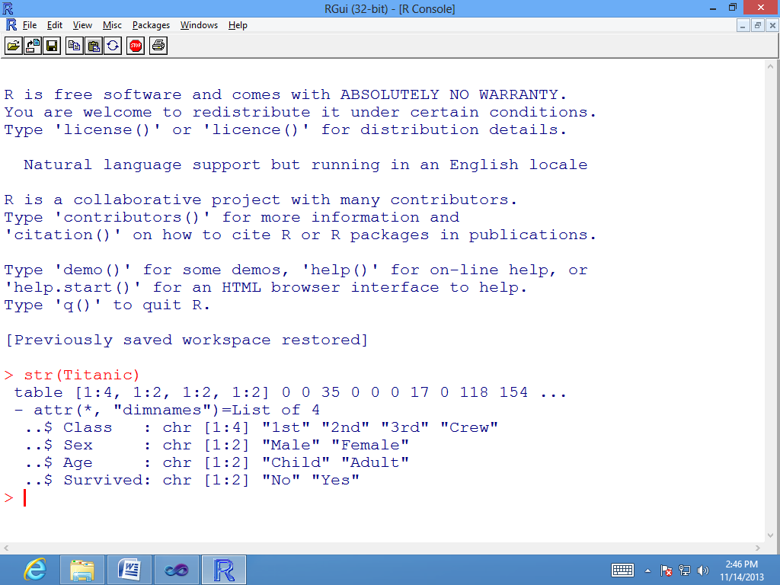

>df<- as.data.frame(Titanic)

>head(df)

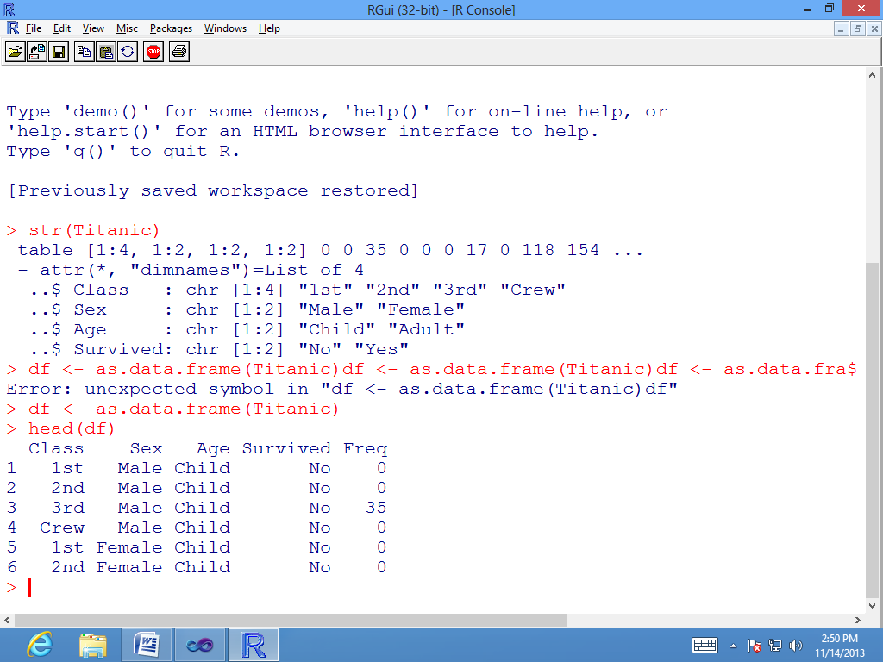

>titanic.raw<- NULL

> for(i in 1:4) { titanic.raw<- cbind(titanic.raw, rep(as.character(df[,i]), df$Freq)) }

>titanic.raw<- as.data.frame(titanic.raw)

>names(titanic.raw) <- names(df)[1:4]

>dim(titanic.raw)

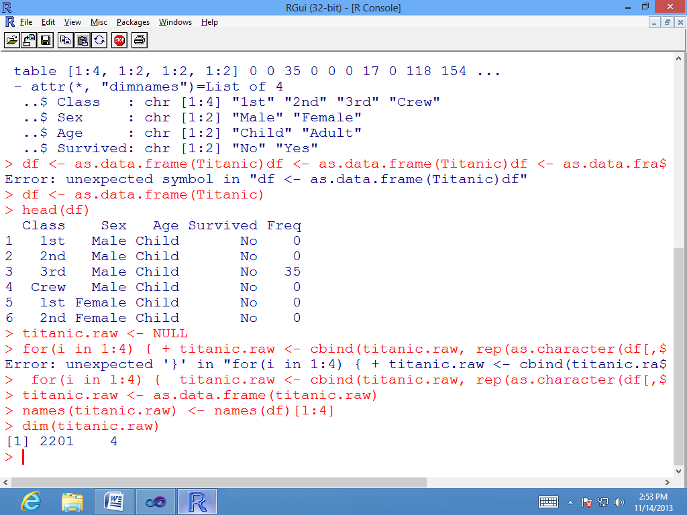

>str(titanic.raw)

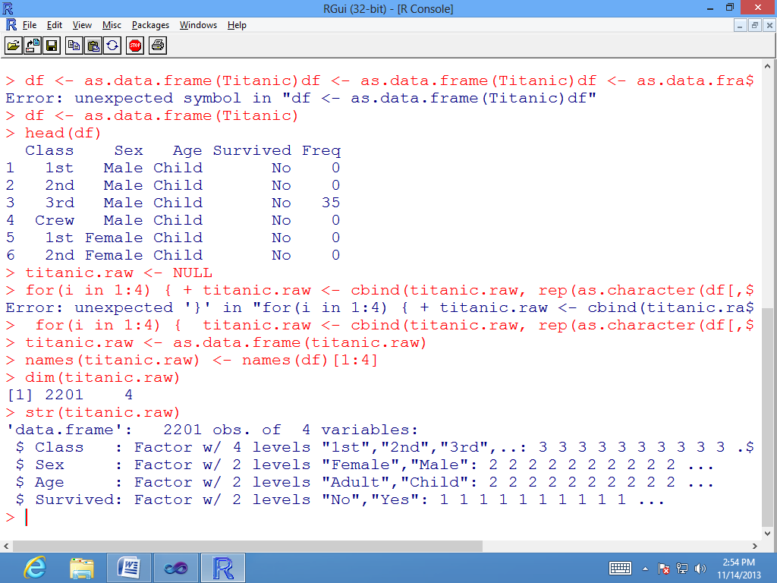

>head(titanic.raw)

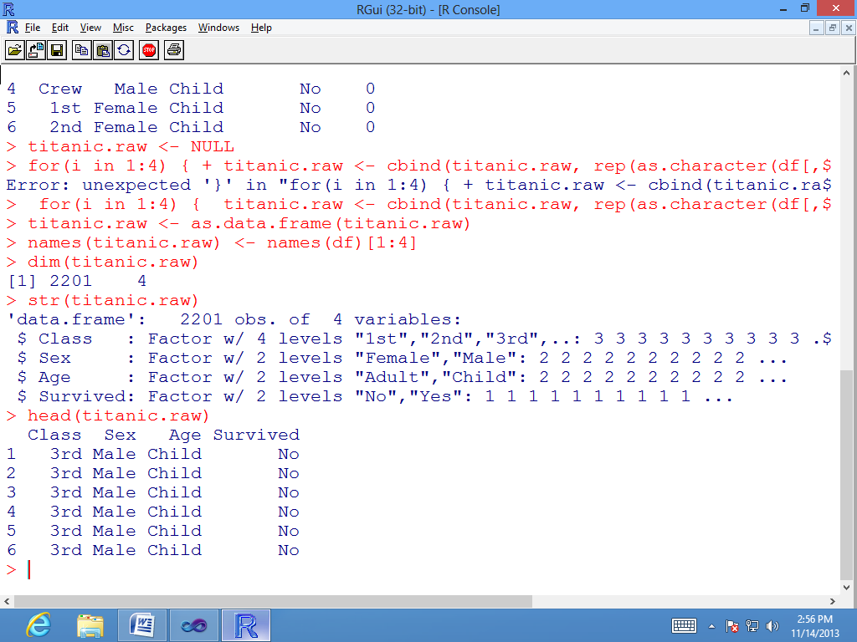

>summary(titanic.raw)

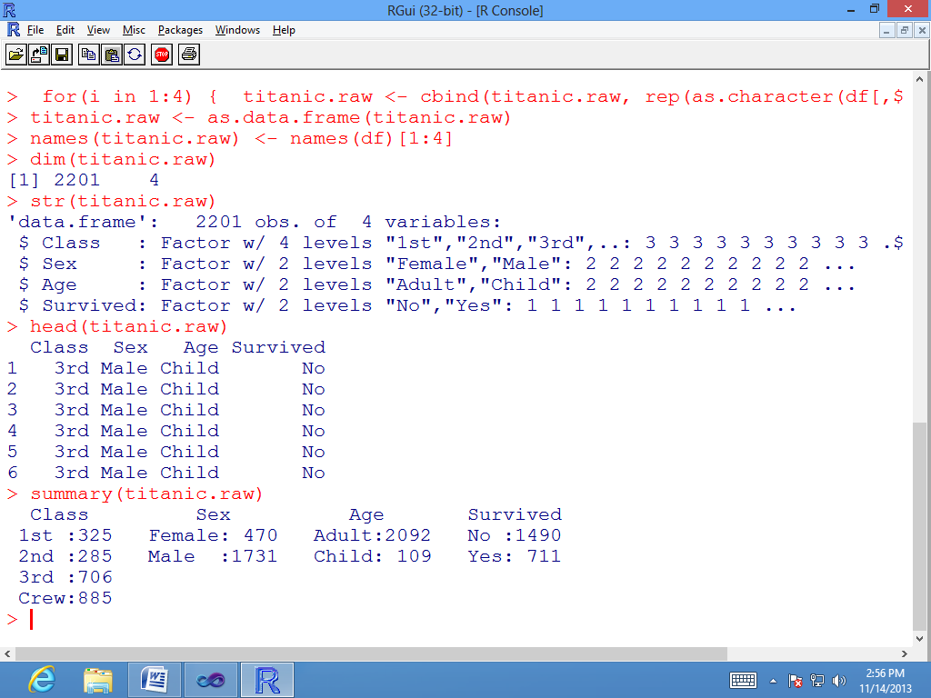

>library(arules)

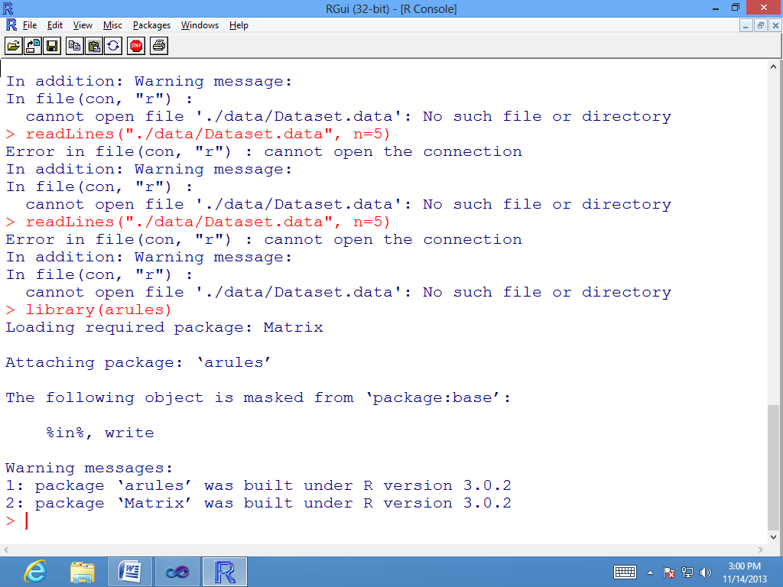

> # find association rules with default settings

>rules.all<- apriori(titanic.raw)

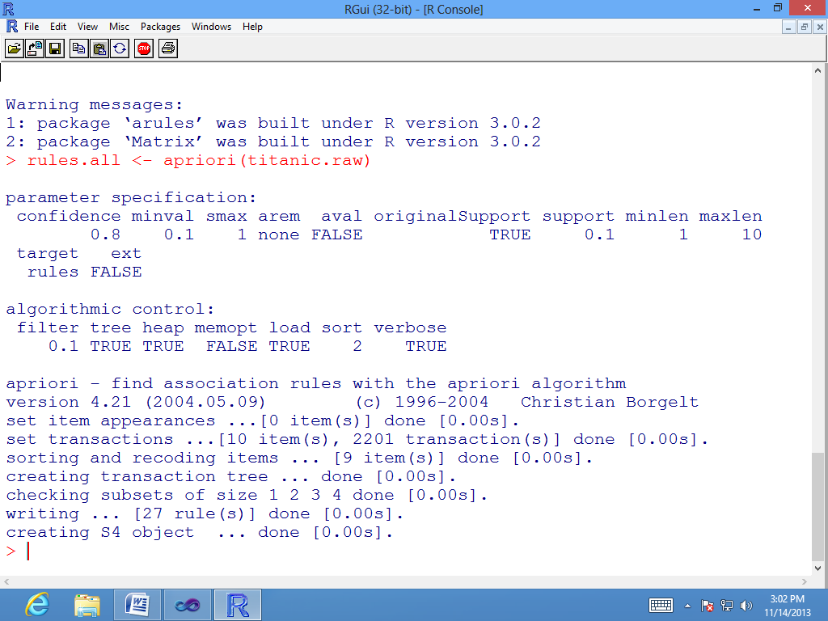

>rules.all

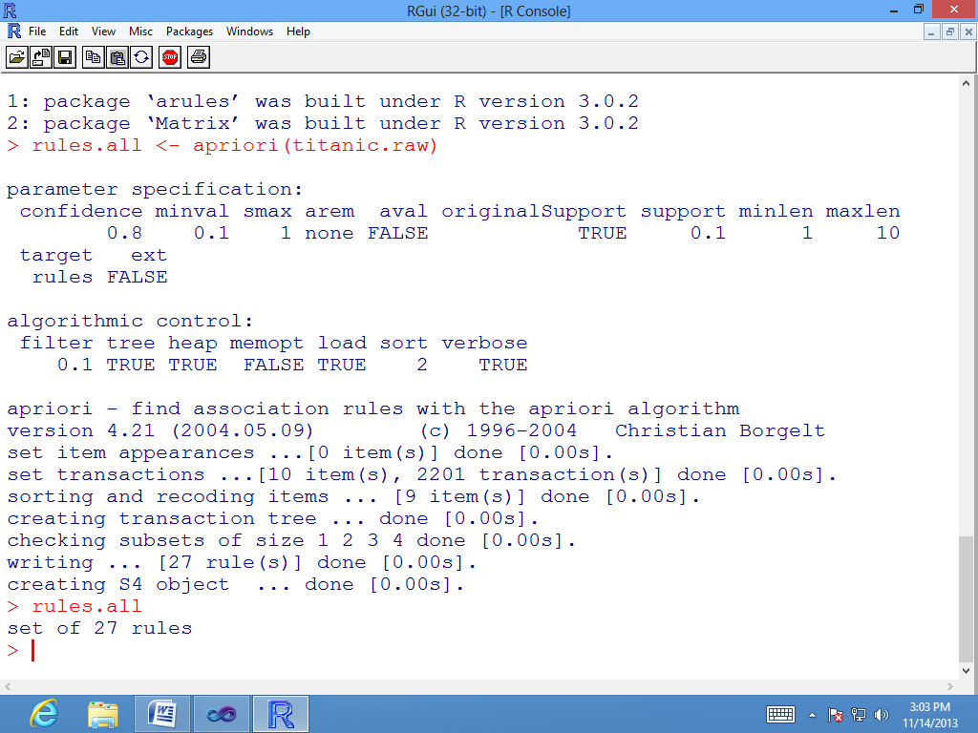

>inspect(rules.all)

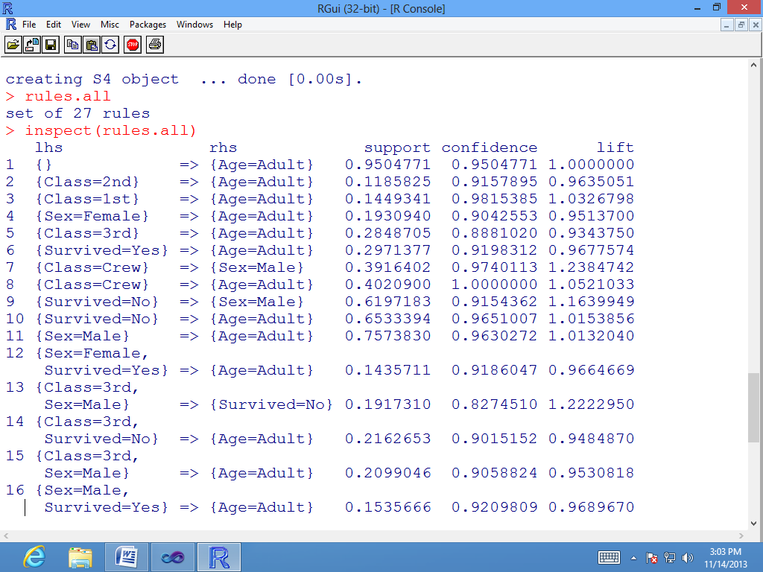

> # rules with rhs containing "Survived" only

>rules<- apriori(titanic.raw, control = list(verbose=F), parameter = list(minlen=2, supp=0.005, conf=0.8), appearance = list(rhs=c("Survived=No", "Survived=Yes"), default="lhs"))

>quality(rules) <- round(quality(rules), digits=3)

>rules.sorted<- sort(rules, by="lift")

>inspect(rules.sorted)

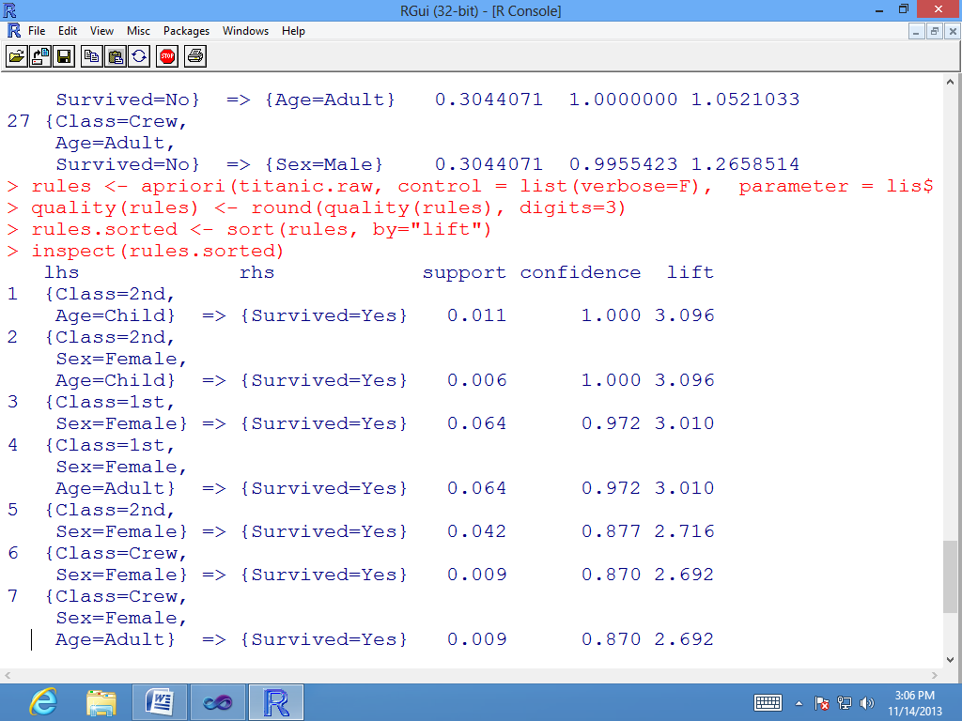

> # find redundant rules

>subset.matrix<- is.subset(rules.sorted, rules.sorted)

>subset.matrix[lower.tri(subset.matrix, diag=T)] <- NA

>redundant<- colSums(subset.matrix, na.rm=T) >= 1

>which(redundant)

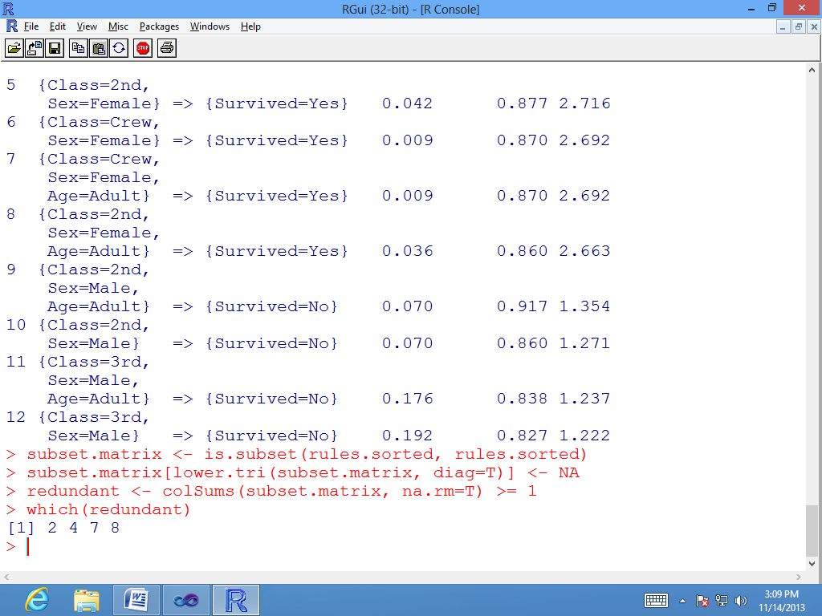

> # remove redundant rules

>rules.pruned<- rules.sorted[!redundant]

>inspect(rules.pruned)

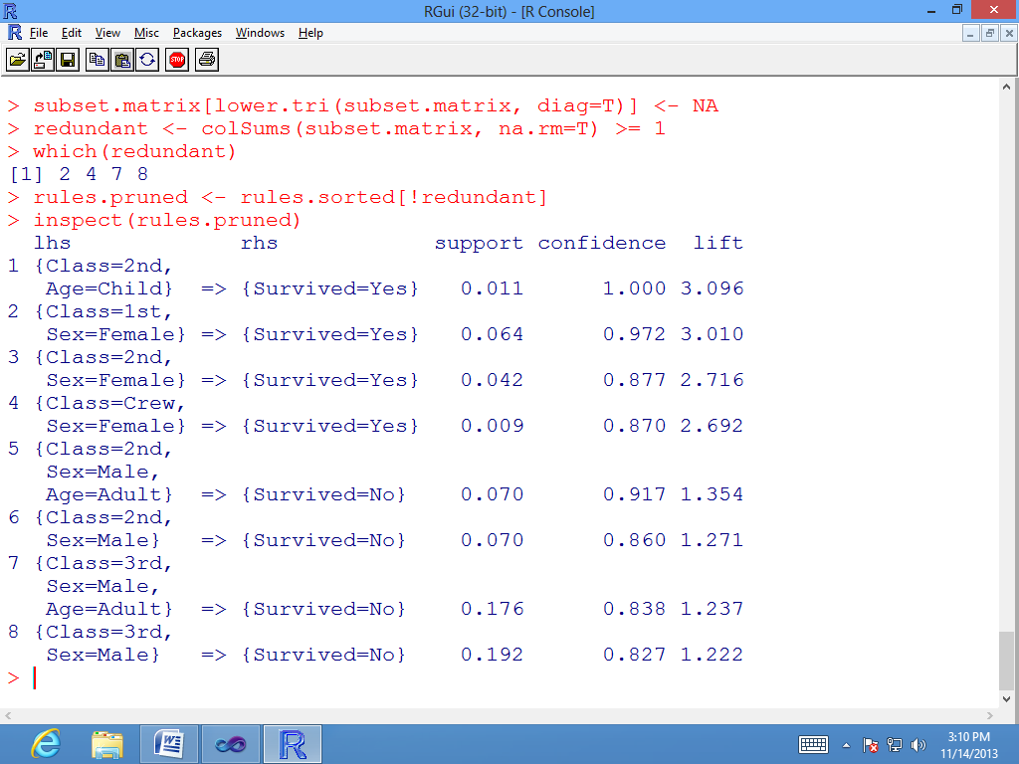

> rules <- apriori(titanic.raw, parameter = list(minlen=3, supp=0.002, conf=0.2), appearance = list(rhs=c("Survived=Yes"), lhs=c("Class=1st", "Class=2nd", "Class=3rd", "Age=Child", "Age=Adult"), default="none"), control = list(verbose=F))

>rules.sorted<- sort(rules, by="confidence")

>inspect(rules.sorted)

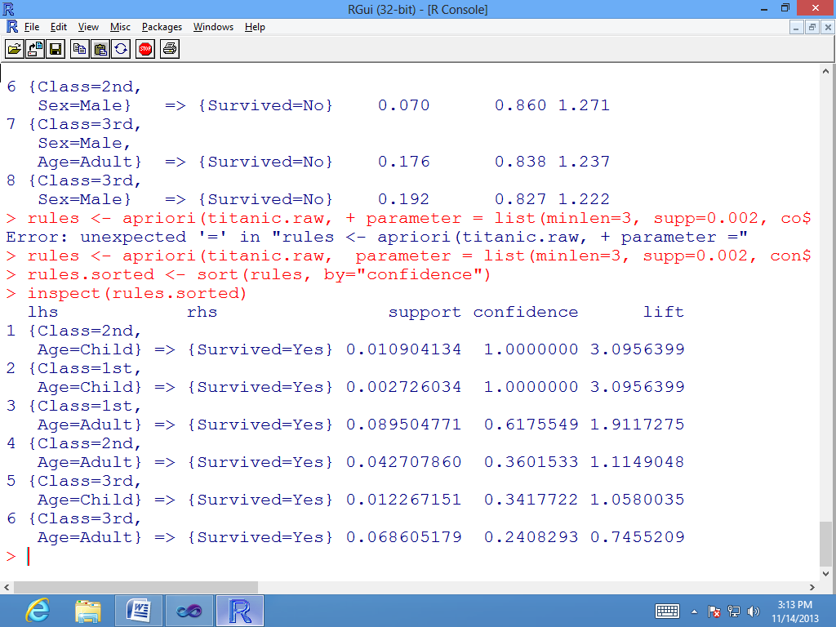

>library(arulesViz)

>plot(rules.all)

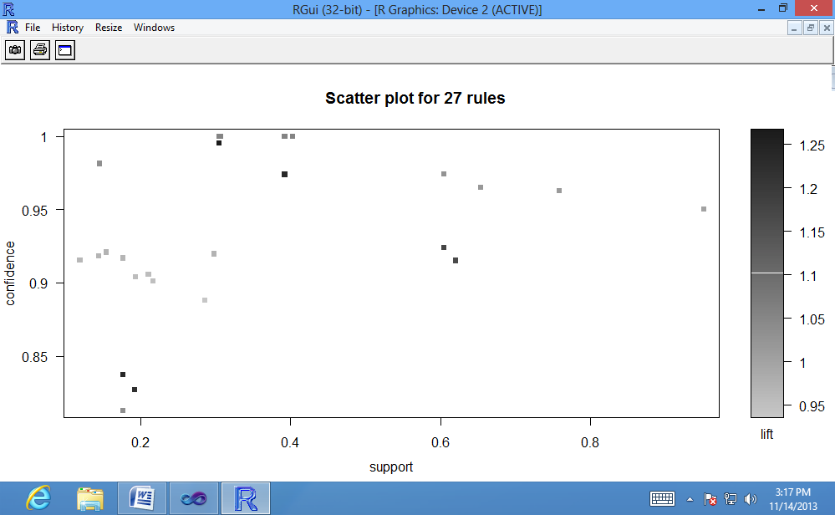

>plot(rules.all, method="grouped")

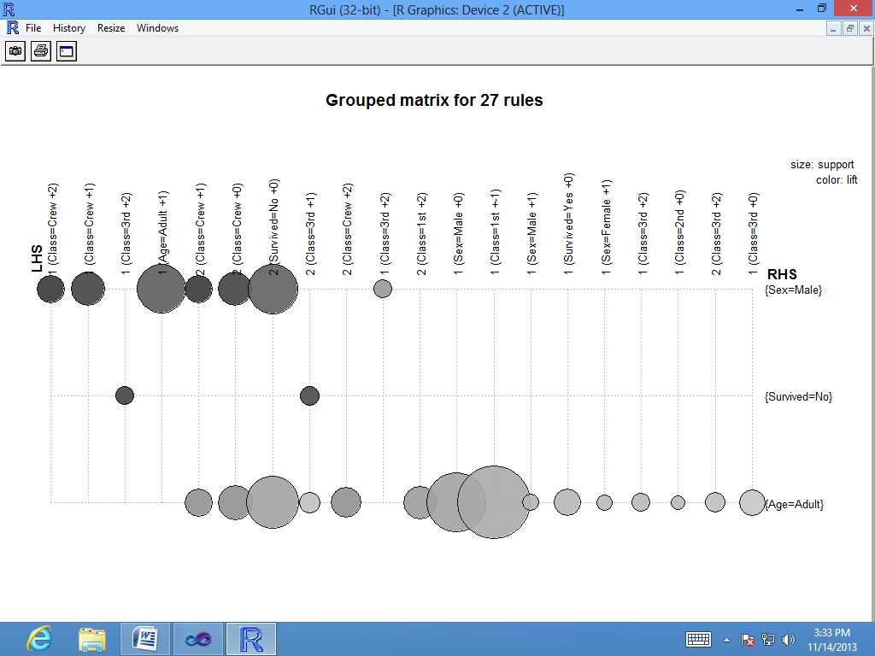

>plot(rules.all, method="graph")

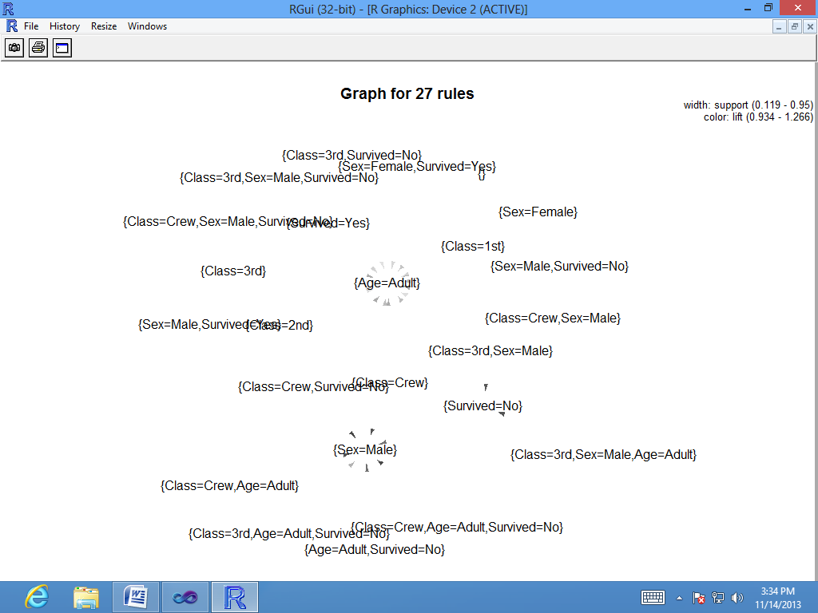

**Conclusion:** Using R-tool, we have thus implemented the apriori algorithm successfully.